Water: A Precious Resource in a Thirsty Land
Reading Nonfiction Text

Subject/Grade: Science 8 & 11

Adapted by: Diana Joy Jensen & Dr. Kate MacLachlan

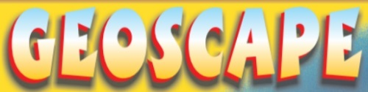
Stage 1: Identify Desired Results
Outcome(s)/Indicator(s)
Environmental Science 20
ES20-HP1 Investigate technologies and processes used for mitigating and managing resource use, waste generation and pollution associated with a growing human population.
b) Investigate the environmental impact of human population changes over the last century on a specific region or area with respect to resource use, waste generation and pollution.
Grade 8 Water Systems
WS8.1 Analyze the impact of natural and human-induced changes to the characteristics and distribution of water in local, regional, and natural ecosystems. [CP, DM]
a) Construct visual representations of the world distribution of water, and the distribution of water in Saskatchewan, including watersheds, lakes, rivers, streams, river systems, wetlands, groundwater, saline lakes, and riparian areas.
d) Apply the concept of systems as a tool for interpreting the structure and interactions of water systems by constructing representation of systems such as the water cycle, watersheds, and continental drainage basins and showing interrelationships between parts of the system.
English Language Arts Grade 6-8
Outcome: CR6-8.1 View, listen to, read, comprehend, and respond to a variety of texts that address identity, social and efficacy.
Outcome: CR6-8.2 Select and use appropriate strategies to construct meaning before, during and after viewing, listening, and reading.
Outcome: CR6-8.3 Use pragmatic, semantic/lexical/graphophonic, and other cues to construct and confirm meaning when viewing, listening, and reading.
Outcome: CR6-8.4 View and demonstrate comprehension and interpretation of visual and multimedia texts with specific features (e.g., circle graphs) and complex ideas including visual components of media such as magazines, newspapers, websites, reference books, graphic novels, broadcast media, videos, and promotional materials.

Outcome: CR6-8.7 Read independently and demonstrate comprehension of a variety of specialized information texts including non-fiction books, grade-level instructional materials, articles, reports, reference materials, instructions, advertising, promotional materials and websites.
Outcome: CR6-8.8 Read Grade 7 appropriate texts to increase fluency and expression.
Key Understandings: (‘I Can’ statements)  I can… apply important skills when reading non-fiction text to help me understand and interpret information and illustrations/ diagrams.  I can…summarize and share important ideas from a non-fiction text and illustrations/diagrams.  I can… create my own scientific questions that could guide further research. | Essential Questions:  What are some strategies you could use to help you understand and interpret a non-fiction reading?  What are some strategies you could use to help you understand and interpret a non-fiction illustration/diagram?  What do you find interesting on the panel?  What do you think is important and why?  What other questions do you still have?

Stage 2: Teacher Background
Reading non-fiction text is an important skill that many students, even so-called “good” readers, find difficult. Identifying features of nonfiction text that alert the reader to important information, separating out important ideas from interesting details, and interpreting information from diagrams or illustrations are all essential to getting the most out of nonfiction reading.

Distilling Important Ideas from Interesting Details
Textbooks are arranged in a predictable format. Information is presented in a logical and sequential fashion; important concepts are stressed. Paragraphs begin with a topic sentence, continue with a group of supporting sentences, and end with a sentence that restates the topic and captures the main idea. Each paragraph elaborates one main idea. Teachers can make copies of textbook reading on the Overhead.

Ironically, identifying important information in exciting, well-written expository text can be troublesome, because compelling details may grab the imagination and lead readers astray. The most important ideas in well-written nonfiction are often deeply embedded in rich detail. Distinguishing what’s important from what’s interesting can mean walking a pretty thin line. Sometimes the interesting ideas are the most
important but not always. Practicing sifting, sorting and separating out important ideas from interesting
details helps readers determine the essence of an authentic nonfiction piece.

Interpreting Information from Illustrations
In nonfiction material, illustrations represent information not always included in the text. In fiction, illustrations usually support the text rather than add new information. Students need to learn how to read and interpret illustrations found in nonfiction in order to access new information.

Helping students read illustrations
Choose an illustration. Cover up the print on the page and ask the students to look carefully at the page and tell what they saw. Chart these findings. Draw students' attention to specific aspects of the illustrations and tell what else they see. Review the statements and eliminate anything that is not a fact. After confirming and
deleting specific statements uncover the print and read it to them. Did the students notice anything about what they learned from the illustrations and what they learned from the printed information?

Pictures:

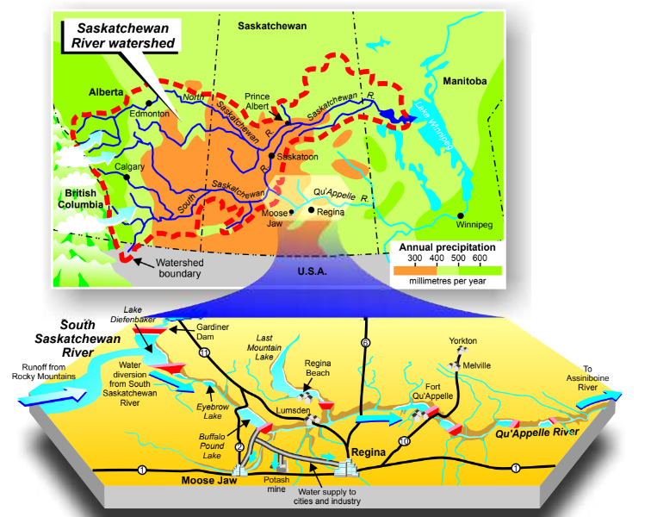

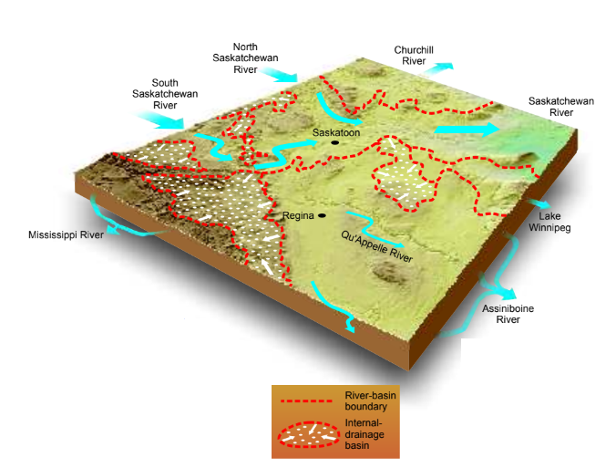

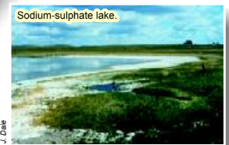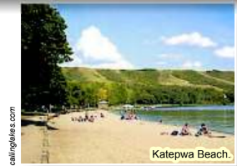

Definitions

Saline: very salty water (deep groundwater, some lakes, and seawater, for example).
Evaporation: the process that changes liquid (water) into (water) vapour.
Drainage Basin: any area of land where precipitation collects and drains into a common outlet - a single stream/river or a set of streams/rivers or another body of water like an ocean or bay.

Stage 3: Build Learning Plan
Set (Warm-up, Focusing the Learning): Time: 5-7 min  Review nonfiction features with students:  The features of nonfiction reading alert the reader to important information. Students need to be taught  to pay attention to these signposts:  - Fonts and special effects. Titles, headings, boldface print, colour print, italics, bullets, captions, labels and the like signal importance in text.  - Textual cues. Nonfiction writing often includes verbal cues that signal importance: for example, for instance, in fact, in conclusion, most important, but, therefore, on the other hand, and such as.  - Illustrations and photographs. Illustrations play a prominent role in enhancing reader comprehension. Colourful pictures and photographs capture attention.  - Graphics. Diagrams, cutaways, cross sections, overlays, distribution maps, word bubbles, tables, charts, graphs, and framed text graphically inform nonfiction readers of important information.  Development: Time: 45 min  1. Have students read the panel silently in their groups, incorporating their skills for reading nonfiction text.  2. In groups have students write about what they have read - this can be any type of thoughts, reactions, opinions, etc. in the form of a short note/letter to other group members.  3. Have the students share their responses with their group members. Let the students discuss their responses with one another.  4. Then, have students look at the panel and identify the fonts and special effects that they see. They should indicate these on the paper using sticky notes, highlighters, underlining, or some other form of identification. Encourage students to make marginal notes as to what the special effects are highlighting.  5. Have students use a different method than in step 4 to identify verbal cues that signal importance in the text. Make notes on the sheet using stickies or the margin to identify what the important information is that the cues point to.  6. Have students identify the purpose of any illustrations, photographs and graphics on the panel. This information should also be written on the panel sheet.  7. Using the notes from their panel sheets, students should re-read the panel and complete the student record sheets. In pairs or small groups, students can compare their responses and their questions.  Learning Closure: Time: 10-15  Complete the activity with a class discussion. Ask for “highlights” from each group. Groups can report to the whole class to generate a master sheet on the smartboard or screen summarizing the important and interesting information and the questions that were generated. |  | Materials/Equipment:  - Copies of poster panel  - Student record sheet  - Highlighters  - Rulers  - Sticky Notes  Possible Adaptations/  Differentiation  - This activity could easily be used as an engage lesson for each panel on the poster. Younger students may all work together on a certain panel. Older students may do a jigsaw activity.  - Great scaffolding activity for reading non-fiction text.  - Students may read aloud to each other, take turns reading, or read silently.  - A teacher may read aloud to a group of students.

Stage 4: Determine Evidence for Assessing Learning
Assessment:
* Use a checklist or rating scale to record observations of student reading behaviour during the first part of activity.
* Use a group participation assessment tool during the small group portion of the activity.
* Make anecdotal observations of student participation and understanding during small group and reporting activities.
* Respond to students‛ written work on panel and on record sheet.
Extensions
- Students could use the questions generated to explore the Water topic further and then create their own “panel” that would answer one of those questions.
- Students could also explore the waste treatment and supply facilities in their own area and the primary uses of water in the area.
- Students could create a glossary with images, definitions and examples of key terms from the panel.

Look at the GeoExplore Saskatchewan website for further information and a deeper understanding of the importance of Saskatchewan’s geological history. It is a digital version of the original paper Geological Highway Map of Saskatchewan. Main tab: “Water & Drainage”

Name:_____________________
Title of Panel:

What is Interesting? | What is Important?

What did I find out from the diagrams, illustrations, and / or photographs?

What other questions do I have about this topic after reading the panel?

