Badlands and Dinosaurs: Hard Rock or Soft Rock?

Subject/Grade: Science 4, Science 7, and Earth Science 30

Adapted by: Hilary Roemer & Dr. Kate MacLachlan

Stage 1: Identify Desired Results
Outcome(s)/Indicator(s)
Grade 4 Science RM4.3 Analyze how weathering, erosion, and fossils provide evidence to support human understanding of the formation of landforms on Earth.
Grade 7 Science EC7.3 Investigate the characteristics and formation of the surface geology of Saskatchewan, including soil, and identify correlations between surface geology and past, present, and possible future land uses.
Earth Science 30 ES30-LS1 Analyze surface geography as a product of weathering, erosion and mass wasting.
Key Understandings: (‘I Can’ statements)  I can... understand the meaning and process of weathering.  I can... understand the meaning and process of erosion.  I can… understand the meaning and process of differential erosion and how this aids paleontologists.  I can… understand how the Badlands are formed. | Essential Questions:  - What is weathering?  - What is erosion?  - What is differential erosion?  - How are Badlands formed?  - Which rock types would form cliffs and which rock types would form valleys?

Stage 2: Teacher Background
Background Information:
It is commonly accepted that rocks are hard, but there are varying degrees of hardness. Think of runners you have owned. The souls of the cheap pair and the expensive pair may look the same when they are new, but the cheap ones have holes in the bottom after a month of jogging, while the expensive pair lasts much longer (hopefully, but of course there are those name brand exceptions). Rocks are similar. Some will be able to withstand the forces of weathering and erosion (hard rocks such as sandstone or conglomerate) while others will not (soft rocks such as shale and mudstone). The badlands look the way they do because of this differential erosion. The steep, cliff-like valley sides (shown in red on the diagram below) are made from sandstones while the slopes and valleys are made from softer shale which cannot stand up to the erosion power of streams.

Terms that are commonly confused with one another are weathering and erosion.

Weathering
Weathering is the breakdown of rocks at the Earth’s surface, by the action of rainwater, extremes of temperature, and biological activity. It does not involve the removal of rock material.
There are three types of weathering, physical, chemical and biological.

Physical weathering is caused by the effects of changing temperature on rocks, causing the rock to break apart. The process is sometimes assisted by water.
There are two main types of physical weathering:
- Freeze-thaw occurs when water continually seeps into cracks, freezes and expands, eventually breaking the rock apart.
- Exfoliation occurs as cracks develop parallel to the land surface a consequence of the reduction in pressure during uplift and erosion.

Chemical weathering is caused by rain water reacting with the mineral grains in rocks to form new minerals (clays) and soluble salts. These reactions occur particularly when the water is slightly acidic.

Living organisms induce Biological weathering by contributing to the weathering process in many ways:
- Trees put down roots through joints or cracks in the rock in order to find moisture. As the tree grows, the roots gradually prize the rock apart.
- Many animals bore into rocks for protection either by scraping away the grains or secreting acid to dissolve the rock.
- Bacteria, algae and lichens produce chemicals that help break down the rock on which they live, so they can get the nutrients they need.

How is erosion different to weathering?
Erosion is the process by which soil and rock particles are worn away and moved elsewhere by wind, water or ice. Weathering does not involve transport of the material.

For more information check the following website:
https://www.geolsoc.org.uk/ks3/gsl/education/resources/rockcycle/page3564.html

Other Key Vocabulary

Badlands: a dry terrain where extensive erosion from wind and water creates steep slopes with little vegetation. The Saskatchewan badlands where originally formed from the water running of glaciers. The badlands continue to erode and slowly fossils become exposed and paleontologists can discover them.

Differential erosion: depending on the rock, it may be less or more resistant to erosion.
Soft rocks such as shale and mudstone easily erode and form the bottom of the valleys. Whereas, conglomerates and sandstones are resistant to erosion and form the steep cliff-like valley sides.

In the Saskatchewan badlands, the weathering began as water running off of the glaciers as they melted. The rocks in these areas are a combination of weak shales and more resistant sandstones. The softer surface sediments were removed by glacial meltwater which then cut down through the soft shales in complex, branching drainage patterns. The gullies that formed later became streams which were normally dry but would sometimes be the site of flash floods that further washed away the valley walls. The high areas in the badlands (the buttes and plateaus) are usually capped by sandstones that were able to stand up against the meltwater from the receding glaciers. However, given enough time, even the buttes can be undermined by stream erosion below them, causing them to collapse.

In this activity, students will be modeling the weathering action of streams and rivers on different rock types (sandstone, conglomerate and shale) to see which ones are most susceptible to erosion.

Badlands Cross-section:

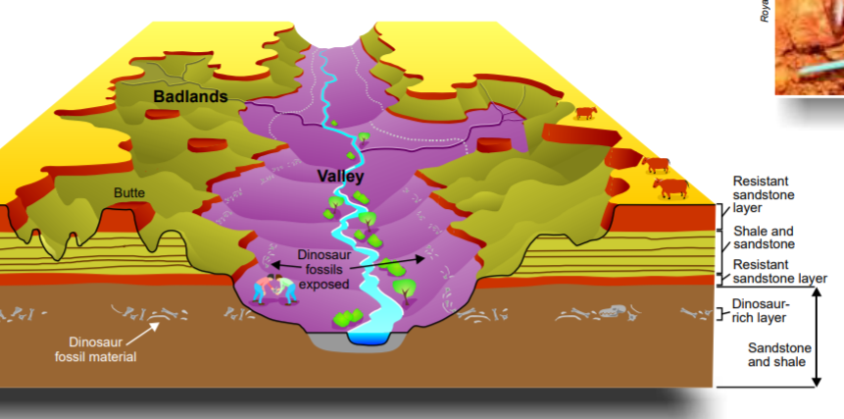

Stage 3: Build Learning Plan
Teacher Preparation:  The “rocks” must be made at least a week before this lesson. If you are short on time in your unit, then you can do this preparation yourself. If you are not short on time you can have your students help you with the preparation.  Make enough alum (or Epsom salts) solution for all rocks. You will need approximately 250 mL of solution for each 8 samples of sandstone and conglomerate. Add 15 mL (1 Tb.) alum (or Epsom salt) to 250 mL (1 cup) water. Heat, stirring occasionally, until the solute disappears and then let the solution cool.  Pre-Activity  If students are helping with preparation:  Rocks must be made at least one week before the lesson when they will be “weathered”. Each student can make one of the three rock types.  Rock Type A (sandstone) – Place 60 mL (¼ cup) sand in a Styrofoam cup (label A). Pour in enough alum solution to just reach the top of the sediment.  Rock Type B (conglomerate) – Place 30 mL (⅛ cup) sand and 30 mL (⅛ cup gravel) in a Styrofoam cup (label B). Mix it up. Pour in enough alum solution to just reach the top of the sediment.  Rock Type C (shale) – Place 60 mL (¼ cup) clay in Styrofoam  Cup (label C), carefully pushing it into the bottom.  IMPORTANT: for rock types A and B, be sure that the sediment is completely saturated with alum solution. It can take a while for it to seep down to the base of the cup. Tapping the cup a few times helps.  Find a place for the rocks to remain undisturbed for at least one week.  Set (Warm-up, Focusing the Learning): Time: 15 min  - Show students some pieces of chalk and a couple pieces of rock. Ask students to predict what they think will happen when the chalk and rocks are put inside a bag/container together and shaken. Have students explain their predictions and then get a volunteer to shake the bag/container.  - Show students the inside of the bag/container and ask them to explain what happened.  - Then, Share the Badlands Cross-section and discuss the features of the badlands with students. Ask them for suggestions as to how this area formed by making connections to the engage activity. Talk about the role of glacial meltwater and stream flash flooding on weathering of different rock types. Go over vocabulary and concepts.  Development: Time:  For the actual activity, have students work in groups of three. Handout student worksheets. Explain that they will be comparing rock types through erosion characteristics. A nail brush will substitute for the abrasive sediment carried by moving water.  - Have one member from each group pick up their rocks (A, B and C), a paper plate, a nail brush, a hand lens and a piece of newspaper.  - Before testing begins, students carefully remove their rocks from the cup. They must be sure to remember which is rock A, B and C. They write a thorough description of each rock on their worksheet. They should carefully observe grains, texture, what is filling in between grains, any layering, etc. Encourage them to use a hand lens during this process.  - Carefully instruct students on how to “weather” their rock. They should pick a flat surface (bottom works best) and brush back and forth in the same place 100 times. They must be careful not to apply so much pressure that they crush their rock, but they need to apply enough to actually wear away at the rock. IMPORTANT: In order to be able to reuse the paper plate for each rock, go in order from A to B to C since C is going to be a bit messy.  - After the 100 brush strokes, they estimate the number of grains that have been removed and use the scale on their Hard Rock or Soft Rock? Worksheet to provide a quantitative value for susceptibility to erosion. Dispose of the eroded material in the plate and place the next rock on it.  - Make sure another student gets to test Rock B, repeating steps 3 and 4. A third student can test Rock C in the same way. It is very important that they all try and apply the same pressure. Ideally, the same student would do all tests in order to control this variable but it is important that all students be a part of the testing process.  - When done, clean up the area and dispose of materials according to teacher directions.  - Students then complete the remainder of their worksheet. |  | Materials/Equipment:  - Student Worksheet  Alum solution  15 mL (1 Tb.) alum per 250 mL (1 cup) water. 250 mL is enough to do approximately eight rocks. You can also use Epsom salts rather than alum.  Preparation Supplies  Styrofoam cups  Sand  Gravel  Clay (available at toy or craft shops)  Alum or Epsom Salts  Water  Hot Plate (Heat)  Big Glass Beaker or Container for heating solution  Safety Considerations:  - If students are using hot plates, take precautions  - Wear safety goggles  Possible Adaptations/  Differentiation  - You could try to find other materials to use instead of making the rocks. For example...  Rock A - Hard cookie or some other hard material that will not easily breakdown and breaks into sand-like grains.  Rock B - Ichiban noodles, or some other hard material that will not easily breakdown and breaks into chunks.  Rock C - Chalk, clay, or some other soft material that will easily breakdown.  Engage Activity  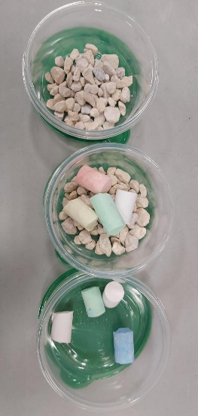  - A couple of Rocks  - A couple of pieces of chalk  - A container or plastic bag  Development Per group  Rocks A, B & C  - 90 mL (3/8 cup) sand  - 30 mL (1/8 cup) gravel  - 1 cup clay (available at toy or craft shops)  - Fingernail brush or toothbrush  - Paper plate  - Hand lens  - Newspaper  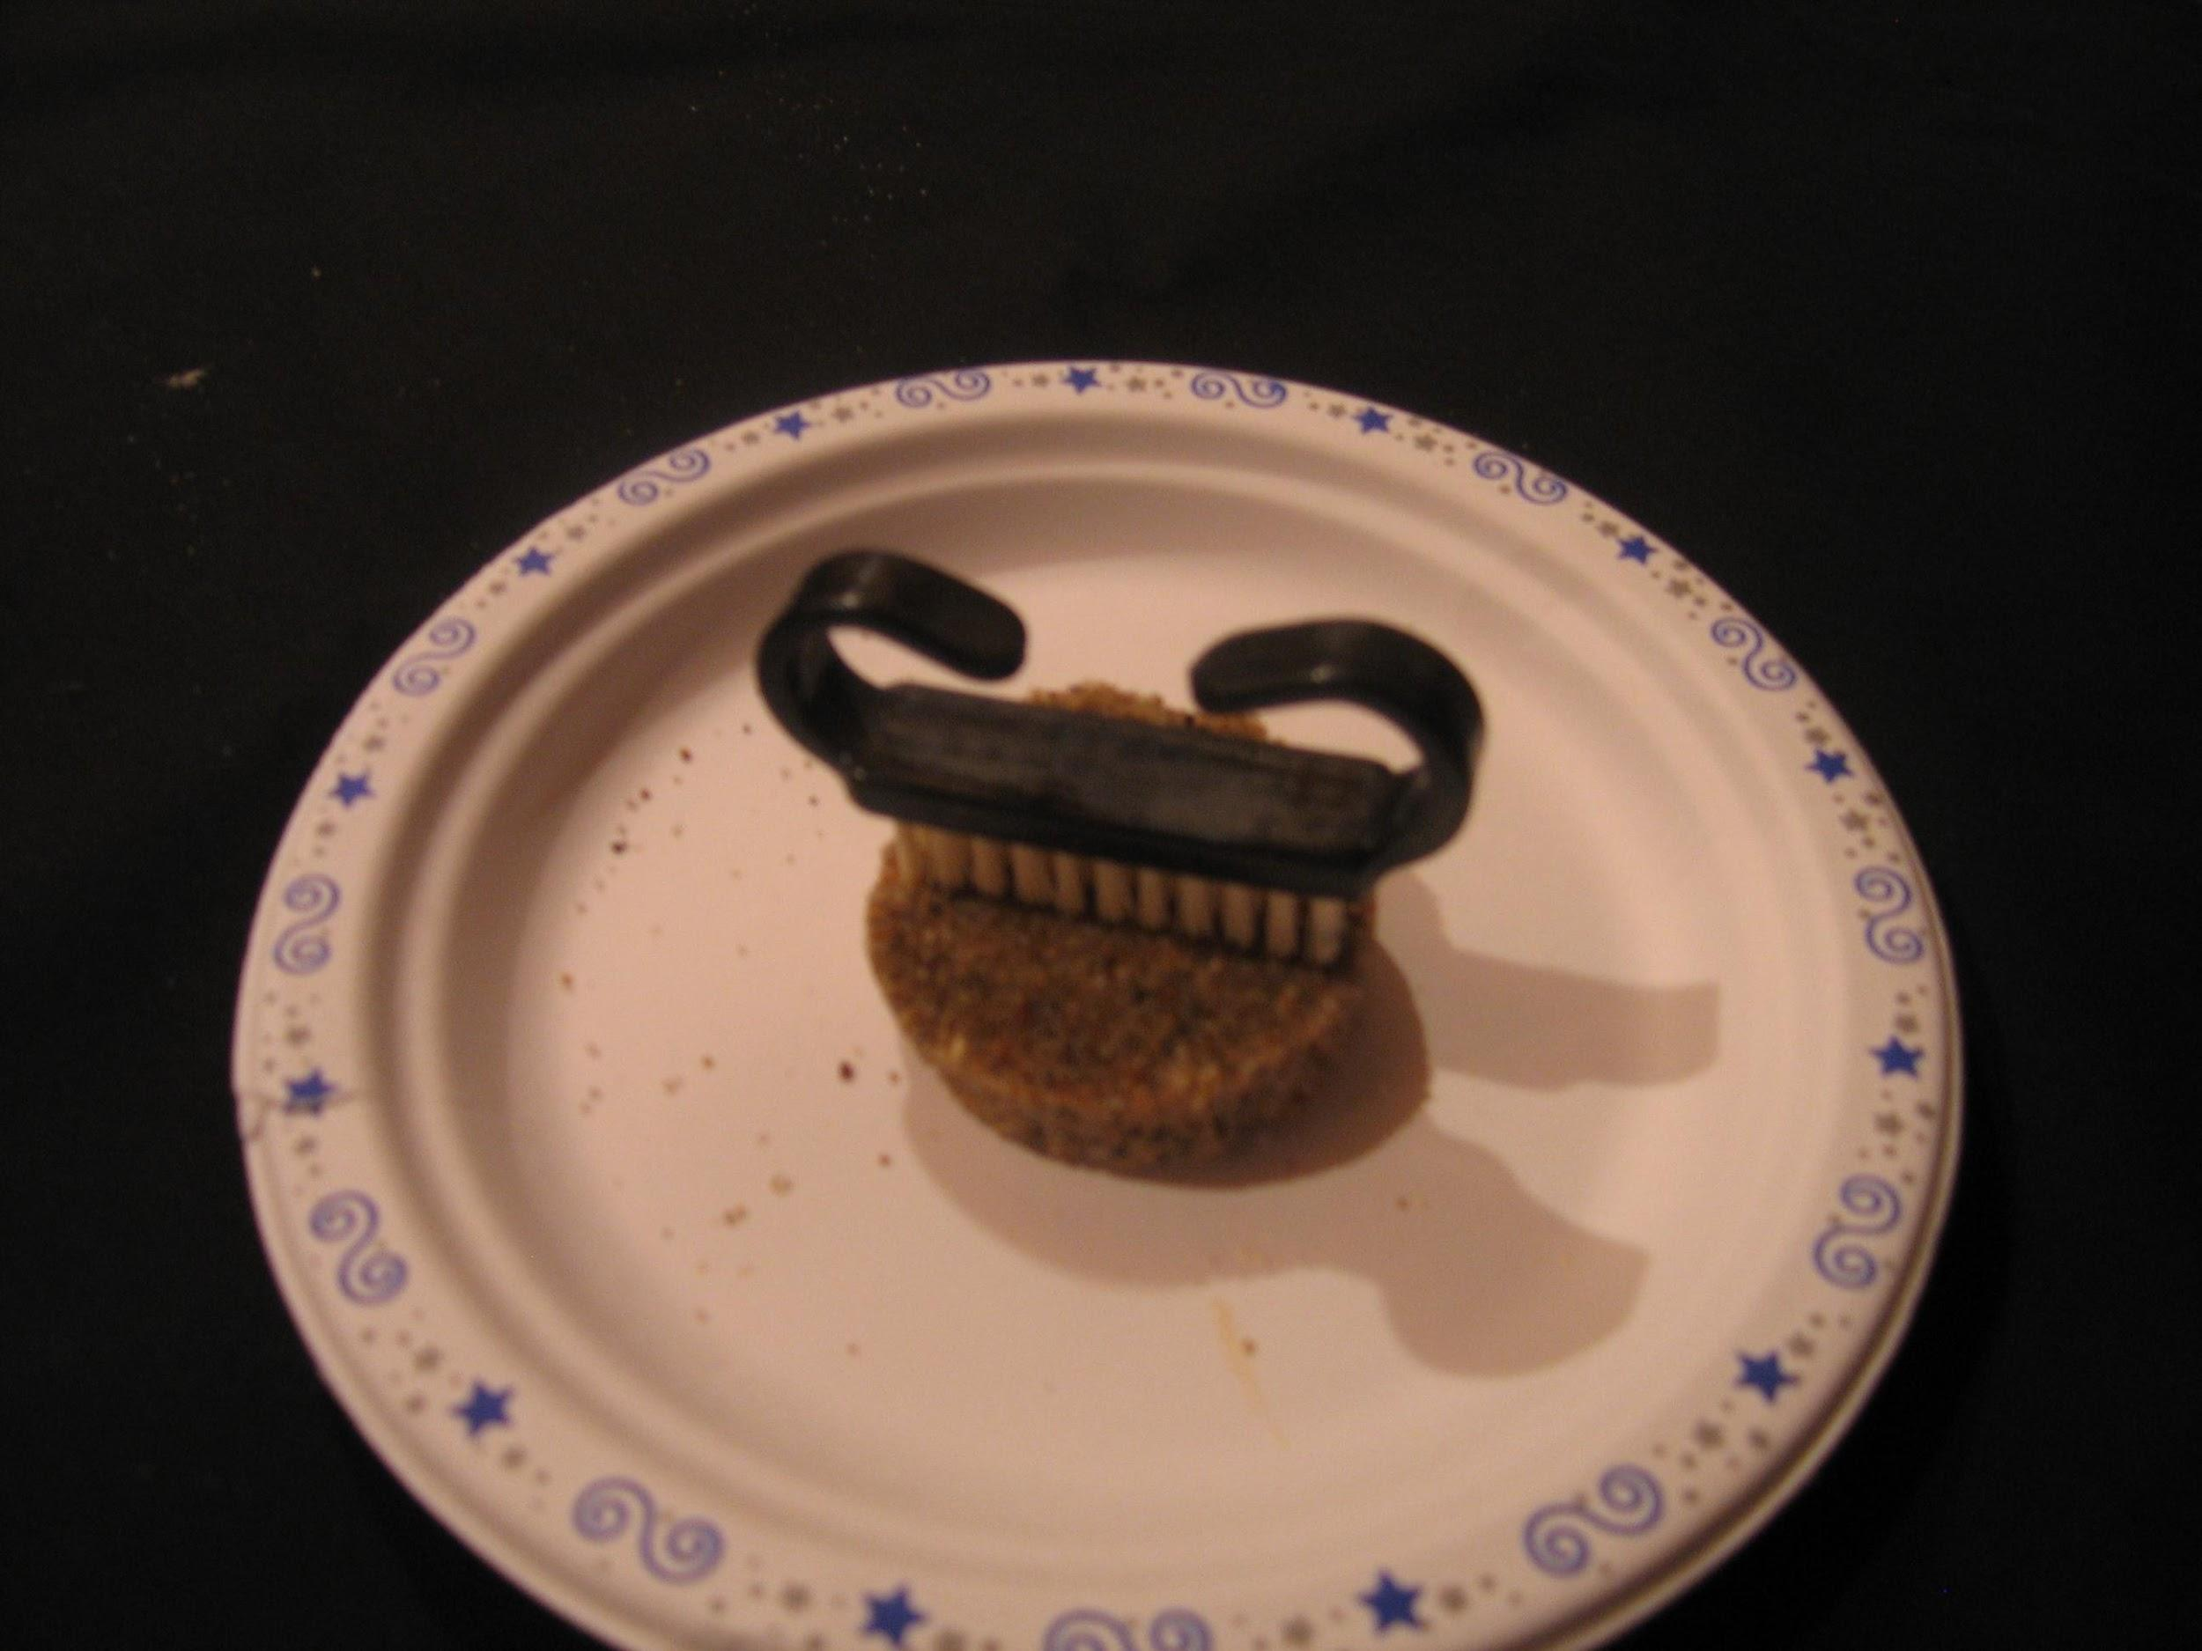  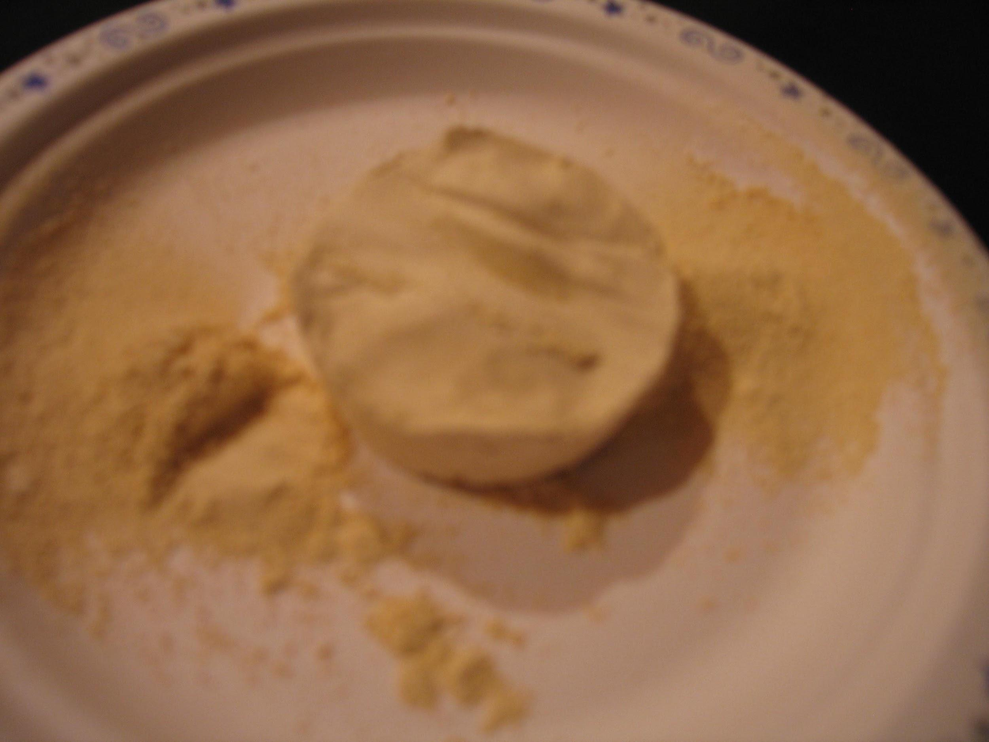

Stage 4: Determine Evidence for Assessing Learning
- Collect the Hard Rock or Soft Rock? Worksheet and assess understanding, connections and observation skills through relevancy of answers and accuracy of recorded data.
- Throughout the activity, access group work and focus skills of individual students.
Extensions
  - Create a timeline for the formation of the badlands, starting with the original sedimentation during the Cretaceous, continuing on through the ice age and on to present day processes.
  - What are the critical factors in the formation of fossils, and how were these achieved in the badlands area of Saskatchewan?

Look at the GeoExplore Saskatchewan website for further information and a deeper understanding of the importance of Saskatchewan’s geological history. It is a digital version of the original paper Geological Highway Map of Saskatchewan:

Main Website
https://skgeolhighwaymap.maps.arcgis.com/apps/MapSeries/index.html?appid=a845cbb370f7401597806887318e2676

For more background information related to this lesson check out
- Main tab “Landforms”

Name: ___________________________

Hard Rock or Soft Rock Student Worksheet

Badlands Cross-section:

Saskatchewan Examples:

Geological Highway Map Road Stop
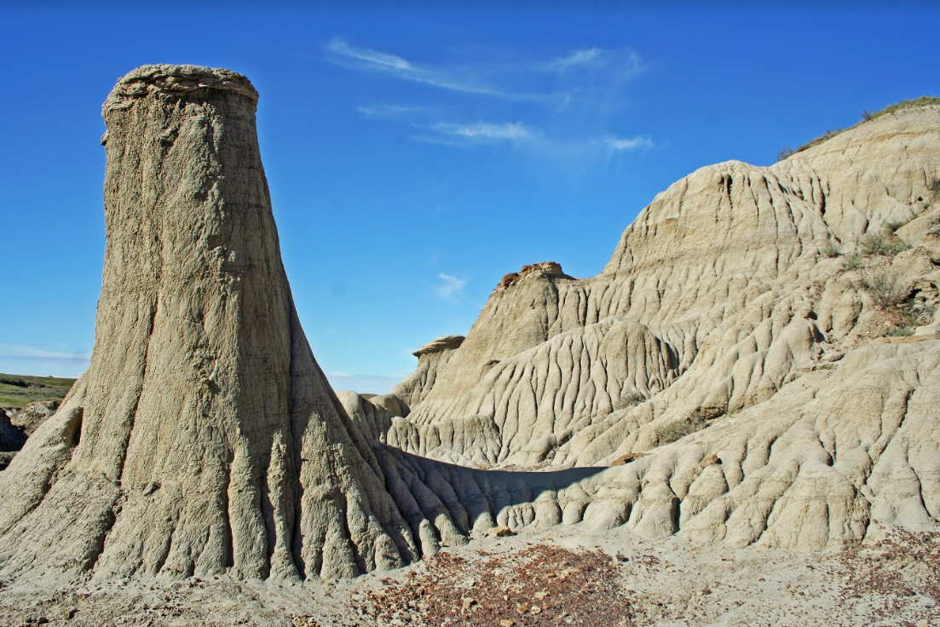 | Avonlea Badlands  The Avonlea Badlands are formed in Upper Cretaceous rocks. Differential weathering creates unique shapes like pillars out of underlying claystone and overlying sandstone. These rock formations are called hoodoos or pedestal rocks.
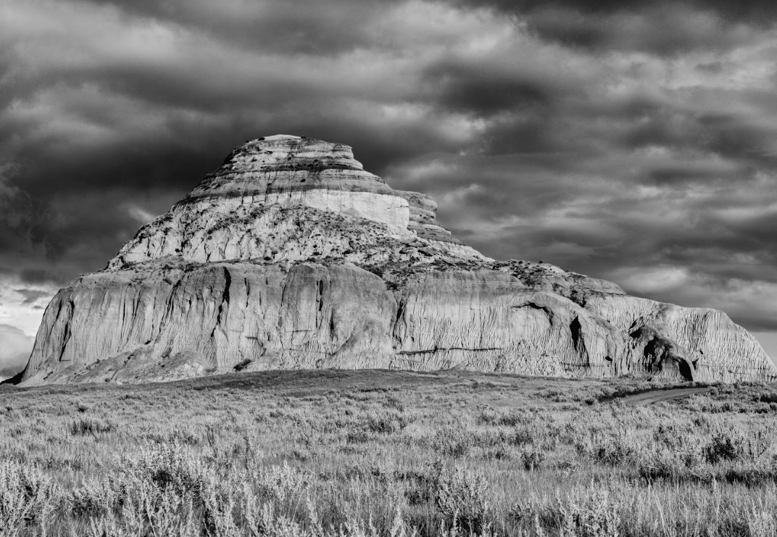 | Castle Butte - Big Muddy Badlands  Castle Butte is approximately 70 m high and 0.5 km in circumference. This landscape was carved by glacial meltwater, exposing Cretaceous and Tertiary rocks to modern weathering and erosion processes.

Recording Sheet:
Rock | Description | Susceptibility to Erosion  (see scale*) | Rock ID
A
B
C
*Susceptibility to Erosion Scale: Very low (<50 grains removed)
Moderate (>50 but <100 grains removed)
Very high (>100 grains removed)
Questions:

- Explain the difference between weathering and erosion using your model as an example. What process were you modeling with the brush?

- How has weathering and erosion in the badlands made it possible for Paleontologists to study dinosaur remains?

- Which rock types would form cliffs and which would form valleys? Explain the basis for your inference.

Answer sheet:

- Explain the difference between weathering and erosion using your model as an example. What process were you modeling with the brush?
- Weathering is the breakdown of rocks into smaller particles by physical, chemical and biological processes.
- Erosion includes the process of weathering, but also involves moving or transporting the particles to somewhere else.
- The brushing process is mostly about weathering, but if you brush the material right off the sample you are also transporting it.

- How has weathering and erosion in the badlands made it possible for Paleontologists to study dinosaur remains?
- The harder, more resistant cap rocks that form the top of hoodoos and buttes protect the softer rock underneath from being completely eroded away. These softer rocks typically contain fossils that are preserved for paleontologists to discover.

- Which rock types would form cliffs and which would form valleys? Explain the basis for your inference.
- Softer rocks such as shale are more easily eroded and valleys would form more easily in softer rocks. Harder rocks such as sandstone and conglomerate would form cliffs and the tops of buttes or hoodoos.

