Our Diverse Prairie Landscape: Saskatchewan is Not Just Flat! The Day After Tomorrow

Subject/Grade: Environmental Science 20 and Grade 8 Water Systems Adapted by: Hilary Roemer & Dr. Kate MacLachlan

Stage 1: Identify Desired Results
Outcome(s)/Indicator(s)
Environmental Science 20 ES20-AH2 Analyze the production, reliability and uses of geoscience data to investigate the effects of a changing climate on society and the environment. a) Examine the types of questions that scientists attempt to answer with respect to Earth's climate and past, present and potential future climate changes. g) Investigate potential environmental, economic and societal impacts of climate change in Saskatchewan on human health, population distribution and access to water and other resources. l) Hypothesize how life on earth might respond to a changing global climate given different scenarios such as sea level rise, extreme weather events, water shortages, increased spread of disease, flooding and acidification of the oceans.
Grade 8 Water Systems WS8.2 Examine how wind, water, and ice have shaped and continue to shape the Canadian landscape. h) Identify factors that affect polar ice cap formation and reduction and their effects on the environment, including possible changes to ocean currents and climate patterns. i) Propose new questions and problems for future study that arise from the study of the effects of wind, water, and ice on the landscape (e.g., “How might changes in glaciers affect Saskatchewan water supplies?” “How might ice cap melting change Canadian coastlines?”).
Key Understandings: (‘I Can’ statements)  I can … explain the impact on a variety of Canadian populations that have world-wide sea level increase with the melting of glaciers.  I can… explain multiple changes that the melting of glaciers would cause across Canada.  I can… show how melting glaciers might change Canada’s coastlines and how that would affect people.  I can… use digital maps and paper maps to infer how sea level rise will affect Canada’s coastlines. | Essential Questions:  - What are some changes that would occur if the polar ice caps and glacial ice were to melt?  - What would happen if the glaciers melted?  - How will the provinces be affected differently, if the glaciers melted?  - Who would be impacted by the melting of the glaciers?  - Would the changes be gradual or sudden?

Stage 2: Teacher Background
Changes to the Earth’s climate are not new, however they have been accelerating over the past few decades. Many students are curious about the impact that climate change will have on the Earth. Recent Hollywood movies have dealt with the topics of glacial and polar ice cap melting. During this lesson students will explore the impacts of sea level increase from the melting of glaciers on Canadian coastlines. Also, students will explore the impacts of climate change on other provinces and territories that are not directly affected by sea level rise.
Atlas of Canada 6th Edition, 1999 – 2009 (archival version)
The potential impacts of climate change in Canada can be shown in the following areas:
- The growing season is expected to be warmer and longer. It is possible that not all agriculture may benefit from this change since the plants may not adapt as quickly to the rate at which changes in the growing season occur (research in biologic engineering of plant seeds has been ongoing and successful).
- Navigation is likely to improve in seasons with ice-covered waters due to a warmer climate that would cause a later freezing and an earlier break-up date for ice in waterways.
- A shorter warmer winter would lower space heating costs.
- Sea level is expected to rise, which will cause flooding and erosion in many coastal regions.
- The move of the permafrost limit towards the north could potentially extend the forest zone and the habitat for both animal and plant species towards the north, but the extendibility may be constrained by the soil quality and the adaptability of species.
- Forests (particularly boreal forests) could be at higher risk of fire, pests and drought.
- While a warmer temperature could be of benefit to commercial agriculture for Ontario, Quebec and the Prairies, increased risks of drought and insect infestations will add stress to crops, and thus may affect the crop yield.
- Both the Pacific and the Atlantic fisheries are expected to be at risk, as climate change may affect both the population and the range of species which are notably sensitive to changes in water temperature.
- Primarily in southern Canada, increasing drought may also threaten water resources, causing decreases in water quality and quantity.
- There could be increased frequency of extreme weather conditions, such as floods, droughts, winter storms, heat waves and tornadoes.
- The increasing frequency and severity of heat waves may lead to an increase in heat stress and death, especially among the very young, the elderly and the ill. A number of indirect impacts are also expected on human health, including an increasing incidence of respiratory disorders, infectious diseases, and allergy problems.

Additional background reading includes:

- The Climate Atlas of Canada combines climate science, mapping and storytelling to bring the global issue of climate change closer to home for Canadians. It is designed to inspire local, regional, and national action that will let us move from risk to resilience. Found at: https://climateatlas.ca/

Stage 3: Build Learning Plan
Set (Warm-up, Focusing the Learning) - Time: 5-10 min  Ask the students to begin by making a list of (at least five) predictions about the effects of the melting of the polar ice caps. How would Canada change? Would this be a slow or rapid change?  Show the Map of Canada (Map of Canada can be found on the last page of this lesson plan) and ask students how the provinces might experience different effects from the melting of the polar ice caps.  Development - Time: 20 - 30 min for each station (3 stations)  Divide students into three groups, so each group can rotate through the three stations. Introduce and explain each station before the students begin the stations.  Engage - Topographic Map Station  Students will use paper copies of topographic maps to create a flood map using tracing paper.  - If the East Antarctic Ice Sheets melted, scientists have predicted a sea level increase of 64.8 meters along Canada’s coastline.  - If the West Antarctic Ice Sheets and the Antarctic Peninsula melted, there would be a sea level increase of 8.52 meters along Canada’s coastline.  - If the Greenland Ice Sheets and all other (except Antarctic) ice caps, ice fields and valley glaciers melted, there would be a sea level increase of 7 meters along Canada’s coastline.  - If all the ice sheets and glaciers melted, there would be a sea level increase of 80.32 meters along Canada’s coastline.  Have students create a flood map using 80-meter sea level rise. Students pick a map from one of Canada’s coastlines (Vancouver map is the easiest one to do, since the contour lines are clearly visible).  - Use tracing paper to trace the coastline and the 80m contour lines. Students colour in from the coastline to the 80m contour line. That is how much land would be flooded if the sea level were to rise 80m.  - Have students complete their maps by having a title, legend, north arrow, labeling important feature, etc.  - Students can colour land, ocean and flood area different colours.  - Have students staple their flood map to their worksheets.  Explore - Digital Map Station  - Have students follow along within their worksheets and go to Flood Map - https://www.floodmap.net/?ct=CA  - Students will explore a location along the Canadian coastline with a high population and answer the questions on their worksheets.  - Then, students will do additional research figuring out the number of people displaced and any plans for preventative measures.  - The last question refers to storm events like hurricanes or typhoons that can cause temporarily sudden flooding. These types of storms will occur more frequently and become more intense due to climate change.  - If they finish early, they can check out this really cool website - https://climateatlas.ca/  Elaborate - Climate Change Articles  - Print out multiple copies of the articles that you want students to read about climate change. Check out these websites –  - https://climateatlas.ca/climate-change-basics  - https://climateatlas.ca/city-reports  - Students create a word cloud (See last page in this lesson plan for an example) based on the big ideas that they have learned from the articles. Challenge students to be creative with their word clouds and to provide meaning/connections with their word choice/presentation (not just a bunch of random words).  - You can focus their word clouds by providing some big ideas/questions on the board for students to start with. Maybe their big idea is a short question that they answer by using keywords. Example - “Impact of Climate Change” is in big bold colourful font and the one word to two-word answers are smaller and surround the question.  - You might have to explain to students what a word cloud is and show an example (print one out for the station). |  | Set Materials/Equipment:  - Map of Canada  - Student worksheets  - Possibly an example of a word cloud for Elaborate Station.  Engage Materials/Equipment:  - Map of Canada  - Tracing paper  - Pencil crayons  - Paper copies of topographic maps (Link below = best quality map and PowerPoint = other maps)  Vancouver Map 92G/6  https://pub.data.gov.bc.ca/datasets/177864/pdf/092g/092G036.pdf  PowerPoint includes lower quality maps of  - North Vancouver  - St. Johns  - Halifax  - Toronto  Note - the scale on the PPT. maps are not accurate.  Possible Adaptations/  Differentiation  - If you have your own topographic maps with contour intervals of 20m or less of the Canadian Coastline, then use those maps along with the ones provided.  - Jigsaw the flood maps by having groups do different predictions of sea level rise.  Explore Materials/Equipment:  - Computers  Flood Map - https://www.floodmap.net/?ct=CA  Possible Adaptations/  Differentiation  - Challenge students to find the exact location that they just created their own flood map for and compare the two.  Elaborate Materials/Equipment:  - Printed out multiple copies of the articles that you want students to read.  Check out these to websites  https://climateatlas.ca/climate-change-basics  https://climateatlas.ca/city-reports  - Pencil crayons  Possible Adaptations/  Differentiation  - Could have students do this station online, if there are enough computers.  - They could also create their word clouds online and print them off or send them to you digitally.

Stage 4: Determine Evidence for Assessing Learning
- Mark Student worksheets and map for understanding
- Check student worksheets and map for understanding and then have a classroom discussion going over the big ideas and any misunderstandings
- Create an exit slip/ entrance slip to check for understanding

Extensions
- Students may use creative writing or poetry to describe post-melt Canada.
- Students may create tableaus detailing scenes from post melt Canada i.e. Learning of the impending melt; choosing a new home; moving across Canada; efforts to correct the change in climate.
- Students may create retail advertisements for ‘new’ waterfront property.
- The activity can be done in reverse: what would happen if the ice were to double?
- Students may choose to debate issues related to global warming for example adding an environmental tax to gasoline, providing rebates for owners of low emission vehicles, providing tax breaks for transit travelers. Would any of these issues differ by city or province? Would it be easier in larger cities to access public transit then in small towns?
- Some students may want to look into the speed at which such a global melting event may occur and what conditions must be met to induce such a change.
- View a Hollywood movie that deals with climate change and analyze the production for scientific accuracy.
- Investigate plans that are currently underway along the coastlines to stabilize infrastructure, building of walls and barriers, adding to the coastline, etc. in anticipation of sea level increase.
Look at the GeoExplore Saskatchewan website for further information and a deeper understanding of the importance of Saskatchewan’s geological history. It is a digital version of the original paper Geological Highway Map of Saskatchewan:

Main Website
https://skgeolhighwaymap.maps.arcgis.com/apps/MapSeries/index.html?appid=a845cbb370f7401597806887318e2676

- Tab - Landforms
  - Subtab - Ice Age

Additional Resources
The Climate Atlas of Canada combines climate science, mapping and storytelling to bring the global issue of climate change closer to home for Canadians - https://climateatlas.ca/

Canada Flood Map: Elevation Map, Sea Level Rise Map - https://www.floodmap.net/?ct=CA

The High-Adventure Science Climate module has six activities and an interactive model.
https://authoring.concord.org/sequences/476/sequence_run/99ccd5a7f12c18960e72034f91d3e93113468bf1
Climate Change - High-Adventure Science Interactive (concord.org)

Name: __________________

The Day After Tomorrow
How will the melting of the polar ice caps affect Canada? Make a list of five predictions about the effects of the melting of the polar ice caps.

Circle - Would this be a slow or rapid change? Why?

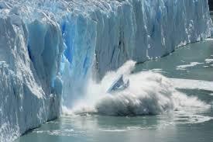

Will different provinces have different impacts?

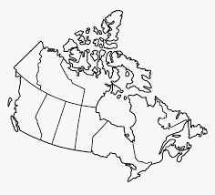

Engage - Topographic Maps
Climate Change increases the global average temperature and is causing glaciers to melt. When glaciers melt the sea level rises.

- If the East Antarctic Ice Sheets melted, scientists have predicted a sea level increase of 64.8 meters along Canada’s coastline.
- If the West Antarctic Ice Sheets and the Antarctic Peninsula melted, there would be a sea level increase of 8.52 meters along Canada’s coastline.
- If the Greenland Ice Sheets and all other (except Antarctic) ice caps, ice fields and valley glaciers melted, there would be a sea level increase of 7 meters along Canada’s coastline.
- If all the ice sheets and glaciers melted, there would be a sea level increase of 80.32 meters along Canada’s coastline.
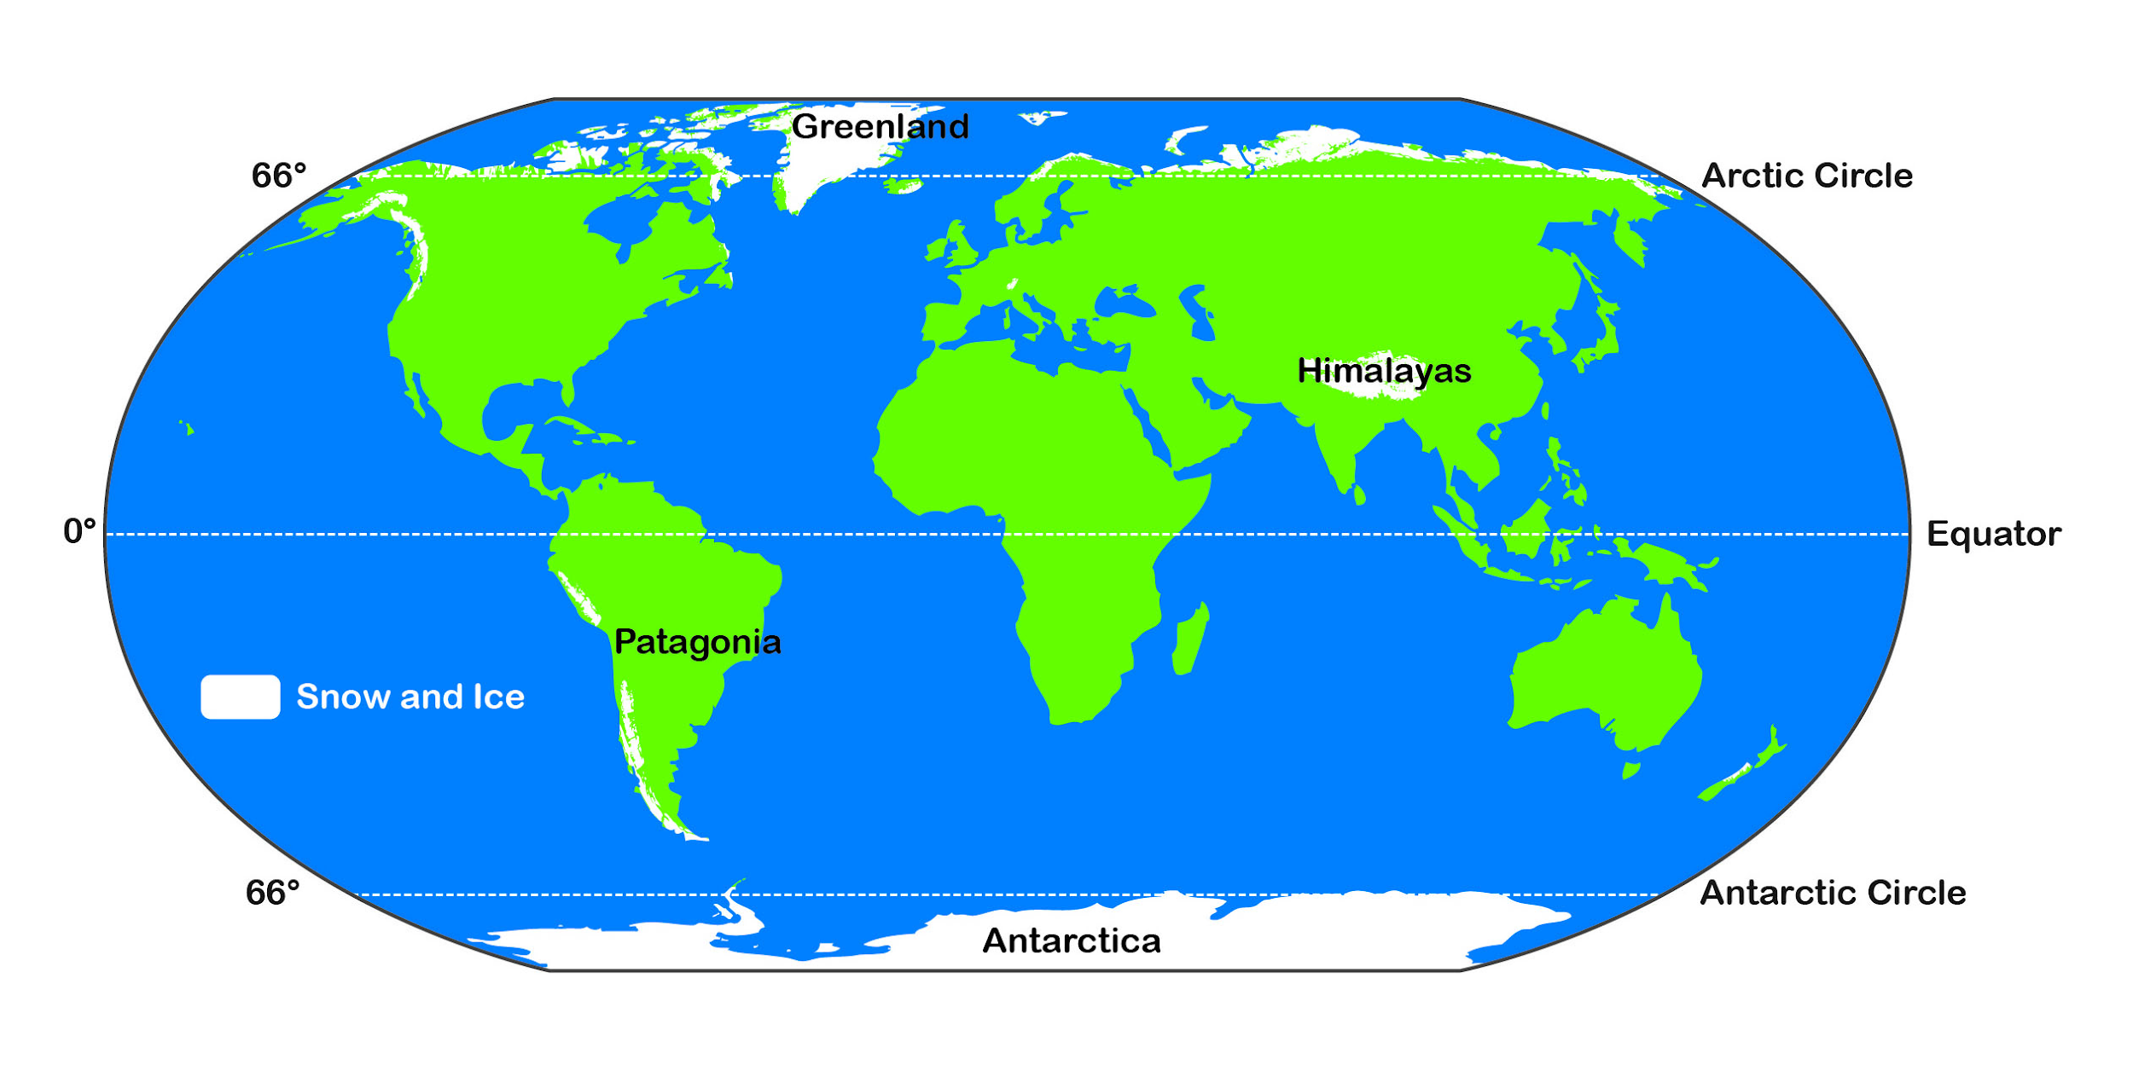
https://www.bgs.ac.uk/discoveringGeology/geologyOfBritain/iceAge/home.html

Task - Pick a map of one of the Canadian coastlines. Using tracing paper, trace out the coastline and the 80m contour line. Colour the non-flooded land (above the 80m contour line) land green, the flooded land red (coastline to 80m contour line) and the ocean blue. Create a title, legend and a North arrow for your map. Also, label important features on your map.
Then, attach your map to this worksheet.
Question - What does your flood map not tell us about the impact of sea level rise?

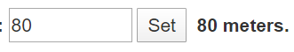
Explore - Digital Maps
Research - https://www.floodmap.net/?ct=CA
If any ‘pop ups’ from the site appear, close them. Set your water level to 80 meters. Pick a highly populated area along the Canadian Coastline to do a ‘location search’ on. Examples - North Vancouver, St. Johns, Halifax, Toronto… Answer the following questions based on the location you picked.

Location: ________________________________

What are your initial thoughts on how sea level rise will impact your location?

_____________________________________________________________________

_____________________________________________________________________

_____________________________________________________________________

_____________________________________________________________________

Record important infrastructures and buildings that will be flooded (hospitals, residential, parks, stadiums, etc.)

_____________________________________________________________________

_____________________________________________________________________

Additional Research - How many people will be displaced by sea level rise at your location?

_____________________________________________________________________

Additional Research - What current technologies/projects/plans does your location have in place to lessen the impact of sea level rise?

_____________________________________________________________________

_____________________________________________________________________

_____________________________________________________________________

_____________________________________________________________________
Question - What else could cause flooding and is related to climate change? Do you think people are prepared for these “events”?

_____________________________________________________________________

_____________________________________________________________________

_____________________________________________________________________

_____________________________________________________________________

- Finished early? Check out this website - https://climateatlas.ca/

Elaborate - Climate Change Articles
Read the following articles on climate change and create a word cloud on the big ideas or “takeaways” from the articles. Have your big ideas in a larger font than the surrounding words. Be creative and create a shape/image with your word cloud. Use colours, different fonts, and font sizes. Idea - Create a word cloud on the impacts of climate change for a specific area.
.

Teacher Resources
- Map of Canada
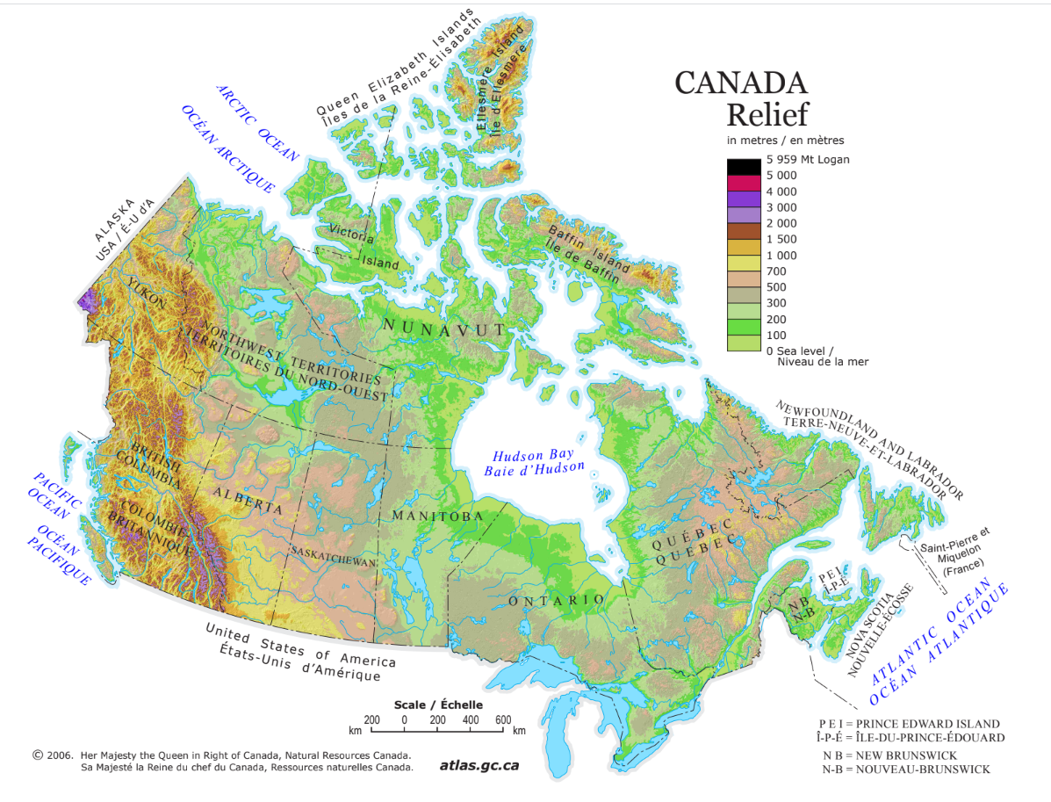
- Word Web Example

