Our Diverse Prairie Landscape: Saskatchewan is Not Just Flat!
Lumsden – Qu’Appelle Valley Contour Maps

Subject/Grade: Earth Science 30

Adapted by: Hilary Roemer & Dr. Kate MacLachlan

Stage 1: Identify Desired Results
Outcome(s)/Indicator(s)
Earth Science 30
ES30-LS1 Analyze surface geography as a product of weathering, erosion and mass wasting.
(c) Explain how anomalous features of Saskatchewan such as Qu’Appelle Valley are characterized by specific depositional and erosional processes. (k)
(d) Describe the effects of mechanical weathering and erosion, including glaciation, on the surface geography of Saskatchewan. (k)
(h) Apply mapping techniques such as creating and interpreting topographic profiles and translating between 2-D surface maps/cross sections and 3D box diagrams to represent surface geographical features. (k)
Key Understandings: (‘I Can’ statements)  - I can interpret contour lines for elevation on a 2D topographic map and understand the 3D topography.  - I can apply mapping techniques and interpret topographic profiles.  - I can explain how glaciation and weathering & erosion has shaped and continues to shape the topography of the Qu’Appelle Valley. | Essential Questions:  - What are contour lines?  - What are topographic maps used for? What does topographic mean?  - How has the landscape of the Qu’Appelle Valley been shaped and changed over time?  - What is currently shaping the topography of the Qu’Appelle Valley?

Stage 2: Teacher Background
Learners will be introduced to topographic maps by completing doodle notes, creating play-dough models and investigating a topographic map of the Qu’Appelle Valley.

Topographic Maps Refresher for Teacher
https://www.nrcan.gc.ca/sites/www.nrcan.gc.ca/files/earthsciences/pdf/topo101/pdf/mapping_basics_e.pdf
http://www.orange.wateratlas.usf.edu/upload/documents/CreatingTopoProfiles.pdf

The Qu’ Appelle Valley is an example of a steep-sided glacial meltwater Channel. It was formed during the last glaciation approximately 14,500 years ago (Storer, 1989). Currently the valley is being eroded and weathered down over time.
- Resource for more information - http://www.cmste.uregina.ca/valley/naturalhistory.html

Stage 3: Build Learning Plan
Set (Warm-up, Focusing the Learning): Time: 20 min  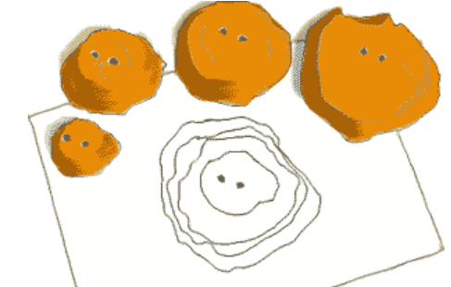  Complete the topographic doodle notes with students by projecting them onto the board and filling them out with students.  Then, give play-dough to students so they can create their own mountains/hills. Use the string to cut mountain/hill horizontally into different layers while keeping it still stacked together. Place skewers down the middle to create holes to use as a reference. Separate the layers and trace around the layers matching up the holes. Have students try to create a side profile.  Optional - Challenge students to create another play-dough mountain/hill and have them make the elevation lines where they are going to cut it. Before they cut it, have them trace out what the contour lines will look like on their paper. Then, cut it into different layers and see if it matches the outline of the prediction.  Investigation: Time: 40 min  Topographic maps- Contour lines connect all points of equal elevation. They are usually drawn every 50 or 100 m on current maps. On older maps such as the Lumsden – Qu’ Appelle map they are drawn every 25 or 50 feet. Topographic maps are drawn to scale. The reduced scale is equal to the real scale.  a) Hand out sheets: Topographical Map of Lumsden – Qu’Appelle Valley question sheet, Lumsden - Qu’ Appelle Valley Contour Map, Lumsden Contour Map Activity.  b) Start with the Topographical question sheet. Students will work independently on sheets.  c) When finished students can work on the Contour Map  Assignment (the extension activity)  Or students can research how the Qu’Appelle Valley was formed.  Or the teacher can guide students through constructing a topographic cross section by using the contour only base map.  Learning Closure: Time: 10 min  Finish off the lesson by asking students to summarize the big takeaways. Have an informal discussion on the lesson and let students ask questions. |  | Materials/Equipment:  - Handouts  - Play-dough  - String  - Skewers  - Scrap paper to transfer line A-B profile to grid  Safety Considerations:  If you do the extension activity with Bristol board and foam, make sure students are handling the scissors properly.  If you use a hot glue gun instead of regular glue, make sure students are using the hot glue gun properly. Keep the hot glue gun away from flammable materials. Set the hot glue gun on a surface that is not flammable. If a student burns themself have them run the burn under cold water for a couple of minutes.  Possible Adaptations/  Differentiation  The worksheet will not likely take the students the full period to complete, so have an activity (extension activity, or research activity or a different activity/video) that you want to do ready to go.

Stage 4: Determine Evidence for Assessing Learning
- Student worksheets and questions
- Formative - informal discussion on the big takeaways of the lesson and any questions that the students may have.
Extensions
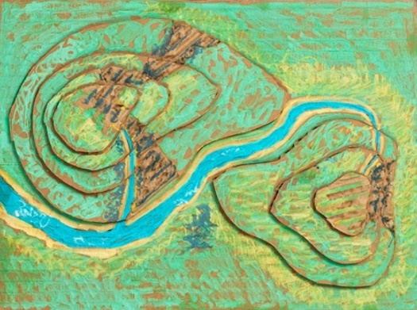
Materials for Extension:
- Bristol board (foam core for extra height)
- Scissors
- Glue

Extension Instructions - Contour Model
Using the contour only map, construct a relief map using Bristol board or foam core. This activity can be done in pairs. Using Bristol board or Foam Core:
* Bristol board and foam core will be cut out to be the same size as the map.
- Place the map on top of the Bristol Board. Make sure the corners are properly even
- Starting with the lowest contour, trace over the contour line you are working on with a pencil. Press down hard with the pencil so as to leave a mark (indentation) on the Bristol board.
- Trace over the mark with a pencil
- Cut out the shape with scissors.
- Trace and cut each of the other contour shapes in turn.
- Glue the contour shapes into position. Begin with the lowest contour shape and work upward in order of height.
- Once the shapes are in place draw in the details, such as rivers and creeks, so the model is more realistic.

Use pale blue as the base - <1625 blue
1625 - 1650 dark green
1650 - 1700 pale green
1700 - 1750 yellow
1750 - 1800 orange
1800 - 1850 red
>1850 brown

Look at the GeoExplore Saskatchewan website for further information and a deeper understanding of the importance of Saskatchewan’s geological history. It is a digital version of the original paper Geological Highway Map of Saskatchewan:

Main Website
https://skgeolhighwaymap.maps.arcgis.com/apps/MapSeries/index.html?appid=a845cbb370f7401597806887318e2676

For more background information related to this lesson check out
- Main tab “Landforms”
- Main tab “Ice Age”

References
Department of Mines and Technical Surveys. Surveys and Mapping Branch, (1954). Lumsden
Topographic Map 72 I 10 West Half. Scale 1:50,000

Melenchuk. A., (1997). Saskatchewan the land. Topic One, Activity 3. Science Directions. Toronto, ITP
Nelson. ISBN. 0-17-604994-0 (U. of R. Library)

Storer, J., 1989. Geological History of Saskatchewan.

Saskatchewan Museum of Natural History. Government of Saskatchewan.

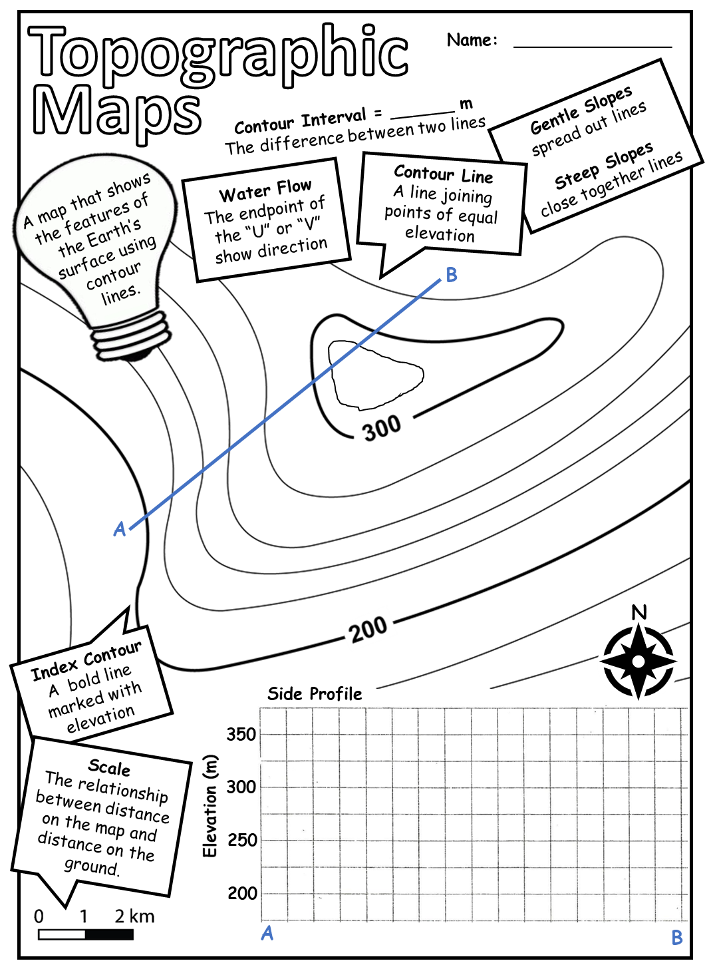
Topographical Map Model
Use the space below to trace each of your mountain/hill layers. Then label contour interval, contour lines, north arrow, and the peak. Try to draw a side profile of your mountain/hill.

Topographical Map of Lumsden - Qu’ Appelle Valley

Lumsden is a town located in the Qu’Appelle Valley. When you look at the base map you will see contour lines that show the shape and the elevation of the land around the townsite. These lines are sometimes called “level lines” because they show points that are at the same level. The closer together the contour lines appear on a topographic map, the steeper the slope.

How to read a topographic map
The top part of this drawing is a contour map which shows the hills illustrated below.
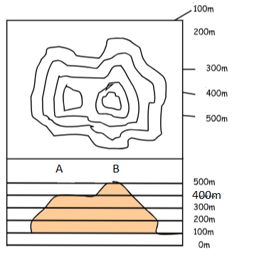
1. Which is higher, Hill A or Hill B?

____________________________________

2. Which is steeper, Hill A or Hill B?

____________________________________

3. How many meters of elevation are there between contour lines?

____________________________________

4. How high is Hill A?

____________________________________

5. How high is Hill B?

____________________________________

Look at the topographical map of Lumsden - Qu’ Appelle Valley.

6. a) How many feet are there between each major contour line? ________________feet

b) How many meters would that be? _____________m

7. The gravel pit is between what two major contour lines?

__________________feet and __________________feet.

8. Which section of the Lumsden map shows the steepest slopes?

- North - East b) North - West c) South - East d) South - West

9. Would you be walking uphill or downhill to go from the Gravel Pit to the Water Tower?

______________________________________________________________________________

10. Lumsden Contour Map Activity
Using pencil crayons colour the map using these colours.

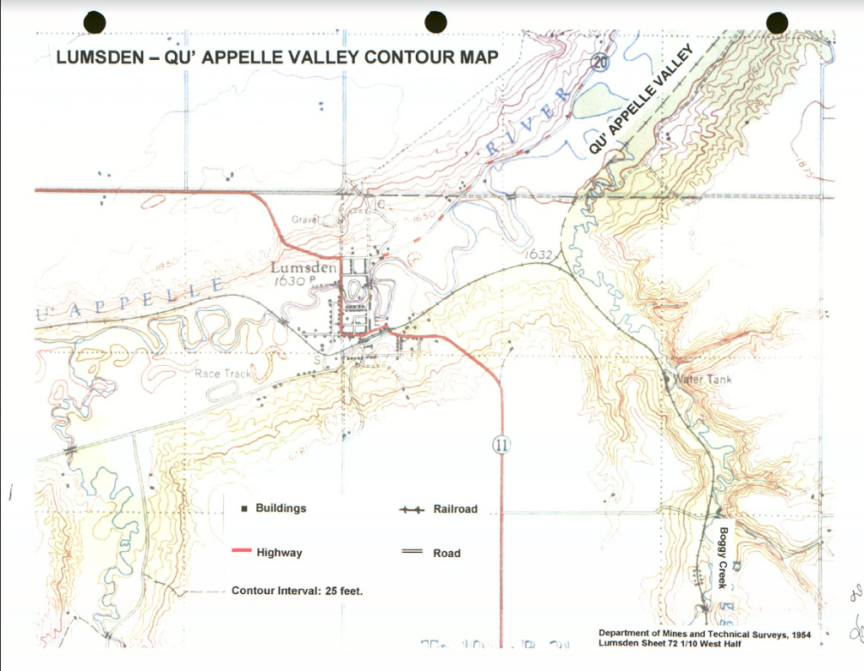
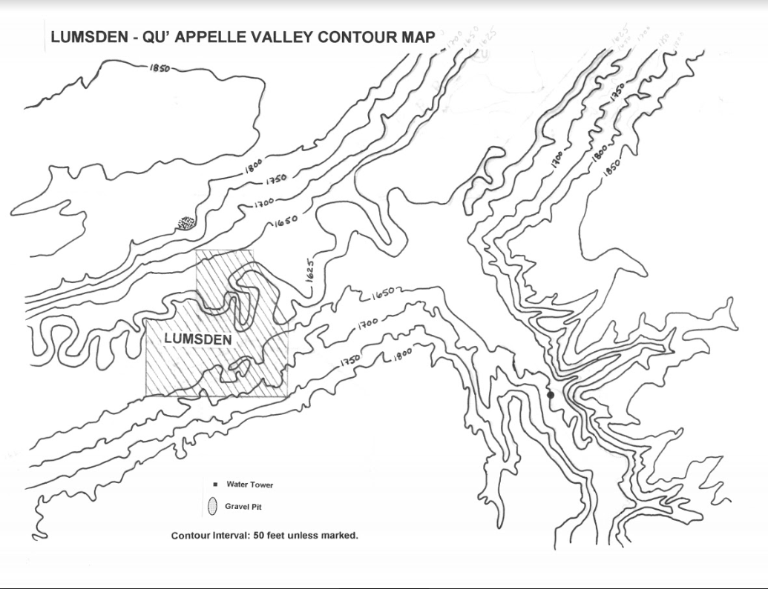
Name:______Teacher_________

Topographical Map of Lumsden - Qu’ Appelle Valley

Lumsden is a town located in the Qu’Appelle Valley. When you look at the base map you will see contour lines that show the shape and the elevation of the land around the townsite. These lines are sometimes called “level lines” because they show points that are at the same level. The closer together the contour lines appear on a topographic map, the steeper the slope.

How to read a topographic map
The top part of this drawing is a contour map which shows the hills illustrated below.
1. Which is higher, Hill A or Hill B?

_________Hill B______________________

2. Which is steeper, Hill A or Hill B?

__________Hill B_____________________

3. How many meters of elevation are there between contour lines?

_________100m______________________

4. How high is Hill A?

_____________400m__________________

5. How high is Hill B?

_____________500m___________________

Look at the topographical map of Lumsden - Qu’ Appelle Valley.

6. a) How many feet are there between each major contour line? ____50____________feet

b) How many meters would that be? _____15.24________m

7. The gravel pit is between what two major contour lines?

________1800__________feet and ______1850____________feet.

8. Which section of the Lumsden map shows the steepest slopes?
- North - East b) North - West c) South - East d) South - West

9. Would you be walking uphill or downhill to go from the Gravel Pit to the Water Tower?

___________________________________Downhill____________________________________

