Our Diverse Prairie Landscape: Saskatchewan is Not Just Flat!
Erratic-al!

Subject/Grade: Earth Science 30, Grade 8 Science and Grade 7 Science

Adapted by: Hilary Roemer & Dr. Kate MacLachlan

Stage 1: Identify Desired Results
Outcome(s)/Indicator(s)
Earth Science 30 Lithosphere
Analyze surface geography as a product of deposition, weathering, erosion and mass wasting processes. [SI, CP]
a) Observe, describe and locate common landforms (e.g., moraines, potholes, drumlins, buttes, coulees, dunes, oxbow lakes and river valleys. (K)
c) Explain how surficial geological features of Saskatchewan such as Qu’ Appelle Valley are characterized by specific depositional and erosional processes. (K)
d) Describe the effects of mechanical weathering and erosion, including glaciation, on the surface geography of Saskatchewan as shown by landforms such as drumlins, moraines, eskers, kettles, and outwash. (K)
Grade 8 Water Systems
WS 8.2- Examine how wind, water, and ice have shaped and continue to shape the Canadian landscape.

f) Create a written, visual, physical, or dramatic representation of the processes that lead to the development of rivers, lakes, continental drainage systems, and ocean basins, including glaciation, continental drift, erosion, and volcanic action.

g) Relate factors that affect glacier formation and reduction and their effects on the environment to the formation of glacial landforms in Saskatchewan (e.g., drumlins, moraines, eskers, and kettle lakes).
Grade 7 Earth’s Crust and Resources
EC7.3 Investigate the characteristics and formation of the surface geology of Saskatchewan, including soil, and identify correlations between surface geology and past, present, and possible future land uses. [DM, SI]
f) Differentiate between weathering and erosion, and explain the role of water in each process.
g) Document the natural surface geological features of the local environment and provide explanations for the origin of those features.
Key Understandings: (‘I Can’ statements)  - I can use a map to interpret information.  - I can create a map using a grid system.  - I can describe and apply my knowledge about glacial landforms to explain the flow direction of a glacier.  - I can describe what a glacial erratic is and how it applies to the activity. | Essential Questions:  - What is a glacial erratic?  - What are some clues an environment may give to the source of an erratic.  - What information is useful on the Geological Highway map for our activity?  - What is a null hypothesis?

Stage 2: Teacher Background
The Laurentide Ice Sheet was the last glacier to advance over Saskatchewan; it reached its maximum thickness and extent approximately 18,000 years ago. The retreat of the Laurentide Ice Sheet went on for the next 10,000 years; through the movement of the ice sheet the landscape of Saskatchewan was created.
In this lesson students will create a map to show the source of an erratic and hypothesize as to the source of the Rockhaven Erratic. Students will also utilize the grid enlargement technique.

Definitions

Eskers: are ridges formed by streams flowing under the ice sheet. Eskers are parallel to the direction of ice flow.

Moraine: Moraines are mounds, ridges or accumulations of till. Moraines are deposited by the glacier and can take a variety of forms. Moraines can be parallel to ice flow or perpendicular to ice flow depending on the type of moraine. An end moraine is the ridge formed at the outer end of a glacier. This type of moraine is perpendicular to ice flow. A lateral moraine is a ridge or mound accumulated on the outer edges of the glacier.

Hummocky Terrain: Hummocky moraines can also be referred to as hummocky terrain. This type of terrain is formed when an area is marked by many hills (hummocks) and kettles.

Drumlin: A drumlin is a hill formed from buildup of glacial debris. A drumlin is not symmetrical; the gently sloped slide is parallel to the direction of ice flow and faces the direction the ice came from. The drumlin is built under the margin of the ice while the glacier is moving.

Striae: are scratch marks caused by the rocks and sediments frozen in the glacial ice as they travel over the landscape.

Erratic: An erratic is a rock that has been moved from its outcrop to an area where the lithology (rock type) is different. Erratics can be very big. There is one at Big Rock Heritage Site near Cutknife, Saskatchewan. It weighs over 2500 tonnes and was once over 10 m by 10m by 10m but has been broken apart.

Glacial Lakes: are formed when glacial meltwater is trapped in low-lying areas. The melt water contains fine sediments that settle on the bottom of the lake bed.

Stage 3: Build Learning Plan
Set (Warm-up, Focusing the Learning): Time: 10min  As a class discuss the clues that an environment may give to the source of an erratic. Some clues may include the position of certain landforms. Eskers are landforms created by streams flowing either on top of or underneath a glacier and are parallel to the direction of ice movement. Drumlins are teardrop-shaped ridges formed by glacial debris beneath a glacier and are oriented parallel to the direction of ice movement. Remember that not all features are parallel to the glacier; ridged moraines and end moraines are perpendicular to ice movement.  Development: Time: 35 min  - Allow the students to form groups of 2-4. Hand out large poster paper and instruct the students to create a grid of 16 squares on the paper (4 x 4). Each square should be at least 6cm by 6cm or larger (this will depend on the size of the poster paper). This will form the basis of the map.  - Using the map on the student activity sheet the students will create a larger, coloured version of the same map; based on the grid drawn on the poster paper.  - Once students have created the map, place a granitic erratic (available from a rock kit or found on the schoolyard) on the “x”mark on the map. The erratic was once part of the granitic intrusion in the north-east corner of the map.  - Each group should then interpret the symbols on the map to work out flow direction.  Learning Closure: Time: 15min  - Have each group present their interpretation of the flow direction and make sure that they provide evidence and reasoning for their explanation.  - Have a class discussion about the interpretations and clear up any misunderstandings.  - Then, ask students to speculate as to the source of the granitic erratic found at Rockhaven. |  | Materials/Equipment:  - Saskatchewan Geological Highway Map 1 per every 3 students  - Poster Paper  - Pencil Crayons  - Granite or rock samples  - Student Activity Sheet  Safety Considerations:  - Handle the glacial erratic sample with care. Do not throw it to or at other students.  Possible Adaptations/  Differentiation  If students have not been introduced to glacial landforms yet, then incorporate a research component to the activity where students research the glacial landforms that they will encounter in the activity.  If students are not familiar with interpreting maps or are overwhelmed by the Saskatchewan Geological Highway map, then create a mini lesson and go through the map together as a class.  Depending on student’s readiness you can guide students through the activity or you can let students guide themselves. You may have different groupings of students based on readiness for the activity where one or two groups are guided through the activity while the other groups work on the activity with less guidance.

Stage 4: Determine Evidence for Assessing Learning
- Students can hand-in the activity sheet and the map that they created on the poster for marks.
- Students should transfer the knowledge gained from the map activity to the exit slip.

Extensions
- Students may use found objects to make their map three-dimensional.
- Students may challenge each other to a treasure hunt using glacial features as the basis for locating the treasure.

Look at the GeoExplore Saskatchewan website for further information and a deeper understanding of the importance of Saskatchewan’s geological history. It is a digital version of the original paper Geological Highway Map of Saskatchewan:

Main Website
https://skgeolhighwaymap.maps.arcgis.com/apps/MapSeries/index.html?appid=a845cbb370f7401597806887318e2676

For more background information related to this lesson check out
- Main tab “Landforms”
- Main tab “Ice Age”

Additional Resources
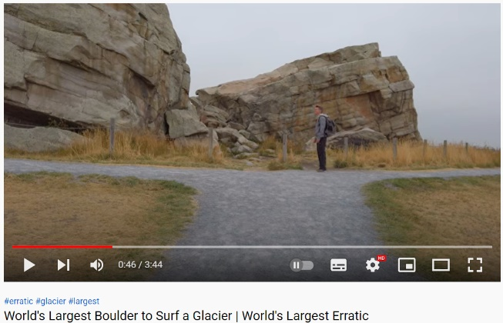

Earth Titan - World's Largest Boulder to Surf a Glacier
World's Largest Erratic
https://www.youtube.com/watch?v=l2tyUj6-_kQ

Name: _________________

Student Activity Sheet

Erratic-al

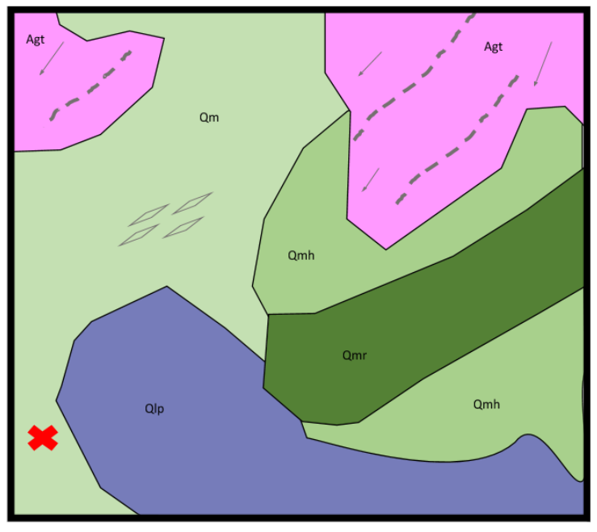

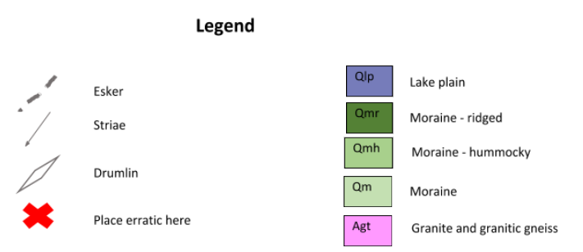

- Enlarge the above map onto poster paper by constructing a grid on both the map and the poster paper. The grid on the map should consist of four squares across and four squares down, creating a total of 16 squares. On the poster paper ensure that there are 16 squares as well, they should be at least twice the size as the squares on your map. Copy the map onto the poster paper by drawing exactly what is on the map onto the same square on the poster paper.

- Use the Geological Highway Map of Saskatchewan to determine the different lithologies (rock types) based on the colours and text symbols in the legend. What to the capital letters Q and A stand for in the legend?

_________________________________________________________________

_________________________________________________________________

- Ask for an erratic, and place it on the map in the correct spot.

- What is one non-glacial way you may be able to determine the source of the erratic?

_________________________________________________________________

_________________________________________________________________

_________________________________________________________________

5. Use the following glacial features to determine the source of your erratic: ridged moraine, esker, striae, drumlins.

6. Look at #21 (south sheet) on the Geological Highway Map of Saskatchewan. Where is the potential source of this erratic?

_________________________________________________________________

_________________________________________________________________

7. Look at the #41 near Pinehouse Lake (north sheet) on the Geological Highway Map of Saskatchewan. What is the pink area just north of #41?

_________________________________________________________________

_________________________________________________________________
8. Create a null hypothesis: The erratic was not transported by glaciers. Accept or reject? If reject, what other hypothesis is proposed to explain the erratic. Is this hypothesis falsifiable?

_____________________________________________________________________

_____________________________________________________________________

_____________________________________________________________________

_____________________________________________________________________

EXIT SLIP: The erratic at Rockhaven is thought to originate at or near #41, yet #41 is not within the pink granitic area. Explain.
Hint: Are there any clues that lead to this area as the source of the erratic?
Hint: Does the legend of the map give any clues?
Hint: What explanation of #41 is provided on the map sheet?

______________________________________________________________________________

_____________________________________________________________________

_____________________________________________________________________

_____________________________________________________________________

_____________________________________________________________________

_____________________________________________________________________

_____________________________________________________________________

_____________________________________________________________________

_____________________________________________________________________

Student Activity Sheet
Answers

Erratic-al

2. Granite - pink
Moraine – light green
Glacial Lake – light purple
Ridged Moraine – dark green
Hummocky Terrain – green
A is for Archean and Q is for Quaternary. These are the ages of the units.

4. A detailed geological study of the erratic can be performed, determining the minerals
that make up the erratic and any other information (such as age of the rock) that can be
compared to the potential source of the erratic.

6. The potential source is the Precambrian Shield.

7. The pink area north of #41 is granitic gneisses and granitic intrusions.

Exit Slip
The erratic is granitic so could be from the large granitic area north of #41. The site at #41 does not represent a single space rather it represents an area where the Precambrian Shield meets Phanerozoic rocks. As well #41 represents the Precambrian Shield, an area encompassing much of the north map sheet. It is important to notice that the glacial landforms indicate that rocks from the shield could have been transported south to areas where granite is not exposed.

