Our Diverse Prairie Landscapes: Saskatchewan is Not Just Flat!
Glacial Learning Stations

Subject/Grade: Science/ 12, 8, 7, & 4

Recreated by: Hilary Roemer & Dr. Kate MacLachlan

Stage 1: Identify Desired Results
Outcome(s)/Indicator(s)
Earth Science 30 Lithosphere Analyze surface geography as a product of deposition, weathering, erosion and mass wasting processes. [SI, CP]
a) Observe, describe and locate common landforms (e.g., moraines, potholes, drumlins, buttes, coulees, dunes, oxbow lakes and river valleys. (K)
c) Explain how surficial geological features of Saskatchewan such as Qu’ Appelle Valley are characterized by specific depositional and erosional processes. (K)
d) Describe the effects of mechanical weathering and erosion, including glaciation, on the surface geography of Saskatchewan as shown by landforms such as drumlins, moraines, eskers, kettles, and outwash. (K)
Grade 8 Water Systems WS8.2 Examine how wind, water, and ice have shaped and continue to shape the Canadian landscape.
f) Create a written, visual, physical, or dramatic representation of the processes that lead to the development of rivers, lakes, continental drainage systems, and ocean basins, including glaciation, continental drift, erosion, and volcanic action.
g) Relate factors that affect glacier formation and reduction and their effects on the environment to the formation of glacial landforms in Saskatchewan (e.g., drumlins, moraines, eskers, and kettle lakes).
Grade 7 Earth’s Crust and Resources ES7.3 Investigate the characteristics and formation of the surface geology of Saskatchewan, including soil, and identify correlations between surface geology and past, present, and possible future land uses.
g) Document the natural surface geological features of the local environment and provide explanations for the origin of those features.

Grade 4 Rocks, Minerals and Erosion RM4.3 Analyze how weathering, erosion, and fossils provide evidence to support human understanding of the formation of landforms on Earth.
a) Construct a visual representation of the diversity of landscapes and landforms throughout Saskatchewan, including those that have significance for First Nations and Métis people.
g) Describe possible short- and long-term effects of wind, water, and ice on local, national, and global landscapes (e.g., sandy beaches, coastline erosion, rounded rock formations, sand dunes, river deltas, glacial deposits, and cracks in rocks).
i) Suggest explanations of how soils form from rocks, including the roles of wind, water, and biological processes (e.g., decomposition of plant and animal matter, and growth of plant roots play) over time.
Key Understandings: (‘I Can’ statements)  I can… construct a visual representation of a landscape.  I can... relate and recount factors that affect glacial formation.  I can… recognize that climate change takes place over a long period of time.  I can… identify some of the events/factors that cause climate change. | Essential Questions:  What are the factors that affect glacial formation?  Describe the history of the Laurentide Ice Sheet?  Why is the Laurentide Ice Sheet relevant to Saskatchewan?  How does a glacier move?  How does a glacier affect the landscape?

Stage 2: Teacher Background
The Laurentide Ice Sheet was the last glacier to advance over Saskatchewan; it reached its maximum thickness and extent approximately 18,000 years ago. The retreat of the Laurentide Ice Sheet went on for the next 10,000 years; through the movement of the ice sheet the landscape of Saskatchewan was created.

There are three stations that students can rotate through. A Glacial Learning Centers handout is included so students know what to do at each station. The handout has some background information, instructions for each station and questions to answer.

Station 1 - reinforcing the concepts of glacier movement and accumulation through a board game.
Teacher Prep for Station 1 - Print the game board and laminate. Depending on how you split up the class have enough supplies.

Station 2 - students will trace the retreat of the Laurentian Ice Sheet through the creation of a flip-book.
Teacher Prep for Station 2 - Have enough supplies so that everyone can create their own flip-book or if you want each group can work together to create one flip- book.

Station 3 - students will draw analogies between food and the movement of a glacier.
The ice cream represents the glacier. When the cookie sheet is put on an angle the ice cream flows down it like a glacier moving (note: a glacier will move even if it’s not on a slope, but the slope is required to get the ice cream to move). The chocolate chips and nerds represent rocks of different sizes that the glacier picks up and moves along as it moves or pushes ahead of it.
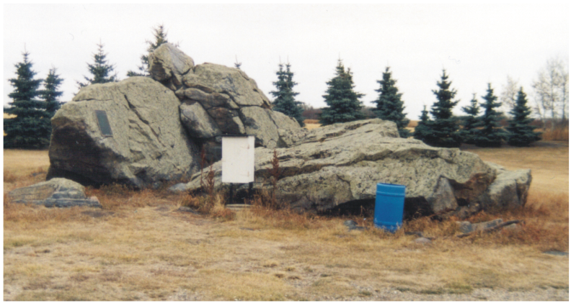
Teacher Prep for Station 3 - Depending on how you split up the class have enough supplies so that each group can do the station. Divide the supplies ahead of time. You might want to be in a classroom that has a sink to wash off the cookie sheets. Make sure to grease the cookie sheets or get the students to grease the cookie sheets.

Ensure that before you switch stations that the students clean up the station that they are at and prepare the station for the next group.

Definitions

Ice Age: long periods of glaciation where thick ice sheets cover vast areas of landscape.
Ablation: removal of snow or ice by melting or evaporation. A net loss of ice from a glacier.
Static: The net loss is equal to the net gain of snow or ice, so the glacial is static.
Accumulation: addition of snow or ice by precipitation of snow and cold temperatures. A net gain of ice from a glacier.

Till: As glaciers move, they pick up sediments, rocks and other debris. As the glacier travels till (glacial debris) is left behind creating some beautiful and interesting landforms. Till is the building block of many of the geographic landforms we see in Saskatchewan. The glacial till left behind after the last ice age is up to 10 meters thick in some locations throughout Southern Saskatchewan.

Erratic: An erratic is a rock that has been moved from its outcrop to an area where the lithology (rock type) is different. Erratics can be very big. There is one at Big Rock Heritage Site near Cutknife, Saskatchewan. It weighs over 2500 tonnes and was once over 10 m by 10m by 10m but has been broken apart.

Moraine: Moraines are mounds, ridges or accumulations of till. Moraines are deposited by the glacier and can take a variety of forms. Moraines can be parallel to ice flow or perpendicular to ice flow depending on the type of moraine. An end moraine is the ridge formed at the outer end of a glacier. This type of moraine is perpendicular to ice flow. A lateral moraine is a ridge or mound accumulated on the outer edges of the glacier.

Advance: as ice is added to the glacier it grows in mass, the increase causes the glacier to slide slowly. A moving glacier is like a bulldozer, pushing some obstacles out of its way and moving over others.
Retreat: ice at the front of a glacier melts causing the glacier to decrease in size. This melt leaves behind a variety of sediments and landforms.

Stage 3: Build Learning Plan
Set (Warm-up, Focusing the Learning): Time: 10 min  - Go over important terms with you class  - Explain the stations  - Divide the class into groups  Development: Time: 40 min  Station 1 - Time Warp Board Game  - Student group arrives at the station to read the instructions within their Glacial Learning Centres handout.  - Students take turns rolling a dice and moving their game pieces as the instructions permit (or making marks with washable marker if the game board is laminated) according to the roll of the dice.  - The goal of the game is to be the first person to cover the province and thus be the longest extending glacier.  - Students must spend a few minutes completing the exit slip before moving to the next station.  Station 2 - Flip-book  - Students will arrive at the station to find the materials necessary to create the flip-book.  - Students will colour the ice sheet light blue and will colour the unglaciated land green.  - Students will cut the pages of the flip-book and arrange them in order to illustrate the retreat of the Laurentian Ice Sheet.  - Students will label the flip-book pages in chronological order.  - Students will answer a series of questions related to the flip-book.  Station 3 - Ice Cream Glacier  - Ensure that the supplies have been divided prior to the first group’s arrival at the station. The cookie sheets need to be greased, this will help the nerds and kisses stay in place.  - When students arrive at the station, they will simulate how a glacier picks up debris.  - Students will sprinkle nerds and kisses onto the cookie sheet. The cookie sheet will then be elevated onto a SLIGHT angle. Students will then drop ice cream onto the elevated end of the cookie sheet.  - Students will record observations of the ice cream moving along the cookie sheet, as per the observation sheet.  - Students will get to eat and enjoy their glacier!  Learning Closure: Time: 10 min  - Have students help you clean up everything.  - Have students all share one thing they learned while doing the stations. This can be done as a class discussion at the end. |  | Materials/Equipment:  Station 1 - Time Warp Game Board  - Game board  - 1–6 sided dice  - Game piece per student or 1 washable marker per student  Station 2 - Flip-book  - Light Blue Pencil Crayon  - Light Green Pencil Crayon  - Scissors  - Stapler  - Flip-books  - Scrap paper  Station 3 - Ice Cream Glacier  - 4L ice cream at fridge temperature  - Ladle  - Bag of Hershey's Kisses (divided) or chocolate chips  - 12 boxes of nerds  - plastic bowl per student  - plastic spoon per student  - greased cookie sheet per group  Safety Considerations:  - Allergies or dietary restrictions of students.  Possible Adaptations/  Differentiation  - In grade 4 these activities would work best as individual lessons. However, in the older grades they would work well as stations.

Stage 4: Determine Evidence for Assessing Learning
- Process: Through their work on the activity you can discuss with groups why they are doing what they are doing, what the different materials they are using represent. Have informal conversations with students as they work to complete the various stations throughout the classroom. Also, you can have an informal end of class discussion as a part of the learning closure to see what students learned.
- Product: You can grade the Glacial Learning Centers handout and the flip-book.

Extensions
- Station 1 - Students may create their own game board using time as a function for the roll of the die.
- Station 2 - students can enlarge the pages in the flip-book to create a poster series.
- Station 3 - students can recreate the edible glacier at home or create a non-edible model of the glacier.

Look at the GeoExplore Saskatchewan website for further information and a deeper understanding of the importance of Saskatchewan’s geological history. It is a digital version of the original paper Geological Highway Map of Saskatchewan:

Main Website
https://skgeolhighwaymap.maps.arcgis.com/apps/MapSeries/index.html?appid=a845cbb370f7401597806887318e2676

For more background information related to this lesson check out
- Main tab “Landforms”
- Main tab “Ice Age”

Additional Resources
National Geographic - Climate 101: Glaciers - https://www.youtube.com/watch?v=WJgpDyP9ewQ

Crash Course Geography #26 - What Are Glaciers? - https://www.youtube.com/watch?v=mkt-0ZuTKXU

Virtual Glaciers and Landscapes - https://vrglaciers.wp.worc.ac.uk/wordpress/

Glacial Learning Stations Name: __________________
Background
The Laurentide Ice Sheet was the last glacier to advance over Saskatchewan; it reached its maximum thickness and extent approximately 18,000 years ago. The retreat of the Laurentide Ice Sheet went on for the next 10,000 years; through the movement of the ice sheet the landscape of Saskatchewan was created.

Station 1 - reinforcing the concepts of glacier movement and accumulation through a board game. The game is called the Time Warp.

Time Warp Instructions:
Students take turns rolling a dice and moving their game pieces as the instructions permit (or making marks with washable marker if the game board is laminated) according to the roll of the dice.
The goal of the game is to be the first person to cover the province and thus be the longest extending glacier.
- Roll a 1 - Heavy snow accumulation, advance one interval
- Roll a 2 - poor snow accumulation, retreat one interval
- Roll a 3 - stay static
- Roll a 4 - temperatures are warm = ablation = retreat one interval
- Roll a 5 - temperatures are cool, advance one interval
- Roll a 6 - creep ahead two intervals

Note - you may try to block other players or trap them. However, if they advance (one interval) onto your glacial they can “melt” your glacier. Anyone can then steal that interval since it is melted now. If they creep (two intervals) onto your glacier they can “melt” your glacier and then steal that interval (spot) for their glacial. Take turns rolling the die to be the first ice sheet to cover Saskatchewan and thus the furthest extending ice sheet! You need to have a connecting glacial from start to finish. Take a few minutes at the end of the game to fill out the exit slip before moving on to the next station.

Time Warp Exit Slip Questions
Who won the game and why? _____________________________________________________________

_____________________________________________________________________________________

Why is this game unrealistic? _____________________________________________________________

_____________________________________________________________________________________

_____________________________________________________________________________________

How could this game be made more realistic? ________________________________________________

_____________________________________________________________________________________

_____________________________________________________________________________________

Station 2 - trace the retreat of the Laurentian Ice Sheet through the creation of a flip-book.

Instructions:
- Shade the ice sheet light blue and the unglaciated area light green.

- Cut the pages of the flip-book and arrange them in order to illustrate the retreat of the Laurentian Ice Sheet.

- Label each of the pages with a date:
*hint - the ice sheet will be largest 17,000 years ago and smallest 8,000 years ago.

8,000 years ago 12,000 years ago
8,500 years ago 14,000 years ago
9,000 years ago 15,500 years ago
10,000 years ago 16,000 years ago
11,000 years ago 17,000 years ago

- Place the cut-out pages in order with 17,000 years ago as the first page and 8,000 years ago as the last page.

- Where is the North, South, East and West on your maps? Draw these in on the first and last pages of your flip-book.

- In which direction does the ice sheet retreat? Create a title page for your flip-book that conveys the direction of retreat.

- Staple the edge and flip through the past - watch the ice sheet retreat.

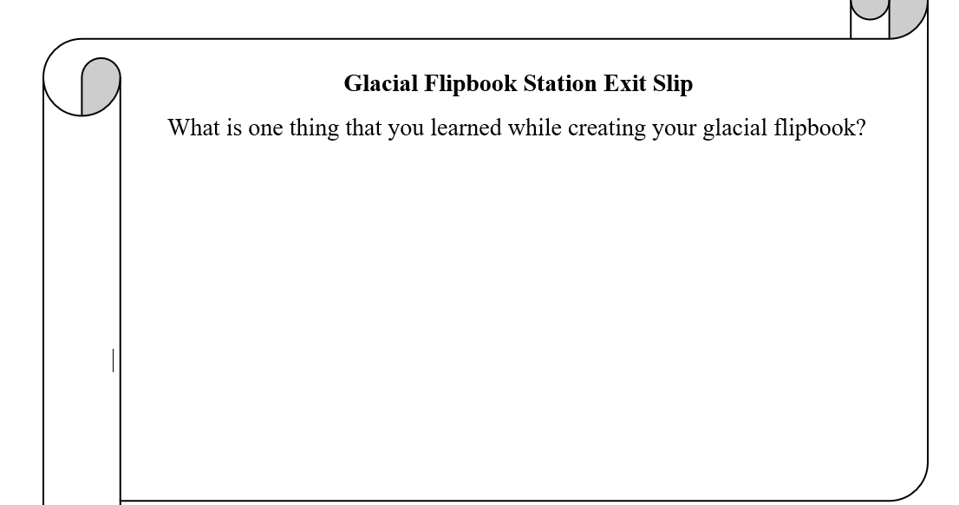
- Clean up and organize your station so the next group can do the station.
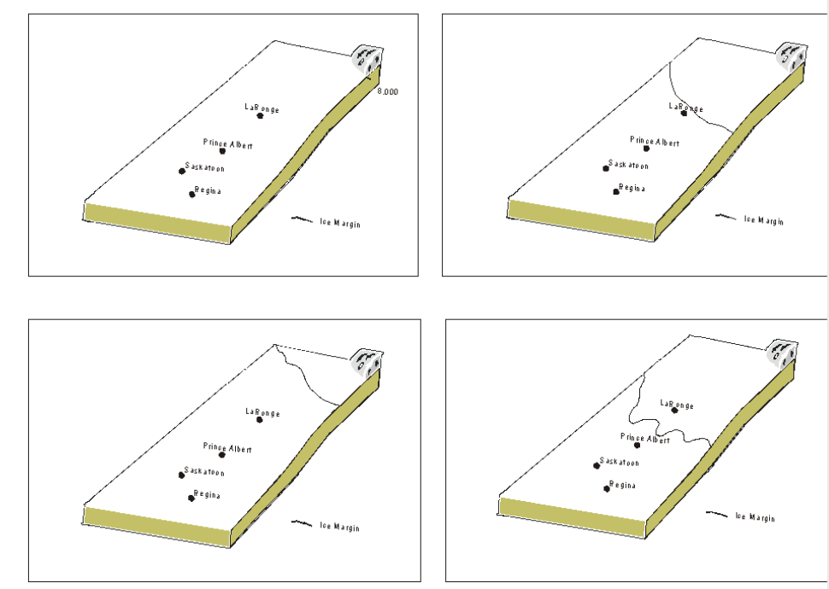
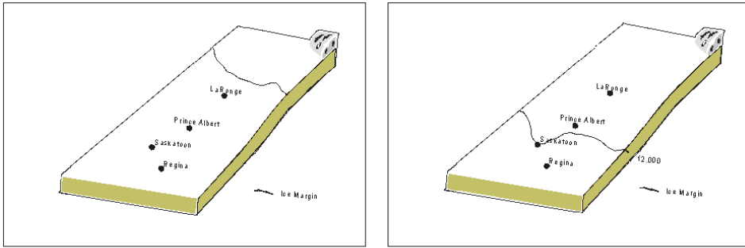

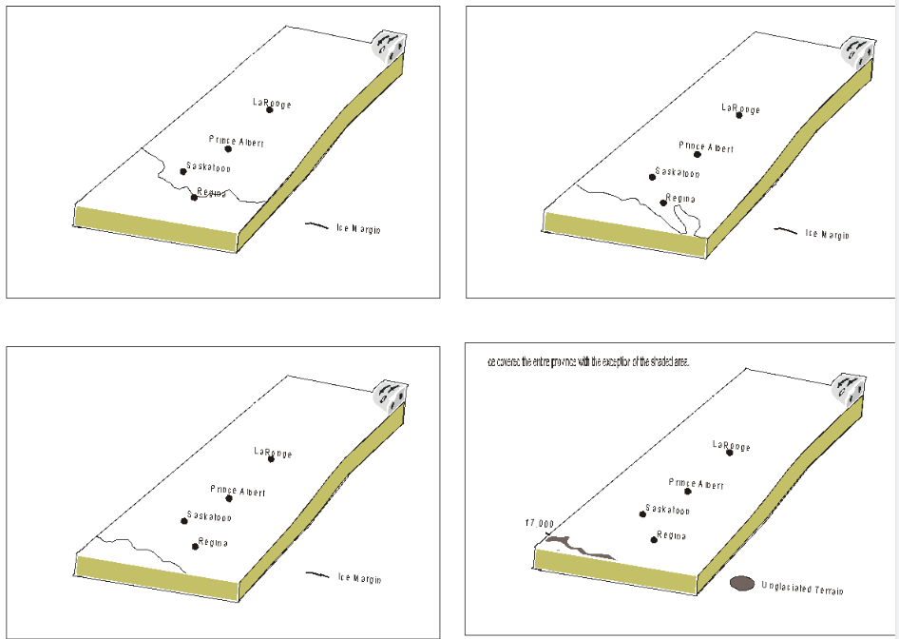

Station 3 - The ice cream represents the glacier. When the cookie sheet is put on an angle the ice cream flows down it like a glacier moving (note: a glacier will move even if it’s not on a slope, but the slope is required to get the ice cream to move). The chocolate chips and nerds represent rocks of different sizes that the glacier picks up and moves along as it moves or pushes ahead of it.

Instructions:
- You will simulate how a glacier picks up debris
- Grease your cookie sheet, if it is not already greased.
- Place the nerds and kisses on the cookie sheet in separate areas.
- Elevated the cookie sheet at a slight angle.
- Drop a scoop of ice cream by using a ladle on the elevated end of the cookie sheet.
- Record, draw, and label your observations of the ice cream moving along the cookie sheet. Record your observations of the glacier’s movement at 0 minutes, 5 minutes and 10 minutes on the observation sheet. Label the original position of the candies (be sure to use different symbols for each type of candy) as well as the ice cream. Use the words glacier, till, moraine, and erratic (if applicable) and the direction of advance.
- Make sure to answer the questions down below.
- Then, divide up the ice-cream and candy for everyone in the group - use bowls and spoons. You get to eat your glacier!
- Clean up your station so the next group can do the station.

Questions:
What are the major differences between this experiment and nature? (You need at least 3, only one can be related to food)

_______________________________________________________________________________________

_______________________________________________________________________________________

_______________________________________________________________________________________

The cookie sheet is slightly elevated in order to allow for the movement of the ice cream, however this also reflects the natural environment. Explain how the slope of the landscape and the slope of the glacier help it move.

_______________________________________________________________________________________

_______________________________________________________________________________________

_______________________________________________________________________________________

_______________________________________________________________________________________

Student Observation Sheet
Edible Glacier

Record your observation of the glacier’s movement at 0 minutes, 5 minutes and 10 minutes in the box below. Label the original position of the candies (be sure to use different symbols for each type of candy) as well as the ice cream. Use the words glacier, till, moraine, erratic (if applicable) and direction of advance.

Name:___Teacher________
Glacial Learning Stations
Station 3 - The ice cream represents the glacier. When the cookie sheet is put on an angle the ice cream flows down it like a glacier moving (note: a glacier will move even if it’s not on a slope, but the slope is required to get the ice cream to move). The chocolate chips and nerds represent rocks of different sizes that the glacier picks up and moves along as it moves or pushes ahead of it.

Instructions:
You will simulate how a glacier picks up debris. Grease your cookie sheet, if it is not already greased. Place the nerds and kisses on the cookie sheet in separate areas. Elevated the cookie sheet at a slight angle. Drop a scoop of ice cream by using a ladle on the elevated end of the cookie sheet. Record, draw, and label your observations of the ice cream moving along the cookie sheet. Record your observations of the glacier’s movement at 0 minutes, 5 minutes and 10 minutes on the observation sheet. Label the original position of the candies (be sure to use different symbols for each type of candy) as well as the ice cream. Use the words glacier, till, moraine, and erratic (if applicable) and the direction of advance. Make sure to answer the questions down below. Then, divide up the ice-cream and candy for everyone in the group - use bowls and spoons. You get to eat your glacier! Clean up your station so the next group can do the station.

Questions:
What are the major differences between this experiment and nature? (You need at least 3, only one can be related to food)
Possible answers include:
- In nature the slope would not be as smooth or as constant
- In nature the obstacle in the glacier’s path would be of varying sizes and consistency - making some more difficult to pick up than others (note - size is not really a problem for a glacier. Rock types and structures have more effect).
- In nature the temperature would fluctuate and would likely be lower than room temperature. The glacier may freeze to the ground - just like the ice-cream can freeze to the pan if put in the freezer.
- In nature there could be an increase (extra ice-cream) or decrease (less ice-cream) in the size of the glacier depending on changes in the climate.
- There is a difference between the consistency of ice-cream and ice.
- The amount of time used for this experiment is artificial.
- The ice-cream picks up pieces because it is sticky. Ice picks up pieces through pressure melting and refreezing.

The cookie sheet is slightly elevated in order to allow for the movement of the ice-cream, however this also reflects the natural environment. Explain how the slope of the landscape and the slope of the glacier help it move.
The slope of the landscape will either allow the glacier to move more easily (if the glacier is moving downslope) or require more ice and pressure to move the glacier if moving on a slight incline - students may refer to the roche moutonnees on the slide show presentation in a previous lesson. As well the thickness and slope of the ice will contribute to its ability to move.

