Riches from the Earth: Renewable or Non-renewable?

Subject/Grade: Grade 4, 7 Science, Grade 4 Social Studies
Recreated by: Diana Joy Jensen & Dr. Kate MacLachlan

Stage 1: Identify Desired Results
Outcome(s)/Indicator(s)
Grade 4- Science
RM4.2 Assess how human uses of rocks and minerals impact self, society, and the environment.
a. Discuss ways in which people of different cultures value, respect, and use rocks and minerals, including First Nations and Métis connections to Mother Earth.
b. Identify objects in their local environment that are made from rocks and minerals (e.g., nickel, table salt, pottery, cement, carvings, brick, jewelry, bicycle, nutrients, battery, copper wiring, soda can, plumbing pipe, and sidewalk).
c. Research historical (e.g., flint arrowhead, gold jewelry, paint pigment, and coal heating) and contemporary (e.g., fertilizer, building products, ceramics, glass, salt, silver fillings, and electronics) uses for rocks and minerals in Saskatchewan.
e. Relate uses for rocks and minerals to characteristics such as functionality, mineral shape, cost, availability, and aesthetics.
f. Identify locations where minerals, including potash, sodium sulphate, salt, kaolin, uranium, copper, coal, diamond, and gold, are extracted in Saskatchewan.
Grade 4- Social Studies
RW4.3 Assess the impact of Saskatchewan resources and technological innovations on the provincial, national, and global communities.
a. Represent on a map the major resources in Saskatchewan (e.g., minerals, potash, oil, uranium, natural gas, lumber, water, crop and livestock production).
b. Locate on a map the major industries in Saskatchewan (e.g., agriculture processing, mining, manufacturing, forestry products, energy refinement, tourism, livestock production).
c. Identify the natural resources and industries found in the local community, and analyze their impact upon the community.
Grade 7- Science
EC7.2 Identify locations and processes used to extract Earth's geological resources and examine the impacts of those locations and processes on society and the environment.
a. Identify questions to investigate arising from practical problems and issues related to the study of Earth's geological resources (e.g., "What types of rocks are best for cement-making or road construction?" and "What are some environmental concerns related to open-pit mining?").
d. Identify locations of Saskatchewan's primary mineral resources (e.g., potash, gold, diamond, salt, uranium, copper, and graphite) and their primary uses.
j. Identify uses for rocks and minerals, such as healing, recuperative powers, and ceremonies, which include ideas not explained by science.
Grade 7 Social Studies
RW7.2 Investigate the influence of resources upon economic conditions of peoples in circumpolar and Pacific Rim countries.
a. Formulate a definition of a natural resource, and differentiate between renewable and non-renewable resources.
Earth Science 30
ES30- LS3 Analyze surface geography as a product of deposition, weathering, erosion and mass wasting processes
b. Explain how specific landforms are a consequence of depositional and denudation processes (e.g., weathering, erosion, and mass wasting). (K)
Key Understandings: (‘I Can’ statements)  I can list examples of natural resources found in Saskatchewan (Grade 5).  I can classify the natural resources of Saskatchewan as renewable or non-  renewable (Grade 5).  I can distinguish between resources used to produce energy and those to produce goods (Grade 5).  I can identify those resources in Saskatchewan, which are renewable (Grade 7).  I can examine the distribution of these natural resources in Saskatchewan (Grade 8). | Essential Questions:  What types of natural resources are found in Saskatchewan and where can they be found?  Explain the difference between renewable and non- renewable natural resources in Saskatchewan.  What are the different uses for resources?  What defines a renewable resource and what are some examples from Saskatchewan.  How are natural resources distributed in Saskatchewan?

Stage 2: Teacher Background
Our lives are made more convenient by the resources we use throughout the day. Many of these resources are imported to Saskatchewan and Canada from other countries but some can be supplied by the province or country. Students will choose various items from the classroom and identify the natural resources that were used to make them. Students will then classify the resources as renewable or non-renewable, and locate sites in Saskatchewan where some of these resources can be found.
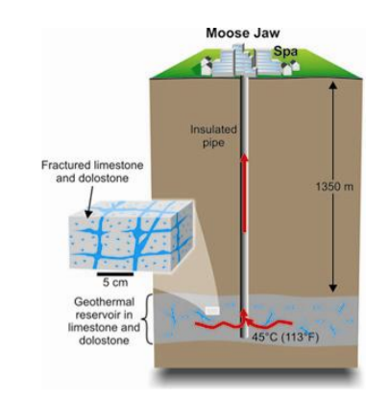
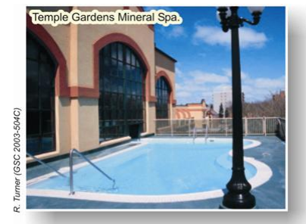
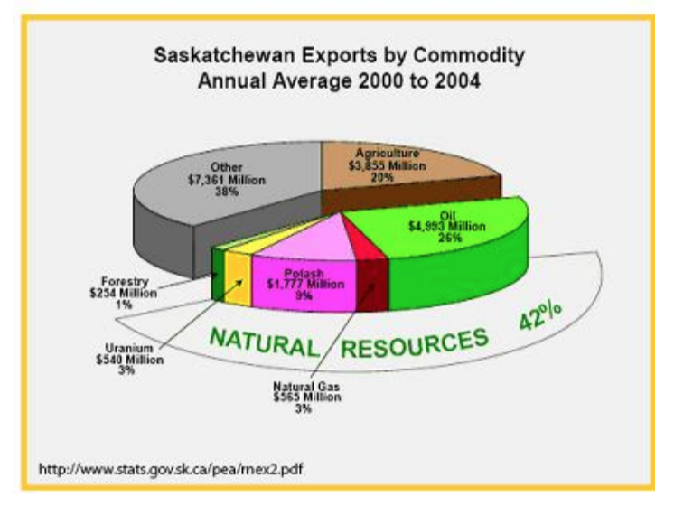
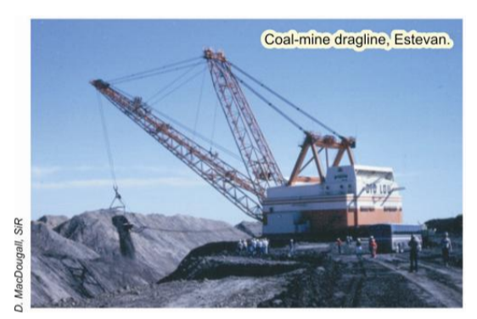
Figure 4. Relative and absolute value of different natural resources to the economy of Saskatchewan.

Stage 3: Build Learning Plan
Set (Warm-up, Focusing the Learning):  Day One:  1. It is important for students to understand the difference between inorganic and organic materials, as well as the  definition of a mineral. A class discussion brainstorming examples of these concepts is a useful first step in this  lesson. Discuss the reason why oil is not a mineral (it is organic) and why ice is (it is inorganic and has a crystal  structure). Encourage students to draw images of the examples for some of the definitions.  Part Two:  2. Students may access the Internet or use other resources to find common uses of the minerals listed in chart one.  3. Discuss with the students any resources that they found interesting uses for. Did any of the resource uses  surprise them?  Day Two: Part Three  4. Challenge the students to find 20 items in the classroom or school that are made in whole or in part from the resources in chart one. Is this a difficult task?  5. Hold a class discussion about the questions at the bottom of the page. As responsible members of society, how can this information be used to conserve resources?  Day Three: Part Four  6. Introduce the Mineral Resource Map of Saskatchewan (available from the Subsurface Geological Lab, 201 Dewdney Ave E.)  7. Stress the concept of a key when creating a map. The reader must understand the meaning of each colour on the map.  8. During a class discussion, ask the students if they were surprised by the minerals and other resources found in Saskatchewan. |  | Materials/Equipment:  * Mineral Resource Map of  Saskatchewan (available from  Ministry of Energy and Resources.)  * Internet access or reference  books  * Activity Sheet:  * Answer Sheet:  Key Vocabulary:  - Renewable  - Non-renewable  - Metallic  - Non-metallic  Possible Adaptations/  Differentiation  - Take “Part Three” beyond the classroom to the entire school, the playground, or as homework to students' homes, furthering their understanding of natural resources in their daily lives.  - Use books from the library to enhance study of natural resources and their uses  Suggested books  - Rocks and Minerals by Simon Seymour  - My Book of Rocks and Minerals by Devin Dennie  - Canadian Natural Resources by Sheryl Normandeau

Stage 4: Determine Evidence for Assessing Learning
Assessment:
Accurate completion of the student activity sheets.

Extensions
Students may research the economic value that each of these resources has for Saskatchewan. For example, the graph in Figure 4 illustrates the contributions that
resource commodities make to the value of Saskatchewan's exports.

Look at the GeoExplore Saskatchewan website for further information and a deeper understanding of the importance of Saskatchewan’s geological history. It is a digital version of the original paper Geological Highway Map of Saskatchewan:

Main Website
https://skgeolhighwaymap.maps.arcgis.com/apps/MapSeries/index.html?appid=a845cbb370f7401597806887318e2676

For more background information related to this lesson check out
- Main tab “Our Resources”

Name: ___________________
Student Activity Sheet
Riches From The Earth: Renewable or Non-Renewable

Saskatchewan has many different renewable and non-renewable resources. Some of these resources have formed over millions of years and once used are irreplaceable. These resources are used in numerous ways throughout our daily lives.

Over the next few lessons, you will:
1. Identify the type of resources listed and classify them as renewable or non-renewable.
2. Identify the uses of these resources.
3. Use the chart to help you identify the resources used in items found within your classroom.
4. Identify on a map the areas where these resources can be mined or
retrieved in Saskatchewan.

Part One- Definitions and Examples

Inorganic- something that is not and never was alive.

Examples:__________________________________

Organic - something that is or was once alive; fluids or solids that have
formed from something that was once alive.

Examples:__________________________________

Mineral- a naturally occurring, inorganic element or compound that has a
characteristic chemical composition, physical properties and crystal form.

Examples:__________________________________

Metal - any of a group of elements that has a shiny lustre, is a conductor of
electricity, and that can be melted, fused or hammered.

Examples:__________________________________

Renewable - a substance that is replaceable as through new growth.

Examples:__________________________________

Non-Renewable - a substance that cannot be replaced once it is used.

Examples:__________________________________

Part Two
Visit the following websites or use a textbook to help fill in the chart:

GeoExplore Saskatchewan https://skgeolhighwaymap.maps.arcgis.com/apps/MapSeries/index.html?appid=a845cbb370f7401597806887318e2676

Government of Canada Minerals and Metals Facts:
https://www.nrcan.gc.ca/mining-materials/facts/20507
- Natural Gas: https://www.nrcan.gc.ca/energy/facts/natural-gas/20067
- Crude Oil: https://www.nrcan.gc.ca/energy/facts/crude-oil/20064

Graphite: https://www.canadacarbon.com/what-is-graphite

Uses of Resources-Chart One

Resource | Metal, Mineral or Organic | Uses | Renewable or Nonrenewable?
Natural Gas
Crude Oil
Graphite
Uranium
Wood
Coal
Potash
Diamonds
Gold
Salt
Copper
Iron
Zinc
Nickel
Lead

Part Three
List 20 items found in your school or classroom that contain the resources listed in chart one. List each of the resources found in each item, highlight each of the items that are made of entirely renewable resources.

Resources in the Classroom-Chart 2
Item | Resources
Follow up questions:
How many items are made from entirely renewable resources?
______________________________________________________________________________
______________________________________________________________________________

How many items are made from entirely non-renewable resources?
______________________________________________________________________________
______________________________________________________________________________

How many items are made from combinations of renewable and non-renewable
resources?
______________________________________________________________________________
______________________________________________________________________________
Part Four
Use the Mineral Resource Map of Saskatchewan http://publications.gov.sk.ca/documents/310/97534-ResourceMap2019.pdf to discover the location of the listed resources found in Saskatchewan. Colour the map below to show the location of those resources found in Saskatchewan. Don’t forget a legend for your map!
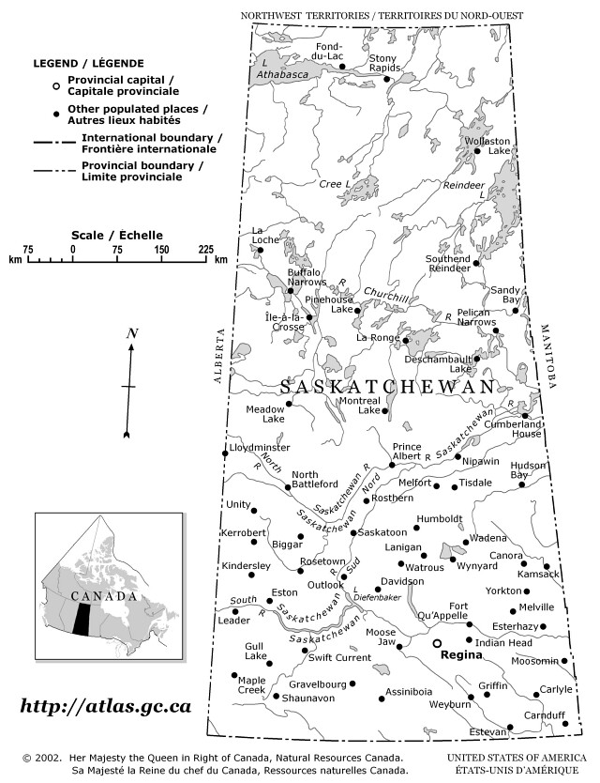
Answer Key

Part One

Inorganic - something that is not and never was alive.
examples: diamond, gold, sand, etc

Organic - something that is or was once alive; fluids or solids that have
formed from something that was once alive.
examples: trees, oil, coal, coral reef, etc.

Mineral - a naturally occurring, inorganic element or compound that has a
characteristic chemical composition, physical properties and crystal form.
examples: diamond, graphite, potash etc.

Metal - any of a group of elements that has a shiny lustre, is a conductor of
electricity, and that can be melted, fused, or hammered.
examples: silver, copper, zinc, iron, gold etc.

Renewable - a substance that is replaceable as through new growth or a cycle.
examples: water, forestry, etc

Non-Renewable - a substance that cannot be replaced once it is used.
examples: oil, natural gas, potash etc.

Part Two

Uses of Resources-Chart One

Resource | Metal, Mineral or Organic | Uses | Renewable or Non-renewable?
Natural Gas | Organic | Het source, energy source | Non- Renewable
Crude Oil | Organic | Fuel, asphalt, lubricants | Non- Renewable
Graphite | Mineral | Lubricants, pencils,  electrical conductor | Non- Renewable
Uranium | Mineral | Energy | Non- Renewable
Wood | Organic | Timber, pulp, posts | Renewable
Coal | Organic | Electricity, Steel | Non- Renewable
Potash | Mineral | Fertilizer, soaps, glass,  ceramics | Non- Renewable
Diamonds | Mineral | Saw blades, jewellery | Non- Renewable  (can be reused)
Gold | Mineral, Metal | Electronics, dentistry,  jewellery. | Non- Renewable  (can be reused)
Salt | Mineral | Chlorine, used in heavy  the chemical industry, de-icing | Non- Renewable
Copper | Metal | Wire, water tubes, cables,  electric appliances | Non- Renewable  (can be reused)
Iron | Metal | Steel | Non- Renewable
Zinc | Metal | Galvanizing (making steel  resistant to corrosion) | Non- Renewable
Nickel | Metal | Coins, Stainless Steel | Non- Renewable
Lead | Metal | Car batteries, protective  casings for cables | Non- Renewable

