Badlands and Dinosaurs: Killer Craters

Subject/Grade: Science 4, 7 & Earth Science 30

Recreated by: Hilary Roemer & Dr. Kate MacLachlan

Stage 1: Identify Desired Results
Outcome(s)/Indicator(s)
Grade 4 Science RM4.3 Analyze how weathering, erosion, and fossils provide evidence to support human understanding of the formation of landforms on Earth. Indicator(s) b) Examine the effects of natural phenomena (e.g., tidal wave, flash flood, hurricane, tornado, earthquake, mudslide, forest fire, avalanche, and meteor impact) that cause rapid and significant changes to the landscape. h) Predict the effects of weathering on various landforms (e.g., butte, cliff, cave, valley, river, waterfall, and beach) in Saskatchewan. n) Pose new questions about Saskatchewan landforms based on what was learned.
Grade 7 Science EC7.3 Investigate the characteristics and formation of the surface geology of Saskatchewan, including soil, and identify correlations between surface geology and past, present, and possible future land uses. [DM, SI]
Earth Science 30 ES30-LS1 Analyze surface geography as a product of weathering, erosion and mass wasting. ES30-AH1 Correlate major changes in Earth’s atmosphere over geologic time with corresponding changes in the biosphere and other components of the geosphere.
Can make connections to any ‘space’ unit - Grade 7/8 Science and Grade 9 Science
Key Understandings: (‘I Can’ statements)  I can... explain the reason for a crater being formed.  I can... explain and model the process of how craters are formed.  I can... understand the impact that craters have on the stratigraphy of the earth.  I can… describe and demonstrate what influences the size and shape of an impact crater.  I can... pose new questions based on what was learned. | Essential Questions:  - Why are craters formed?  - How are craters formed?  - How does the impact of a crater cause significant changes to the landscape?  - What influences the size and shape of an impact crater?  - How did the dinosaurs become extinct and what does that have to do with Saskatchewan?

Stage 2: Teacher Background
Background Info - https://www.lpi.usra.edu/education/explore/shaping_the_planets/impact-cratering/

What are craters?
Craters are roughly circular, excavated holes made by meteorite impacts. The circular shape is due to material flying out in all directions as a result of the explosion upon impact, not a result of the impactor having a circular shape (almost no impactors are spherical). Craters are the most common surface features on many solid planets and moons—Mercury and our Moon are covered with craters.

What happens when an impactor hits?
When an impactor strikes the solid surface of a planet, a shock wave spreads out from the site of the impact. The shock wave fractures the rock and excavates a large cavity (much larger than the impactor). The impact sprays material — ejecta — out in all directions. The impactor is shattered into small pieces and may melt or vaporize. Sometimes the force of the impact is great enough to melt some of the local rock. If an impactor is large enough, some of the material pushed toward the edges of the crater will slump back toward the center and the rock beneath the crater will rebound, or push back up, creating a central peak in the crater. The edges of these larger craters may also slump, creating terraces that step down into the crater.

What are the major parts of a crater?
- Floor – The bottom of a crater, either bowl-shaped or flat.
- Central peaks – Peaks formed in the central area of the floor of a large crater.
- Walls – The interior sides of a crater, usually steep. They may have giant stair-like terraces that are created by slumping of the walls due to gravity.
- Rim – The edge of the crater.
- Ejecta – Rock material thrown out of the crater area during an impact event. It is distributed outward from the crater's rim onto the planet's surface as debris. It is loose materials or a blanket of debris surrounding the crater, thinning at the outermost regions.

What influences the size and shape of a crater?
- Velocity -The faster the incoming impactor, the larger the crater. Typically, materials from space hit Earth at about 20 kilometers per second. Such a high-speed impact produces a crater that is approximately 20 times larger in diameter than the impacting object.
- Mass - The greater the mass of the impactor, the greater the size of the crater.
- Geology of the surface
- Planet size - Smaller planets have less gravitational "pull" than large planets; impactors will strike at lower speeds.
- Angle of Impact - Craters most often are circular. More elongated craters can be produced if an impactor strikes the surface at a very low angle, less than 20 degrees.

Why does the Moon have so many craters while Earth has so few?
On Earth, impact craters are harder to recognize because of weathering and erosion of its surface. The Moon lacks water, an atmosphere, and tectonic activity, three forces that erode Earth's surface and erase all but the most recent impacts. Approximately 80% of Earth's surface is less than 200 million years old, while over 99% of the Moon's surface is more than 3 billion years old. Essentially, the Moon's surface has not been modified since early in its history, so most of its craters are still visible.

Focusing on Saskatchewan
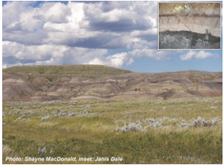
One of the inevitable questions that arise when discussing dinosaurs focuses on their extinction. Dinosaurs and many other species became extinct as the result of a huge meteorite that crashed into the Yucatan Peninsula in Mexico 65 million years ago, creating the huge, impact crater. An impact of this size would have thrown up melted beads of rock that encircled the entire Earth. As they fell out of the atmosphere, some ended up in the swamps and ponds that covered southern Saskatchewan at that time. This material eventually ended up as a 1–1.5 cm thick layer of kaolinite clay. Over the next three months, dust and aerosols continued to rain down on the land and were compressed into a 1 cm layer of satiny claystone. Deposition after this catastrophic interval consisted of shale and about 10 years after the initial impact, plants (ferns) had recovered enough to once again provide material for the formation of coal.

The Cretaceous-Tertiary (K-T) boundary, which marks the end of time for dinosaurs and the end of the Mesozoic Era, is now clearly visible in the strata at Grasslands National Park (Picture). The extinction of dinosaurs, 65 million years ago, coincides approximately with the base of a coal seam with high levels of iridium.

Note: Information for this section was collected with kind permission from A. R. Sweet who wrote the paper Plants, a Yardstick for Measuring the Environmental Consequences of the Cretaceous-Tertiary Boundary Event, Geoscience Canada, Vol. 28, No. 3, September 2001.

The K-T boundary is not the only evidence of impact craters in southern Saskatchewan. On the northern flank of the Cypress Hills, near the town of Maple Creek, a meteorite hit the earth about 75 million years ago and created an impact crater 6 km in diameter. This is no longer clearly visible at the surface because of time and erosion, but drill holes in the area have provided confirmation of the central uplift in this structure.

Impact events are probably more common than you think. Approximately 140 impact craters have been identified and these are mainly in populated areas that have been explored. Other impacts have occurred in the oceans, in remote land tracts, or have long since been hidden under sediments or recycled through plate tectonics. Just about all craters have deep central depressions, raised rims, and a radiant ring of ejected material surrounding them. Many of the larger ones also have a raised uplift in their centre. Craters have a characteristically round shape that makes them easy to spot on satellite images. When they are found, scientists are called in to study them. Geologists are becoming more interested in them because some have been found to be associated with valuable ore deposits.

In Saskatchewan there are five impact craters. Go to GeoExplore Saskatchewan - https://skgeolhighwaymap.maps.arcgis.com/apps/MapSeries/index.html?appid=a845cbb370f7401597806887318e2676 under tab Geo 101 and subtab Meteorite Impacts for more information on meteorites and for Saskatchewan examples.

Stage 3: Build Learning Plan
Class periods needed: 1-2  Teacher Prep time: 10 minutes  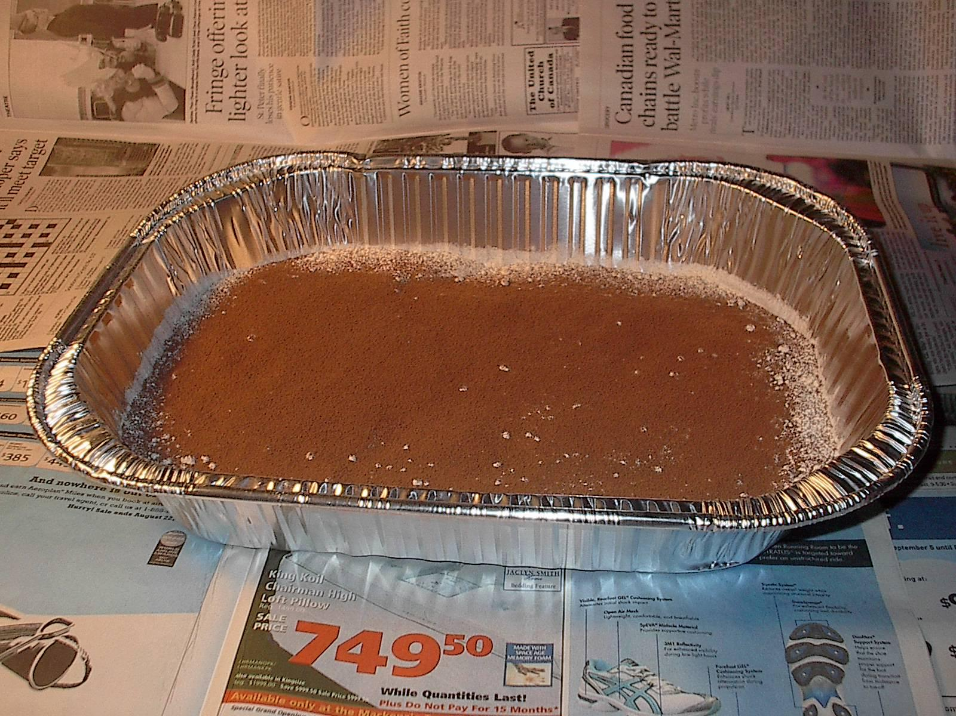  - Sprinkle 4 cups of flour over the bottom of each of three pans to a depth of about 3 cm. Gently shake and tap the pans to make sure the surface is even and smooth.  - Using the sieve, sprinkle a thin, even layer of the cocoa or tempera paint over the entire surface.  - Have a sifter of sieve with cocoa or dry tempera for resurfacing the tub after an impact if necessary.  - Copy student worksheets and project GeoExplore Saskatchewan website on board.  Set (Warm-up, Focusing the Learning): Time: 5-10 min  Hook - Depending on grade level -  - Ask students - What is a shooting star? Have you ever wished on a shooting star?  - Ask students - What killed the dinosaurs? Then, show the videos in “Additional Resources”  - Doodle - Have students draw their answer to what killed the dinosaurs.  - Show news video - https://www.youtube.com/watch?v=gRrdSwhQhY0  - Show images of craters on the Moon and Mars. Ask students what these are and if Earth has them.  https://www.lpi.usra.edu/education/explore/shaping_the_planets/impact-cratering/  - Describe to students the background information on impact craters - what they are, how they are formed, etc.?  - Then, discuss the first page of the student worksheet. Saskatchewan has one of the world’s best-preserved pieces of evidence of the impact that killed off the dinosaurs.  Development: Time: 30 min  - Go through GeoExplore Saskatchewan website with students on Meteorite impacts. Have students use arrows to match the image of the meteorite crater to the examples on the second page of their worksheet.  - Tell students that they are going to be experimenting with impact craters. This activity will be done as a whole class, with volunteers coming to the front to do the tests. If you have enough supplies, students can also do this in groups.  - Set up the testing area in front of the class. Place newspapers under the tubs in case there is a bit of splatter. Set the first tub out.  - To make the craters, students will use the meter stick and drop the balls from a height of 40 cm and then 80 cm. Another student will then measure the dimensions needed for the Effect of Projectile Size and Height on Crater Dimensions worksheet (depth, diameter, length of longest ray).  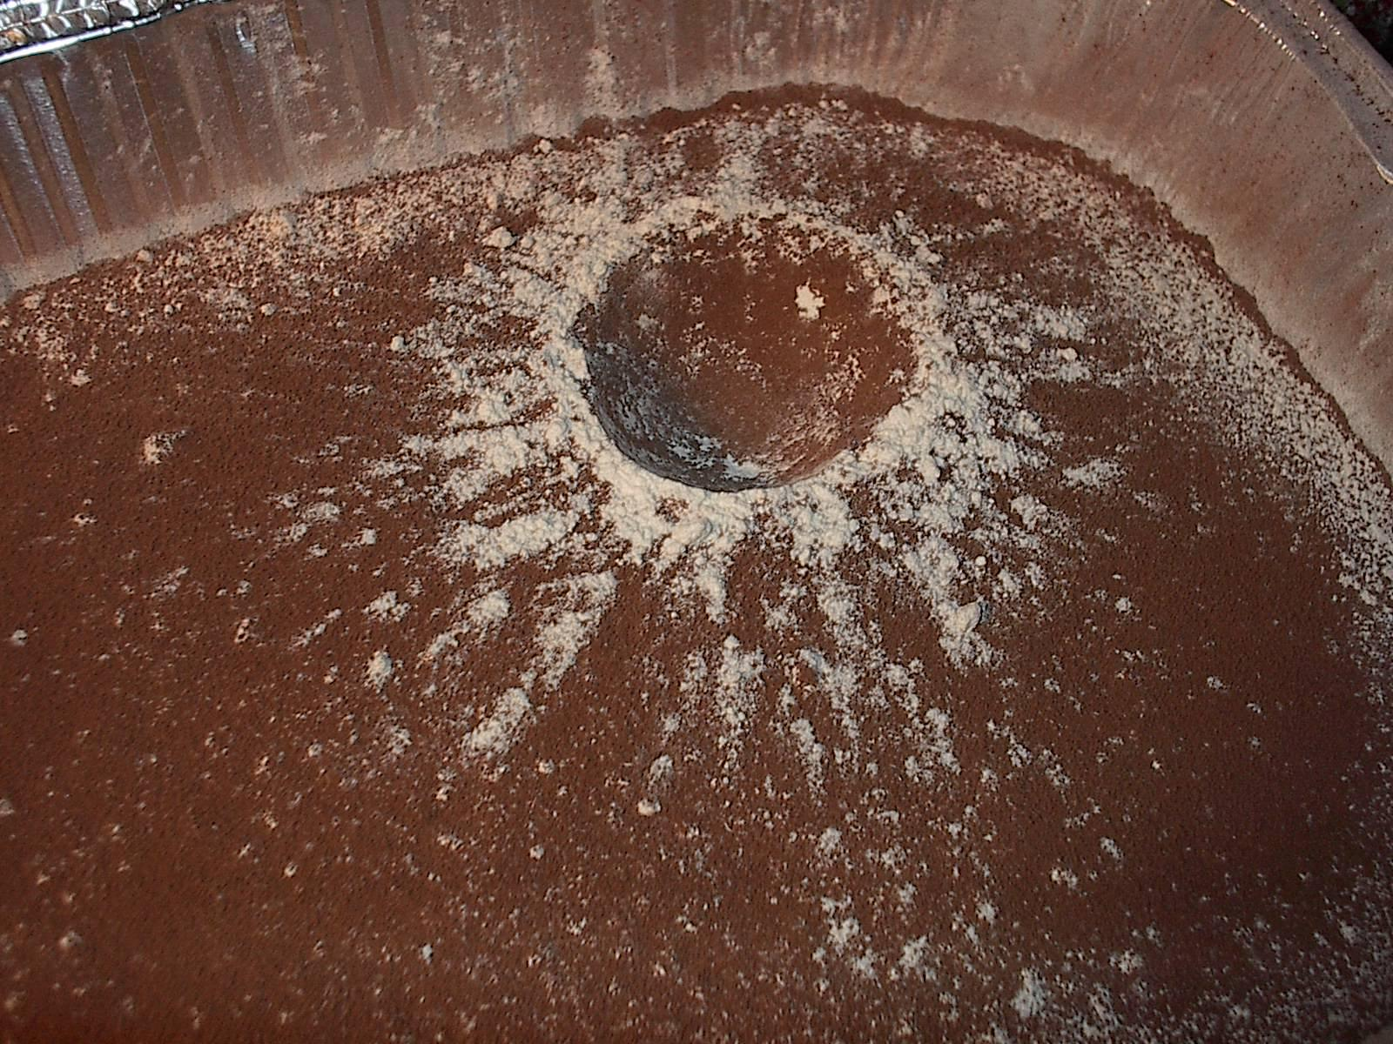  Ask for two volunteers – one to drop the ball and one to measure. The first tub will be used to test the smallest ball. Make sure that both students have goggles on. The “dropper” holds the meter stick beside the tub and uses it to place the ball 40 cm above the surface over the center of the tub. The ball is then dropped. The “measurer” reads out the data so that class members can fill in their worksheet.  - Ask for another two volunteers who will repeat, only dropping the ball from 80 cm this time.  - Continue calling students up, using different tubs for each ball size. Remind students using the largest ball that they should try and get the impact closer to the center since the rays may be cut off if too close to the edge.  Learning Closure: Time: 15 min  - When all of the tests are completed, leave the tubs intact so that students who did not get to come up have a chance to create a crater if there is time.  - Students then complete the graph, comparing the diameter of the crater for each of the different tests. Remind students to think carefully about scale, and to include a legend for their data. This will be a triple line graph.  - Have a closing discussion, going over the graph and big idea of the lesson. |  | Materials/Equipment:  Projected website to guide students through - GeoExplore Saskatchewan  Link in teacher background.  Each Student  - Killer Craters Student Handout/ worksheet (4 pgs.)  Tubs  - 3 large tubs (not glass) at least 25 x 30 x 8 cm. Aluminum turkey roasting pan is just about right.  - 12 cups of flour  - 3 cups cocoa or dry tempera paint  - Sifter or sieve  - Old newspapers  Other  - 1 small solid ball (should be bigger than a marble since these are very difficult to pick out without damaging the crater)  - 1 medium solid ball  - 1 large solid ball  - Ruler  - Meter stick  - Safety glasses  Safety Considerations:  - Safety glasses for students to protect eyes  Possible Adaptations/  Differentiation  - Allow students to respond to post-experiment questions: verbally, through video or presentation.  - Have students do individual experiments focusing on one variable at a time in the form of a POE (Predict, Observe, Explain). Have each group share their experiments and findings with the class.  Questions to ask...  What are your observations? You can write student observations on the board.  Why does the ejecta pattern form the way it does?  How did the crater size change when balls of different masses were dropped at the same height?  How does drop height correlate to crater size? What is drop height actually representing? (velocity)  How does this experiment model Newton’s Second Law?  Force = Mass x Acceleration  How does the angle of impact affect the crater shape?  How does the volume of the meteorite affect the crater impact?  In summary:  - The higher the ball's starting point, the greater its velocity at impact.  - The greater an object's velocity, the larger its impact crater.  - When dropped from a given height, the greater the mass, the larger the crater.  - When dropped from a given height, the greater the volume, the larger the crater.

Stage 4: Determine Evidence for Assessing Learning
- Formative - closing discussion about the graph and big ideas of the lesson.
- Could collect the data chart and graph to assess data recording and graphing skills.
- Could create an experiment question sheet that students write responses to …
- Using extrapolation on your graph, what crater diameter would you expect when a golf ball is dropped from a height of 120 cm? (Depends on the data)
- What do you think has the most effect on an impact crater — the size of a projectile or the height it is dropped from? Explain by providing evidence from your data. (Depends on the data)
- Why do you think the moon and Mars are covered with impact craters while they are relatively rare on the surface of the Earth? (Hint: What do we have that they don’t?) (They have no atmosphere to deflect or burn meteors up)
- Predict the effects of weathering on a crater. (Possible answers could include - crater filling up with water, rim/edges of crater eroding and filling in on itself, crater becomes buried by sediment or vegetation grows).
- Pose new questions based on what you learned.
- What was your biggest takeaway of this lesson or the ‘big idea’?
- Students could respond to these questions in the form of a Flipgrid (video response)

Extensions
- Do some research on the Chicxulub crater in Mexico and the Maple Creek crater in southern Saskatchewan. Compare the two in terms of size and learn more about the effect of the Chicxulub impact. Based on your findings, infer what affect the meteorite creating the Maple Creek crater had on this region when it hit.
- Design your own impact crater experiment and test for a variety of different variables, including angle of impact, mass of projectile, type of surface, etc.
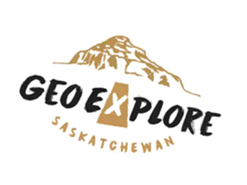
- Find satellite images on the internet that show impact craters and map them. Can you see any patterns? If so, propose a possible explanation for your observations.

Look at the GeoExplore Saskatchewan website for further information and a deeper understanding of the importance of Saskatchewan’s geological history. It is a digital version of the original paper Geological Highway Map of Saskatchewan:

Main Website -
https://skgeolhighwaymap.maps.arcgis.com/apps/MapSeries/index.html?appid=a845cbb370f7401597806887318e2676

Geology 101:
- Sub tab: Meteorites:

Additional Resources
Videos
The Day the Dinosaurs Died – Minute by Minute Kurzgesagt – In a Nutshell - https://www.youtube.com/watch?v=dFCbJmgeHmA

What Happened to Asteroid After It Wiped Out Dinosaurs? Bright Side - https://www.youtube.com/watch?v=4lbIhxDCCRU

Information
Impact Craters on the Moon Lesson and Activity Demo Video https://www.nasa.gov/stem-ed-resources/impact-craters.html

American Museum of Natural History Virtual Meteorite Exhibits https://www.amnh.org/exhibitions/permanent/meteorites

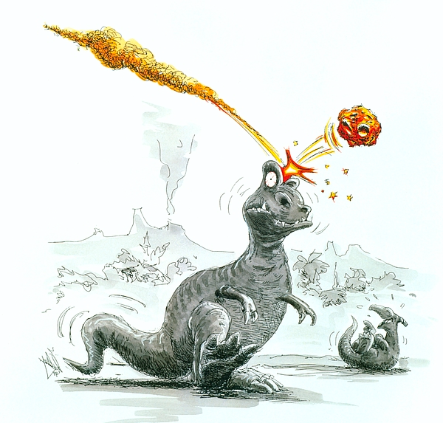
Name: ___________________________

Killer Craters

Dinosaurs and many other species became extinct as the result of a huge meteorite that crashed into the Yucatan Peninsula in Mexico 65 million years ago, creating the huge, impact crater we now call the Gulf of Mexico. An impact of this size would have thrown up melted beads of rock that encircled the entire Earth. Over the next three months, dust and aerosols continued to rain down on the land and were compressed into a 1 cm layer of claystone. Deposition after this catastrophic interval consisted of shale and about 10 years after the initial impact, plants (ferns) had recovered enough to once again provide material for the formation of coal.

The Cretaceous-Tertiary (K-T) boundary, which marks the end of time for dinosaurs and the end of the Mesozoic Era, is now clearly visible in the strata at Grasslands National Park. The extinction of dinosaurs, 65 million years ago, coincides approximately with the base of a coal seam with high levels of iridium.

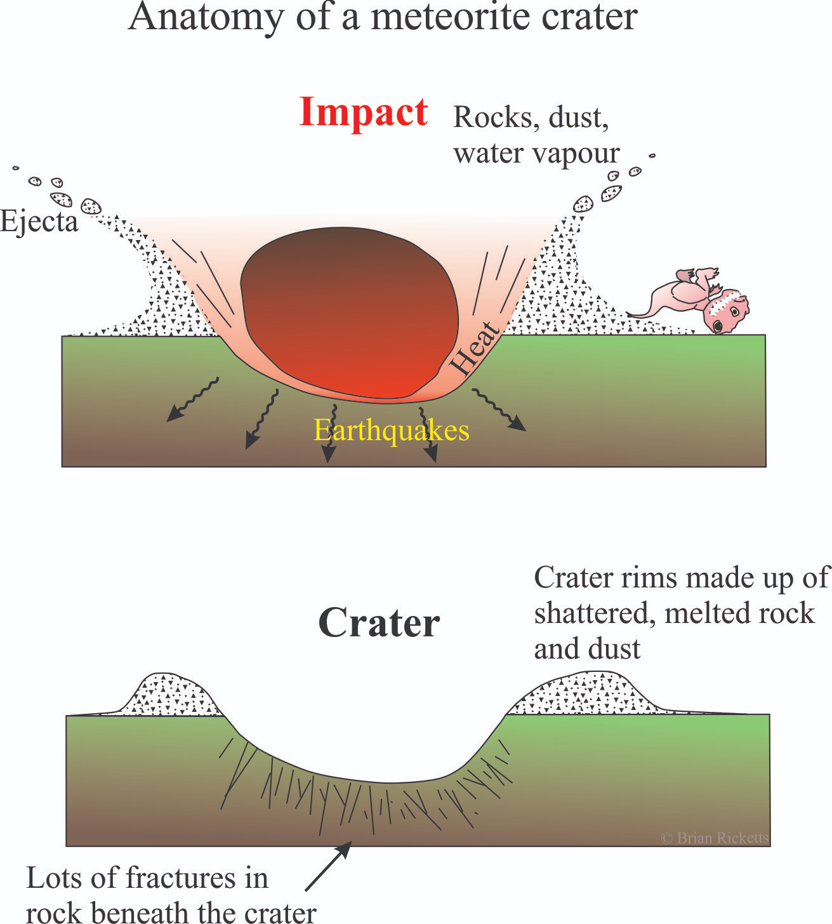
Impact events are probably more common than you think. Approximately 140 impact craters have been identified. In Saskatchewan there are five impact craters. Just about all craters have deep central depressions, raised rims, and a radiant ring of ejected material surrounding them. Many of the larger ones also have a raised uplift in their center. Craters have a characteristically round shape that makes them easy to spot on satellite images. When they are found, scientists are called on to study them. Geologists are becoming more interested in them because they have been found to be associated with valuable ore deposits.

Saskatchewan Meteorite Impacts

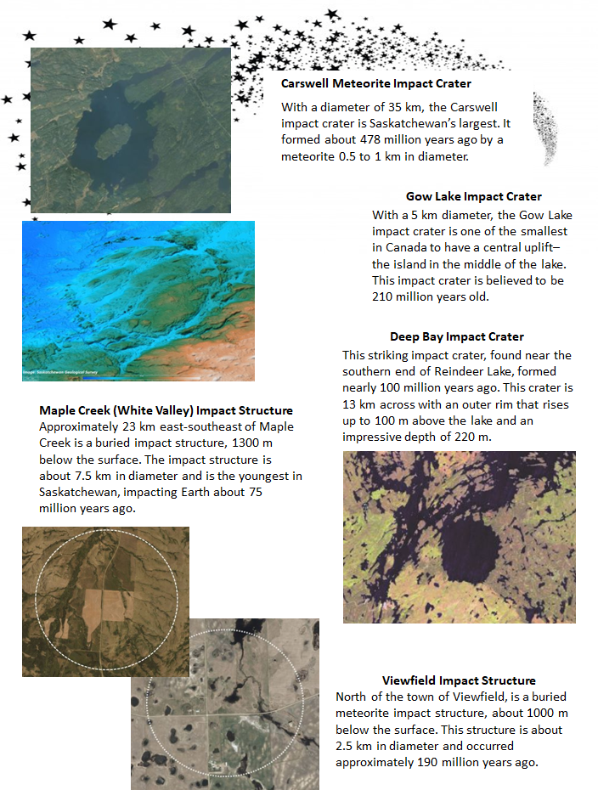
Meteorite Impact Crater Experiment
Effect of Projectile Size and Height on Crater Dimensions

Test  (Projectile and Height) | Depth of Crater  (mm) | Diameter of  Crater (mm) | Longest Ray Length  (mm) | Description of Crater
Small at 40 cm
Small at 80 cm
Medium at 40 cm
Medium at 80 cm
Large at 40 cm
Large at 80 cm

Draw and Label an Impact Crater from the experiment…
Effect of Projectile Size and Height on Crater Diameter

What are your conclusions from this experiment?

