Campbell GEOrock Garden Virtual Tour
Subject/Grade: Earth Science 30, Science/7, and Science/4
Recreated by: Hilary Roemer & Dr. Kate MacLachlan
GeoExplore Tabs: Geo 101 – Rock Cycle – 1.2.9
Stage 1: Identify Desired Results
Earth Science 30
ES30-LS1 Examine the processes that lead to the formation of sedimentary, igneous and metamorphic rocks and minerals. [SI]
Indicator(s):
a) Differentiate the three main rock groups (i.e., sedimentary, igneous and metamorphic) by their processes of formation, including the roles of time, heat and pressure. (K)
e) Outline the basic transitions inherent in the rock cycle, and the forces that disrupt equilibrium to cause these transitions.
g) Classify igneous rocks according to criteria such as method of formation (i.e., intrusive or extrusive) and mineral composition (e.g., felsic or mafic).
h) Explain how geologists can infer how an igneous rock was formed by examining its texture (i.e., intrusive or extrusive).
j) Describe how the general mechanisms of mechanical and chemical weathering processes, erosion and deposition contribute to the development of sedimentary rocks. k) Describe how the agents of metamorphism (i.e., heat, pressure, directional stress and chemically active fluids) influence the formation of metamorphic rocks. l) Compare the characteristics of foliated and non-foliated metamorphic rocks.
Science 7
EC7.2 Identify locations and processes used to extract Earth’s geological resources and examine the impacts of those locations and processes on society and the environment.
Indicator(s):
b) Distinguish between rocks and minerals using physical samples, pictures, and/or video recordings and identify the minerals most often found in rocks in Saskatchewan and around the world (e.g., quartz, calcite, feldspar, mica, hornblende).
c) Classify rocks and minerals based on physical properties such as colour, hardness, cleavage, lustre, and streak.

EC7.3 Investigate the characteristics and formation of the surface geology of Saskatchewan, including soil, and identify correlations between surface geology and past, present, and possible future land uses.
Indicator(s):
a) Model the processes of formation of the three major types of rocks: sedimentary, igneous, and metamorphic.
c) Construct a visual representation of the rock cycle (e.g., formation, weathering, sedimentation, and reformation) and relate this representation to the surface geology of Saskatchewan and Canada.
d) Develop and use a classification key for rocks based on physical characteristics and method of formation.
Science 4
RM4.1 Investigate physical properties of rocks and minerals, including those found in their local environment. [CP, SI]
Indicator(s):
a) Pose questions about the properties of rocks and minerals (e.g., What is the difference between rocks and minerals? Where do we find rocks and minerals? Do rocks become minerals?).
b) Document the locations and characteristics of rocks that exist in their local environment.
g) Record observations of rocks and minerals using jot notes, labelled diagrams, and charts.
h) Compare the physical properties of rocks and minerals from their local environment with those from other geological areas.
i) Develop their own classification scheme to organize their understanding of rocks and minerals.
k) Differentiate between rocks and minerals.
l) Develop simple generalizations about the physical characteristics of rocks and minerals based on observation and research.

RM4.3 Analyze how weathering, erosion, and fossils provide evidence to support human understanding of the formation of landforms on Earth.
Indicator(s):
c) Explain how rocks can be classified as igneous, sedimentary, or metamorphic based on the processes by which they form.

Key Understandings: (‘I Can’ statements)  I can… describe what a rock is.  I can… explain what Igneous, Sedimentary and Metamorphic rocks are.  I can… make observations that describe the physical properties of various types of rocks.  I can… use observed characteristics of rocks to determine what type of rock I am looking at.  I can… infer the setting this rock was formed in based on its physical properties.  I can… record and organize my observations into a chart. | Essential Questions:  - What is a rock?  - What is an igneous rock?  - What is a sedimentary rock?  - What is a metamorphic rock?  - What are some physical properties of rocks that can be used to identify them?  - What setting was this rock formed in based on your observations?  Concepts:  - Rock Identification  - Physical Properties of rocks  Scientific Inquiry  - Make observations that describe physical properties of the different rock types  - Record and organize observations in a chart format

Stage 2: Teacher Background
The lesson and virtual tour were inspired from a teacher’s guide called, From Earth to Sky. The lesson and virtual tour are focused on Regina’s GEOrock Garden located at Campbell Colligate in Regina, Saskatchewan. The GEOrock Garden consists of 32 rocks of various sizes and composition.

There are lessons, activities and labs that can be completed before the virtual tour to ensure appropriate prior knowledge. However, the virtual tour does include a brief review of rock types and the rock cycle.
- https://sgshome.ca/outreach/geoscape-saskatchewan (updated lessons, activities, labs, etc.)
- https://sgshome.ca/outreach/georock-garden-at-campbell-collegiate (original Earth to Sky guide)

Stage 3: Learning Plan
Engage Activity – Ask students…  - What does “From Earth to Sky” mean?  - Is there a relationship or connection between the Earth and the Sky?  - What are some examples of the relationship or connection?  Have students participate in a class discussion to share their responses and ideas.  Also, you can ask students to share any prior knowledge about what rocks are and the different rock types. Create a brainstorming web, flowchart, or concept web on the board as students share their responses.  Explain:  During the introduction part of the PPT. the teacher will introduce the Georock Garden and explain the different rock types. Students will complete their worksheets and answer inquiry questions asked by their teacher.  Students’ prior knowledge about the different rock types will affect the pacing of the lesson. Rock types might be a review or it could be new for students.  The PPT. has teacher notes included for each slide to help explain the slide, make it more engaging for students and includes questions you can ask students.  Explore:  Students (or teacher) will pick 6 rocks to explore while on the virtual tour. For each of the 6 rocks students should…  - Record the rock sample number within the star on the handout  - Circle the rock type predictions  - Write down or draw with labels observations that support the predictions based on the pictures within the virtual tour presentation  - Listen to the teachers’ explanation of the sample, and write down information about the about the sample (whether or not the prediction was correct). Make sure students do not change their predictions. Include the correct rock type within the explanation part.  The teacher needs to determine pacing at each virtual stop by asking students to raise their hands if they are selecting that rock. If students raise their hands, give them time to fill-in the handout before going into the explanation. Instead, the teacher could preselect the 6 rock samples that they want students to focus on so they are not pausing at every slide (timesaver option).  Elaborate: Students can pick one rock from the virtual tour and write a story about the rock’s life. Students can research more about the rock they picked and create a narrative or comic including information about how the rock formed, where it has traveled, how it has changed/grown up, etc. | Materials/Equipment:  - GEOrock Garden Virtual Tour PPT.  - Appropriate Student Handouts/Worksheets  - Highlighters  Optional Materials/Equipment:  - A rock showing different minerals within it  - Various rock samples, if available  - Paper and water (Sedimentary rock demo)  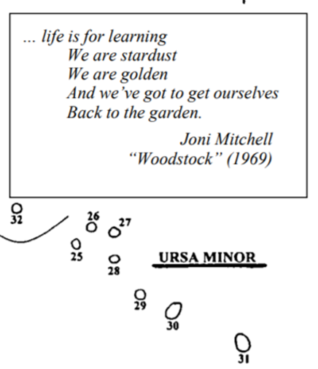  Teaching Style Preferences:  The lesson can be entirely teacher guided, student guided or a combination of both depending on the classroom dynamics.  If you have access to laptops, students can work individually or in groups to explore the virtual tour on their own while completing the handouts.  - Students need to be responsible by only looking at the presentation notes for each slide, after they have completed the predictions and observations.  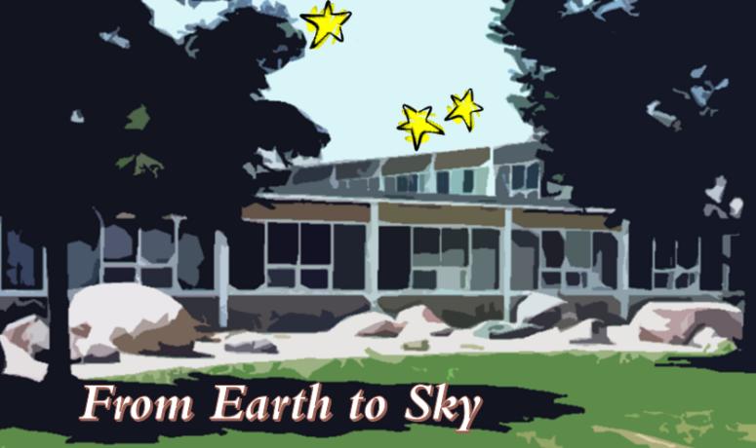  Alternatively with some changes, the presentation could not include the notes and students could receive the explanations later. This could be a two-part lesson. The first part could focus on the introduction, predictions and observations. The second part could focus on the explanations and elaboration.
Stage 4: Determine Evidence for Assessing Learning
Learners will show they achieved the skills by…
- Responses to in class questions and discussions
- Check flowcharts and worksheets for completion
- Elaborate – Rock Story Activity
- Drawing and recording observations of different rock samples
- Being able to identify different samples based on physical properties

Feedback that students will receive…
- Informal class responses and discussion on trying to identify the different rocks
- Grading of worksheets or designing a rubric for the Rock Story Activity

Extensions
- Students can create their own tour guide of a rock garden with their favorite types of rocks.

- Students can further research star constellations and complete an art piece or research project about a star constellation that they selected including the mythology.
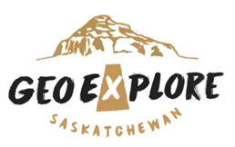
Look at the GeoExplore Saskatchewan website for further information and a deeper understanding of the importance of Saskatchewan’s geological history. It is a digital version of the original paper Geological Highway Map of Saskatchewan:

Main Website
https://www.arcgis.com/apps/MapSeries/index.html?appid=a845cbb370f7401597806887318e2676&entry=11

For more background information related to this lesson check out
- Main tab “Geo 101”

Name: ________________
Campbell GEOrock Garden
Virtual Tour
Answer the following questions, and fill in the following boxes by listening to the presentation.
Fill In the Rock Type flowchart

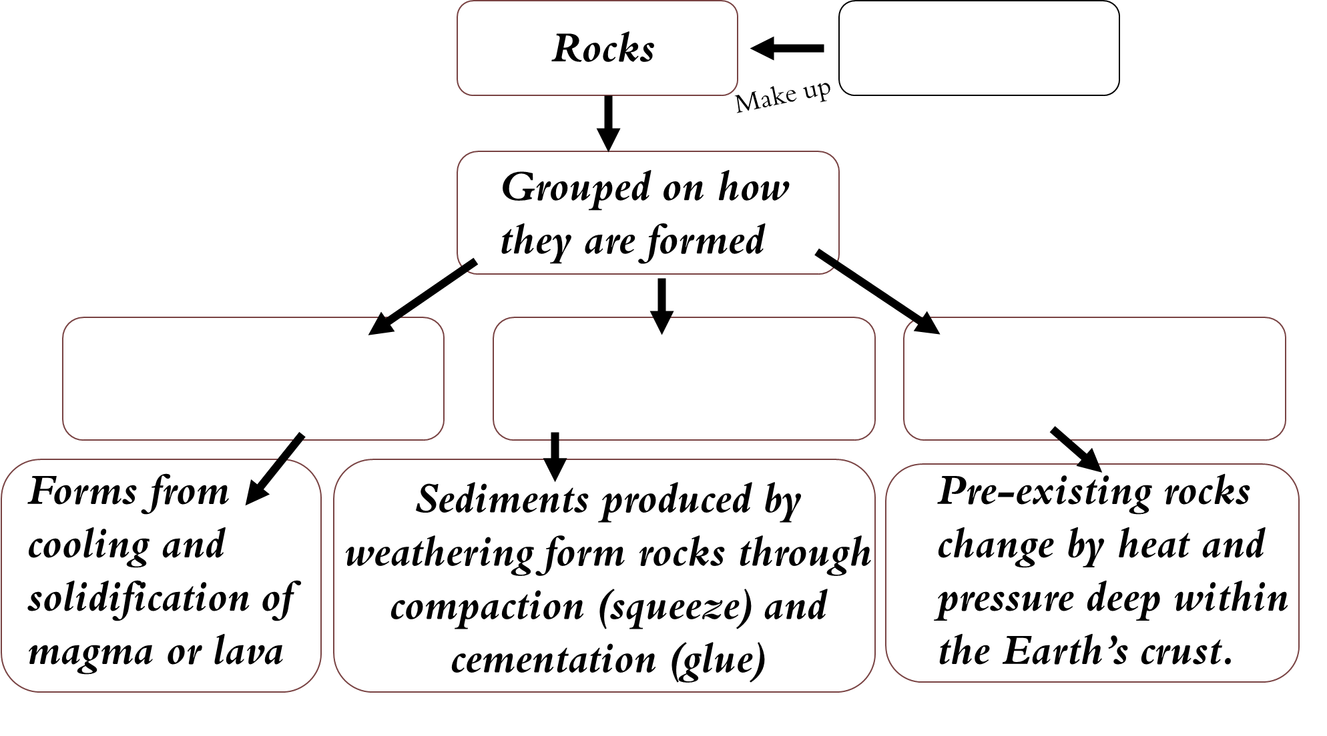
Highlight & Define Key Words

Solidification: ____________________________________________________________________

Magma: _________________________________________________________________________

Lava: ___________________________________________________________________________

Sediments: ______________________________________________________________________

Weathering: ___________________________________________________

______________________________________________________________

Change: _______________________________________________________

Circle Predictions → Sedimentary Igneous Metamorphic
Observations | Explanation
Circle Predictions → Sedimentary Igneous Metamorphic
Observations | Explanation
Circle Predictions → Sedimentary Igneous Metamorphic
Observations | Explanation
Circle Predictions → Sedimentary Igneous Metamorphic
Observations | Explanation
Circle Predictions → Sedimentary Igneous Metamorphic
Observations | Explanation
Circle Predictions → Sedimentary Igneous Metamorphic
Observations | Explanation
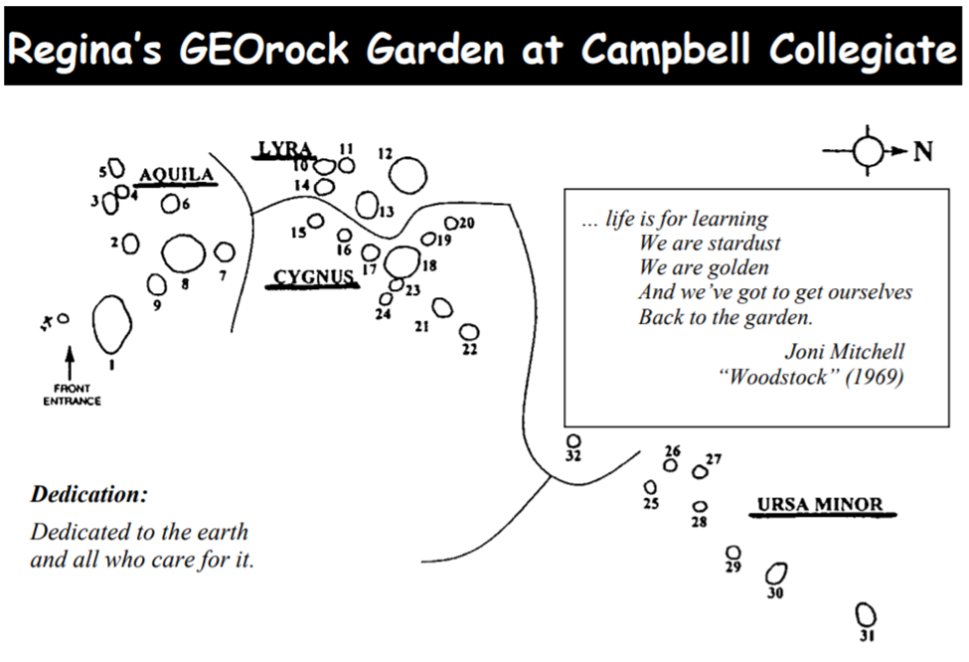
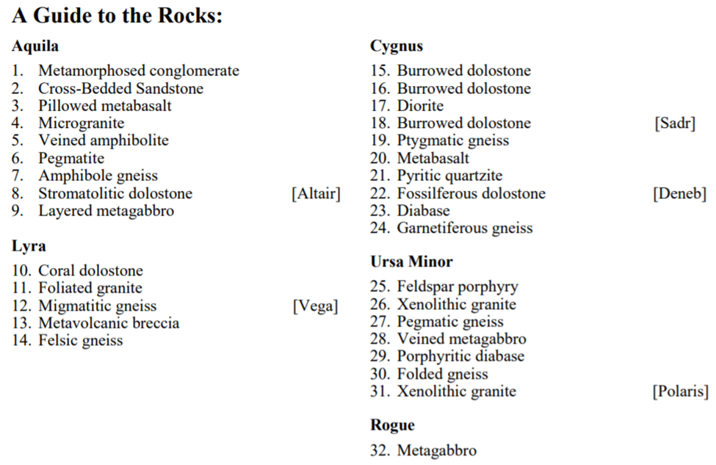

Presentation Notes
Slide 1 - Engage Activity – Ask students…What does “From Earth to Sky” mean? Is there a relationship or connection between the Earth and the Sky? What are some examples of relationships or connections between the Earth and the Sky? Have students participate in a class discussion to share their responses and ideas.

Slide 2 - Saskatchewan’s first GEOrock Garden is located in the front courtyard of Campbell Collegiate in Regina. The GEOrock Garden consists of 32 rocks of various sizes and composition. The rocks were arranged in the form of the four summer-sky constellations: Aquila, Lyra, Cygnus and Ursa Minor (Little Dipper), with three of the five largest boulders closely reflecting the Summer Triangle. The garden was laid out in this way because our planet came from space and rocks are connected to the stars.

Slide 3 - This is the layout of the GEOrock Garden at Campbell Collegiate. Can you recognize some of the constellations represented?

Slide 4 - Ask students what “naturally occurring” means. Rocks are named based on how they formed and the types of minerals they are composed of. If you look close enough, you can see the different minerals. Show and pass around a rock sample (ex. granite) that students can easily see different minerals making up the rock. If you pick granite tell students that the slightly pink minerals are orthoclase feldspar, the white minerals are plagioclase feldspar, the milky grey minerals are quartz or muscovite, and the black minerals are biotite or hornblende. Granite is an igneous rock. Explain that minerals make up rocks and that rocks are classified or organized into three groups based on how they form.

Slide 5 - The three main rock groups are Igneous, Sedimentary and Metamorphic. Have students add this to their chart. Did you know??? The oldest rocks in Saskatchewan are about 3.3 billion years old and are located north of Lake Athabasca.

Slide 6 - Nearly all of the Earth's crustal material originates from flowing molten magma deep within the Earth. As magma or lava cools it becomes solid and forms igneous rocks. Ask - What does solidification mean? Answer – turning into a solid. Ask – what is the difference between magma and lava? Answer – magma forms below the surface and lava is when it erupts onto the surface. Have students add the definitions to their worksheets. Ask – Where do you think this picture might be from? Do we have volcanos in Canada? Answer – The picture is of Ring Mountain in British Columbia. It is a volcano called Tuya and was active around 2.5 million years ago. If you have some rock samples of igneous rocks, then pass them around to students to look at.

Slide 7 - Sedimentary rocks are formed by breaking down existing rock into tiny pieces called sediments. The process of breaking down rock is called weathering. Then, the sediments accumulate and become buried. The sediments are squeezed and compacted together physically and chemically. You can use paper and water to demonstrate. Have the students coach you through it asking questions along the way. Tear the paper into tiny pieces (existing rocks breaking down into sediments by weathering). Then, pile all the sediments together. Try to squeeze the pieces together (compaction). Ask students why it is not working and eventually have them suggest using water to act as a glue (cementation). Then, show students your sedimentary rock (wet paper ball).
Image – is of sedimentary rocks at Five Islands, Nova Scotia. If you have rock samples of sedimentary rocks, then pass them around for students to look at.

Slide 8 - Ask - what happens to the minerals in a rock when it experiences heat and pressure? What has happened to the minerals in the picture? Why are the minerals forming lines? Do you recognize the pre-existing rock (original)? Note, that the heat is not hot enough to form igneous rocks. The image is a rock called Granitic Gneiss. The pre-existing rock was an igneous rock called granite. By adding heat and pressure the minerals flatten, stretch out or align and form lines or banding. Gneiss is Metamorphic rock with banding. Different minerals form depending on the temperature and pressure that metamorphism occur under. If you have any samples of metamorphic rocks, pass them around so students can observe.

Slide 9 - Rocks are in a constant cycle of changing. They are created, deformed, eroded, lifted up and moved. The story of most of the rocks in the GEOrock Garden began more than one-and-a-half billion years ago when they originated as molten rock deep in the earth or as sediments eroded from mountain ranges and deposited in rivers and oceans. Buried thousands of meters deep, many of these rocks were changed by heat and pressure (metamorphosed) and by the flow of fluids through them. Other rocks (the dolostones) are only about 400 million years old and were formed from limey deposits in tropical seas full of marine life forms, now seen as abundant fossils. Uplift and erosion left the rocks exposed to plucking by glaciers that moved across the land from northern Saskatchewan and Manitoba as recently as 20,000 years ago. Large chunks of rock held in the glaciers were shaped by the pressure and movement of ice and water.

Slide 10 - During the virtual tour, you will pick six rocks to explore. On your page, you will see that it is broken into three sections. You put the sample/rock number within the star. Then circle your prediction of which rock type(s) it is, based on observing the photos. Write you observations that helped with your prediction. Finally, your teacher will explain what the rock is. You need to add some of the explanation to your handout, whether or not your prediction was correct. Do not change your prediction! Include the correct rock type as a part of the explanation.

Slide 11 - We are starting the virtual tour with some of rock samples in the Aquila constellation.

Slide 12 - Rock Name: Metamorphosed Conglomerate
The rock is metamorphic. Observe the elongated rock clasts that form banding due to heat and pressure squishing the rock. The original rock was a sedimentary rock called conglomerate. Conglomerates have rounded pebbles within a finer matrix/groundmass. The matrix is usually sand or silt. The conglomerate was buried very deep and was changed by heat and pressure into a metamorphic rock.

Slide 13 - Rock Name: Cross-bedded Sandstone
This is a sedimentary rock called sandstone. It is made up of sand sized fragments compacted (squeezed) and cemented (glued) together. Observe the crisscrossing layers called cross bedding. When the environment has sand and water or wind, the sand forms ripples which creates layers at an angle to the main beds.

Slide 14 - Rock Name: Pillowed Meta-Basalt
This is an igneous rock called basalt. The minerals are dark and very small but can be seen by using a microscope. Basalts have mostly plagioclase and pyroxene minerals. Basalt lavas can flow across wide areas. The pillows/balloon structures are formed by lava erupting underwater or flowing into water and cooling. This Pillowed Basalt was buried and experienced heat and pressure that metamorphosed it. The pillows have been flattened into disc shapes.
Did you know that basalt is a common rock on the Moon?

Slide 15 - Rock Name: Pegmatite
Pegmatites are Igneous rocks formed from magma that has lots of water in it. The water helps to form very large crystals. They are extreme because the minerals are unusually big, greater than a centimeter. If they have space to grow, pegmatite minerals can become several meters long and weigh several tons.

Slide 16 - Rock Name: Amphibole Gneiss
If you predicted that this rock was metamorphic because you observed the banding, then you are correct! This is a metamorphic rock called gneiss. Gneiss refers to the alternating light and dark bands. Due to high heat and high pressure the minerals will rotate and align forming bands. The temperature and pressure is not too high to cause melting. It forms during mountain building when two tectonic plates are colliding. Amphibole refers to the dark minerals in this rock.

Slide 17 - As we continue with the virtual tour, we are now exploring some of the rocks within the Lyra constellation.

Slide 18 - Rock Name: Coral Dolostone
The biggest hint with this rock is that there are coral fossils. Fossils are rarely if not at all preserved in metamorphic and igneous rocks. This rock is a sedimentary rock called dolostone. It forms in warm shallow marine environments. The main mineral is dolomite. The formation of dolostones is debated amongst geologists because we have rarely observed dolostones forming. Many believe that dolostones form from a chemical process to another sedimentary rock called limestone.

Slide 19 - Rock Name: Magmatic Gneiss
I am melting! This is a mix between a metamorphic rock and a igneous rock. The metamorphic rock gneiss (alternating light and dark banding) experienced such high temperatures and high pressures that it is partially melting into an igneous rock (granite). Migmatite means mixed rock. The dark patches are the unmelted metamorphic rock and the white patches are the part that melted and formed pockets/bands that cut across the unmelted part.

Slide 20 - The next part of the virtual tour takes us to the rocks that are organized into the Cygnus constellation.

Slide 21 - Rock Name: Diorite
You might recognize this rock from Minecraft. This is an igneous rock called diorite. Some call this rock salt and pepper for its appearance. The white plagioclase minerals contrast with the black hornblende and biotite minerals. Diorites form from the cooling of magma underground. The minerals form slowly underground creating a courser texture (medium-grained means minerals less than a 1cm).

Slide 22 - Rock Name: Borrowed Dolostone
We have seen this rock already on the virtual tour. It is dolostone. Remember that dolostone is a sedimentary rock that forms in warm shallow marine environments. The “burrowed” refers to the tunnels or holes that were preserved from little marine creatures that lived within the loose sediments. The borrows are an example of a trace fossil. Trace fossils are the preserved behavioral evidence of a creature like footprints, burrows, and imprints. Trace fossils are not the actual bones or tissue of the creature. This rock is also interesting because it has glacial striae (scratches), shown in the left-hand photo. All the rocks in the rock garden came from a gravel pit and was transported hundreds of kilometers and then deposited by a glacier. During the transportation, the rock was scratched against the ground or other rocks causing it to get scratched.

Slide 23 - Rock Name: Ptygmatic Gneiss
This is a metamorphic rock called gneiss. Remember the banding? However, this banding is not in parallel layers. The pink layers are highly folded. These types of folds are called ptygmatic and they form when thin layers of harder rock are surrounded by softer rock. Ptygmatic is pronounced as “tig-matic.”

Slide 24 - The last constellation for the virtual rock tour is Ursa Minor or also known as the Little Dipper.

Slide 25 - Rock Name: Xenolithic Granite
Granite is an igneous rock that forms from magma underground. The minerals grow larger because of the slow cooling time. The main minerals in granite are quartz and feldspar, but this granite also has quite a lot of mafic (dark) minerals. Xenolithic means that there are inclusions of another rock (or mineral) within. As the magma was cooling to form a granitic rock, another older rock become incorporated into it. What is the connection between diamonds and xenoliths? Diamonds are formed deep in the mantle and are brough to the surface by magma as xenoliths They did not form in the magma that brought them to surface.

Slide 26 - Rock Name: Pegmatitic Gneiss
This is a metamorphic rock called gneiss, which has banding of light and dark minerals. However, the original or preexisting rock is still recognizable. The original rock was an igneous rock called pegmatite. Remember pegmatites have minerals that are larger than 1 cm. The pegmatite was metamorphosed into a gneiss. The large pink minerals are potassium feldspar (orthoclase).

Slide 27 - Rock Name: Veined Meta-Gabbro
Gabbro is an igneous rock formed underground (intrusive) from the cooling of magma. The main minerals that are in a gabbro are plagioclase felspar and pyroxene (augite). It has a coarse-grained texture from minerals growing larger due to slower cooling. Igneous rocks that form above ground (extrusive) have a fine-grained texture because they cool (solidify) quicker causing the minerals to be smaller. Meta refers to the gabbro having some evidence of being metamorphosed. Also, there are veins that run through the rock. Veins form when the existing rock (gabbro) cracks forming fractures. The fractures are then filled with minerals forming from surrounding fluids.

Slide 28 - Rock Name: Porphyritic Diabase
This is an igneous rock. Porphyritic refers to the igneous rock having some minerals bigger than the rest. It has larger crystals floating in a finer grained matrix. This type of texture means that the magma cooled slowly for a bit forming the large minerals and then cooled quickly forming smaller crystals. Diabase means that the igneous rock has similar minerals to gabbro and a basalt, however the texture is in-between being fine-grained (basalt) and course-grained (Gabbro). In this case the larger crystals (phenocrysts) are plagioclase feldspar.

Slide 29 - Rock Name: Folded Gneiss
Notice the banding of light and dark minerals. This rock is a gneiss. Remember that a gneiss is a metamorphic rock formed at high temperatures and high pressures. The temperatures and pressures are not too high to cause the rock to melt, but the minerals align to form the bands. These bands are not in parallel lines. Additional pressures on the rock caused the layers to fold.

Slide 30 - Thank you for participating in the virtual tour highlighting some of the rocks in Campbell’s GEOrock Garden!

