Metamorphic Rock Intro & Lab
Subject/Grade: Earth Science 30, Science/7, and Science/4
Created by: Hilary Roemer & Dr. Kate MacLachlan
GeoExplore Tabs: Geo 101 – Rock Cycle – 1.2.8
Stage 1: Identify Desired Results
Earth Science 30
ES30-LS1 Examine the processes that lead to the formation of sedimentary, igneous and metamorphic rocks and minerals. [SI]
Indicator(s):
a) Differentiate the three main rock groups (i.e., sedimentary, igneous and metamorphic) by their processes of formation, including the roles of time, heat and pressure. (K)
e) Outline the basic transitions inherent in the rock cycle, and the forces that disrupt equilibrium to cause these transitions.
(k) Describe how the agents of metamorphism (i.e., heat, pressure, directional stress and chemically active fluids) influence the formation of metamorphic rocks.
(l) Compare the characteristics of foliated and non-foliated metamorphic rocks.

Science 7
EC7.2 Identify locations and processes used to extract Earth’s geological resources and examine the impacts of those locations and processes on society and the environment.
Indicator(s):
b) Distinguish between rocks and minerals using physical samples, pictures, and/or video recordings and identify the minerals most often found in rocks in Saskatchewan and around the world (e.g., quartz, calcite, feldspar, mica, hornblende).
c) Classify rocks and minerals on physical properties such as colour, hardness, cleavage, lustre, and streak.

EC7.3 Investigate the characteristics and formation of the surface geology of Saskatchewan, including soil, and identify correlations between surface geology and past, present, and possible future land uses.
Indicator(s):
a) Model the processes of formation of the three major types of rocks: sedimentary, igneous, and metamorphic.
c) Construct a visual representation of the rock cycle (e.g., formation, weathering, sedimentation, and reformation) and relate this representation to the surface geology of Saskatchewan and Canada.
d) Develop and use a classification key for rocks based on physical characteristics and method of formation.

Science 4
RM4.1 Investigate physical properties of rocks and minerals, including those found in their local environment. [CP, SI]
Indicator(s):
a) Pose questions about the properties of rocks and minerals (e.g., What is the difference between rocks and minerals? Where do we find rocks and minerals? Do rocks become minerals?).
b) Document the locations and characteristics of rocks that exist in their local environment.
g) Record observations of rocks and minerals using jot notes, labelled diagrams, and charts.
h) Compare the physical properties of rocks and minerals from their local environment with those from other geological areas.
i) Develop their own classification scheme to organize their understanding of rocks and minerals.
k) Differentiate between rocks and minerals.
l) Develop simple generalizations about the physical characteristics of rocks and minerals based on observation and research.

RM4.3 Analyze how weathering, erosion, and fossils provide evidence to support human understanding of the formation of landforms on Earth.
Indicator(s):
c) Explain how rocks can be classified as igneous, sedimentary, or metamorphic based on the processes by which they form.

Key Understandings (‘I Can’ statements)  I can… explain what a Metamorphic rock is.  I can… explain how different Metamorphic rocks are formed.  I can… make observations that describe the physical properties of Metamorphic rocks.  I can… describe the textures or Metamorphic rocks (grain size, foliated or non-foliated).  I can… use observed characteristics of rocks to determine what type of rock I am looking at.  I can… infer the setting this rock was formed in based on its physical properties.  I can… record and organize my observations into a chart. |  | Essential Questions  - How do Metamorphic rocks form?  - What are the different types of Metamorphic rocks?  - Where do Metamorphic rocks occur?  - How can you identify a Metamorphic rock? What are its physical characteristics?  - How is foliation formed and what does it look like?  Concepts  - Rock Identification - Metamorphic Rocks  - Physical Properties of Metamorphic Rocks  - Foliated and Non-Foliated Rocks  - Metamorphic Environments  Scientific Inquiry  - Make observations that describe physical properties of Metamorphic rocks  - Record and organize observations

Stage 2: Teacher Background
This lesson was created for older students, but can be adapted for younger students.

Teacher Preparation -
- Have a system to label your rocks. For example, use white out, black permanent marker and clear nail polish to label your rock samples with numbers. Then, create a spreadsheet with the numbered rock labels and the rock name. If you are using borrowed rock kit and cannot label them, then make sure the rocks are in the correct spots of the kit to begin with and then take a picture.

- Divide your class into groups and make rock kits/boxes/trays for each group. Each kit should have four Metamorphic rocks. During the lab make sure students write down which kit they used, so if you have to double check observations/answers you can find the exact rock that they were observing. Alternativity, you could have students take one rock at a time from a table/collection of rocks.
Stage 3: Learning Plan
Engage Activity:  Throughout the activity ask students questions about what is happening and circulate around.  1. Pass out different coloured Play-Dough to students. Each student should have three different colours. The different colours represent different minerals.  2. Ask students to create minerals(sediments/grains) with the Play-Dough by making small lumps or balls.  3. Then, students will form a Sedimentary rock by gently squeezing together the minerals of Play-Dough pieces. Just enough that they stick together.  4. Students will cut their rock in half using a butter knife. Observe the shape of the minerals and ask students what they see. The minerals should be very similar to what they started with.  5. Gently press the two halves back together. Then, have them create a metamorphic rock by applying pressure by flattening the “rock” onto the table like a thick fluffy pancake not paper thin. You are simulating the pressure in the Earth that changes existing rocks into Metamorphic rocks. Also, mention that heat is involved (Heat from your hands).  6. Once again, cut the rock in half and ask students what they observe. The minerals flattened, elongated and aligned into layers. Notice the direction you pressed (stress direction/pressure) in comparison to the direction that the minerals flattened. You pressed downwards and the minerals elongated (stretched) in the opposite direction. This is called foliation which is a physical property in Metamorphic rocks.  7. Tell students that not all Metamorphic rocks are foliated. Ask students what they think the reason is.  If the pressure is the same in all directions when metamorphism is happening then you will not develop a folation.  Explain:  During the PPT. students will create a flowchart. Have students use a piece of paper that is 17 by 22 or folds into a normal 8.5 by 11 paper.  Depending on the grade, you can use a normal 8.5 by 11 if you think they will have enough room. Have students fold the page into three equal parts. Each third will be for each rock type. Everyone’s flowchart might look different, but that is okay. This is a different way of organizing notes. For younger grades, you may want to create a fill in the blank flow chart based off of the information that is relevant to them. In this lesson students will fill in the Metamorphic section of their flow chart.  Note – Minerals & Rocks Doodle Notes (New!)  The “Metamorphic” PPT has teacher notes included for each slide to help explain the slide, make it more engaging for students and includes questions you can ask students. Some slides might suggest to pass around a rock sample to help demonstrate a point.  Depending on lesson length and availability of laptops you may have to break this lesson plan into multiple lessons. Make sure you do refreshers.  Explore:  Explain that students will work in groups and will have to observe and fill out the worksheet for all four samples that they have at their table. Let the groups pick a box set of Metamorphic Rocks. Encourage students to create large drawings with labels pointing to certain physical properties. Walk around the room asking questions regarding the samples and the physical properties they are observing. Re-enforce the new terminology by seeing if students can use it appropriately when observing samples. Once each group has completed their lab, they can explain their findings to the rest of the class through an informal presentation with the name and properties observed. Make sure students wash/sanitize their hands after.  Elaborate:  Students can complete a WebQuest about Metamorphic Rocks specifically related to Saskatchewan. The worksheets are included below. | Materials/Equipment:  - Metamorphic Rocks PPT.  - Appropriate Student Handouts/Worksheets  - Metamorphic Rock Kits  - Flowcharts  - Laptops or computers  - Different colours of Play-Dough  - Butter Knives  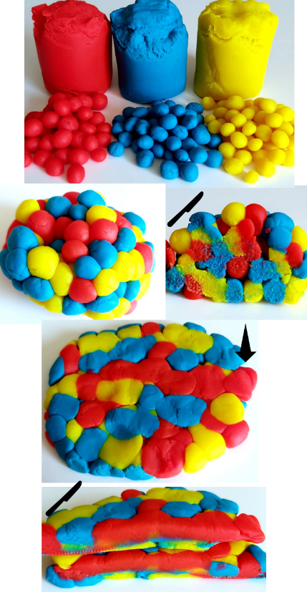  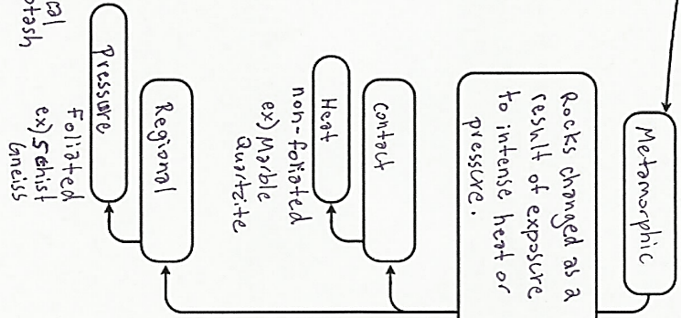  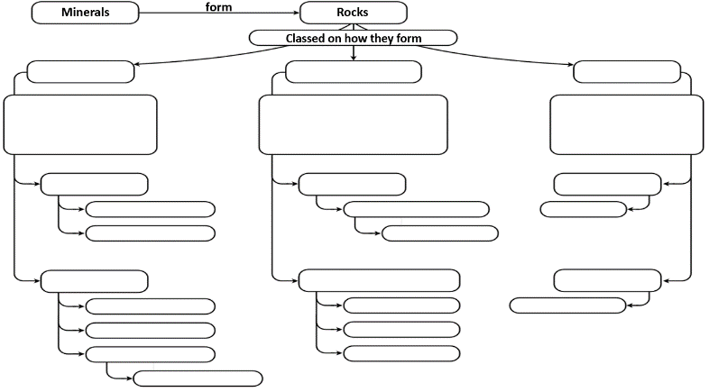  Rough Idea for Flowchart:  Safety:  - Some samples might be pokey and sharp  - Do not throw or toss items to anyone  - If something breaks, inform the teacher immediately  - Return all materials and samples  - Wash hands before and after handling samples  Possible Questions  - What characteristics can you observe that might be able to help you in describing the metamorphic rocks at your table?  - Is the metamorphic rock foliated or non-foliated, how can you tell?  - Which direction is the greatest pressure coming from?  - How do you know that this is a metamorphic rock?  - What is the grain size?  - Where does this metamorphic rock form?  - What is the protolith (parent)?
Stage 4: Determine Evidence for Assessing Learning
Learners will show they achieved the skills by…
- Responses to in class questions and discussions
- Check flowcharts for completion
- Drawing and recording observations of different Metamorphic samples
- Being able to identify different samples based on physical properties (colour, grain size, clastic/non-clastic, setting/deposition environment, energy level…)
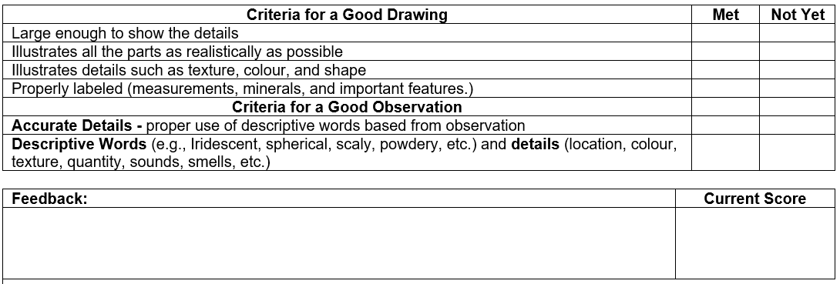
Feedback that students will receive…
- Informal class responses and discussion on trying to identify Meta. rocks
- Feedback from identification worksheet
- Create a Criteria Chart similar to the one shown to encourage practicing & reflecting on drawing and observation skills. It is important for scientists to communicate clearly by using detailed accurate descriptions with proper terminology and labeled carefully represented drawings with measurements for reference.

Extensions
- If you have a microscope and thin section samples of Metamorphic rocks, you can setup a separate station with questions that students have to take turns completing throughout the lab.

- For younger students, you could simplify the information about the main rock types and instead of labs have students create their own Mineral/Rock ID booklet. Focus on observations rather than correct terminology for physical properties.

- Have students work in partners and give them chart paper to create a rock cycle from what they know about the rock types. Do not have them try to copy a rock cycle from a diagram or the internet. Let students apply their own learnings and understandings over the past lessons to create their own rock cycle. Once they have created the rock cycle, review it with them. Ask questions to clarify any misunderstandings and then give them three rocks to place on the appropriate sections on their rock cycle (Igneous, Sedimentary and Metamorphic).
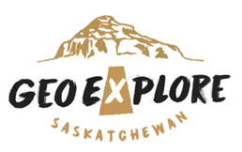
Look at the GeoExplore Saskatchewan website for further information and a deeper understanding of the importance of Saskatchewan’s geological history. It is a digital version of the original paper Geological Highway Map of Saskatchewan:

Main Website
https://www.arcgis.com/apps/MapSeries/index.html?appid=a845cbb370f7401597806887318e2676&entry=11
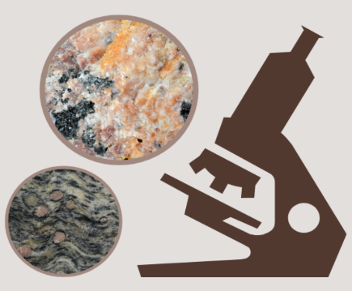
For more background information related to this lesson check out
- Main tab “Geo 101”

Additional Resources
Check out the Doodle Notes for Minerals and Rocks (NEW!)

Virtual Hand Samples and Microscope Samples of Rocks
https://www.virtualmicroscope.org/

Name: ________________
Metamorphic GeoExplore Lab
- Wear Safety Goggles
- HCl - use a small amount and dry the sample with paper towel
- HCl will ruin your clothes if you spill it on yourself
- If you notice irritations then wash your hands
- Some samples might be pokey and sharp – use caution
- Return all materials and samples

Background Information: Metamorphic rocks form when any pre-existing rocks undergo a change caused by heat and pressure deep within the Earth’s crust. There can be a change in texture (grain size or foliation), mineral composition or chemical composition.
- Foliated Metamorphic Rocks – have parallel alignment of minerals. This is common in Regional Metamorphic rocks that are formed when high temperature and high pressure due to plate tectonics causes metamorphism of large areas of rock.
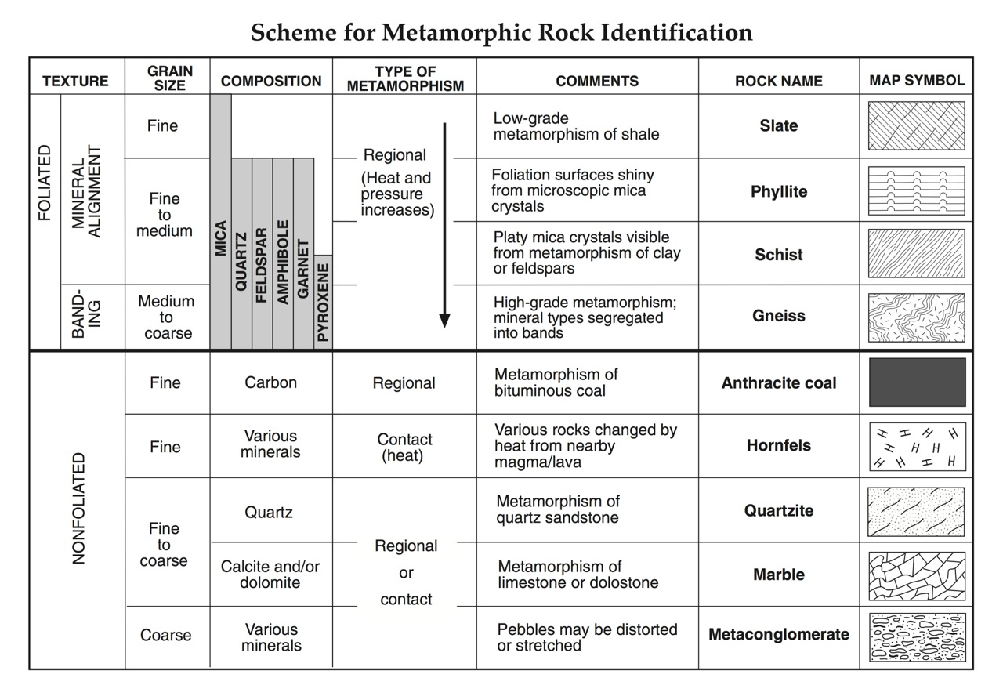
- Non-Foliated Metamorphic Rocks – do not have any observable alignment of minerals. This is common with Contact Metamorphism. When magma (igneous intrusion) comes into contact with the surrounding rock, it heats up the surrounding rock and causes metamorphism.
Metamorphic Name: Physical Properties/ Observations
Drawing | Colour
 | Foliated or Non-Foliated
 | Grain Size
 | Protolith
 | Grade of Metamorphism
 | Type of Metamorphism
 | Other
 | Other

Metamorphic Name: Physical Properties/ Observations
Drawing | Colour
 | Foliated or Non-Foliated
 | Grain Size
 | Protolith
 | Grade of Metamorphism
 | Type of Metamorphism
 | Other
 | Other

Metamorphic Name: Physical Properties/ Observations
Drawing | Colour
 | Foliated or Non-Foliated
 | Grain Size
 | Protolith
 | Grade of Metamorphism
 | Type of Metamorphism
 | Other
 | Other

Metamorphic Name: Physical Properties/ Observations
Drawing | Colour
 | Foliated or Non-Foliated
 | Grain Size
 | Protolith
 | Grade of Metamorphism
 | Type of Metamorphism
 | Other
 | Other

Name: ________________
Metamorphic GeoExplore WebQuest
Answer the following questions, and fill in the following boxes by going to GeoExplore Saskatchewan
Where do you find Metamorphic Rocks in Saskatchewan?  (Hint – Canadian Shield tab)  - __________________________  - ________________________  Pick your colours to shade in your map that represents the different Metamorphic Rocks.  Why did Metamorphic Rocks form at those locations?  ______________________________________  ______________________________________  ______________________________________  ______________________________________  ______________________________________ | Shade in the Map showing the location of Metamorphic Rocks in Saskatchewan
______________________________________  ______________________________________  ______________________________________ | Check Mark → The Metamorphic Terminology  ❐ Gneiss ❐ Gold ❐ Diamond  ❐ Shale ❐ Slate ❐ Trans-Hudson
Circle → True or False  There was an episode of mountain building in Saskatchewan in the La Ronge–Reindeer Lake–Flin Flon area 2100 to 1800 million years ago.  Exploration of in the 1900s resulted in a …  ____________ ____________ | What resources are associated with Metamorphic Rocks in Saskatchewan?  (Hint - Our Resources tab)  1. ___________________________  2.___________________________  3.___________________________  4.___________________________
Draw a meta-conglomerate and Label stress directions & location in Sask.

Interesting Fact write a fact related to this lesson and that can be found in the WebQuest | I spy two new resources in Saskatchewan that will be produced in the near future. What are they? (Hint – Our Resources tab)  1. ____________________  2. ______________________

Extensions Presentation Notes
Slide 1 - Ask – How do you think this rock formed? Student answers will vary but emphasize using their observations to explain their reasoning. Some key observations are the layers of ‘rock’ and the folding or bending of the rock. A key idea is, it is a multiple step process. Ask students what do you think happened first and then next. This rock is of a folded metasedimentary migmatite. This rock started as a Sedimentary rock that was put under high pressure and temperature. This caused the sedimentary rock to turn into a metamorphic rock that was squeezed into folds. The term, “migmatite” means mixed (mixture of dark and light rock). It formed by partially melting a metasedimentary rock. The light-colored rock was the melted part that squeezed out and cut across the unmelted darker material. The white rock is felsic (mostly feldspar) and the dark rock is mafic (mostly hornblende).

Slide 2 - The three main rock groups are Igneous, Sedimentary and Metamorphic. Have students add this to their chart if they have not already. Each rock group should take up a third of the page. This lesson covers Metamorphic Rocks, students should add onto the Metamorphic part of the flowchart. Metamorphic can be broken into two parts. “Meta” meaning to change and “morphic” meaning form. Metamorphic is to change form. Also, hand out samples that students can examine and pass to each other. The samples should represent each different metamorphic rock and should be handed out when you are talking about the appropriate concept or type of metamorphic rock (samples may show different grades and the different between foliated and non-foliated metamorphic rocks). Give time for students to pass the samples around and make sure you get back the samples before giving out the next set of samples.

Examples
- Garnet bearing Metamorphic rocks
- Slate, Schist and Gneiss = Regional + Foliated
- Sandstone to Quartzite = Contact + non-foliated
- Limestone to Marble = Contact + non-foliated

Slide 3 - Have students add how Sedimentary rocks are formed to their charts. Ask students to recall the Play-Dough activity and relate the activity to Metamorphic rock formation. Then, ask students to explain how the rock from the image on the slide formed. What type of rock was it initially and why? Do you recognize the pre-existing rock (original)? What has happened to the minerals? The image is a rock called Granitic Gneiss. The pre-existing rock was an Igneous rock called Granite. Students may recall this from a previous lab. Then, by adding heat and pressure the minerals stretch out and clump together in bands or layers. Gneiss refers to a metamorphic rock with layers of different minerals.

Slide 4 - The next couple of slides are going to explain some words that students might not be familiar with. You can have students underline, highlight, circle, etc. and have them add the definitions to their own flowcharts. Pre-existing means what you started with. What was the original rock? Also, called the protolith or parent rock. The rock cycle shows that both Sedimentary and Igneous rocks can change into Metamorphic rocks. Even Metamorphic rocks can be re-metamorphosed into a different type of Metamorphic rock.

Slide 5 - When the pre-existing rock experiences heat and pressure it changes in texture. Minerals rotate and align themselves to create foliation. Aligned minerals create a foliation called schistosity. Depending on how high the temperature and pressure get the minerals may also segregate in layers with different mineral compositions. This type of foliation is called gneissic layering. Notice the direction you pressed (stress direction/pressure) in comparison to the direction that the minerals flattened. You pressed downwards and the minerals elongated (stretched) in the opposite direction. Not all Metamorphic rocks are foliated. If the pressure was the same in all directions when the minerals formed, then they will not be aligned and there will not be a foliation. To identify Metamorphic rocks, usually the first step is to observe if the rock is foliated or non-foliated. Bottom Image – Marble. Marble is a metamorphic rock formed from a Limestone (Sedimentary). It is mostly made up of one mineral called Calcite. Top Image – Gneiss. Gneiss is a high temperature and high-pressure metamorphic rock formed from a Granite (Igneous). If you have samples of the mentioned rocks, hand them out to students.

Slide 6 - Another change during metamorphism is different minerals forming. Different minerals form at different temperatures and pressures. These minerals can help us understand how the metamorphic rock formed and what the original rock was (parent/source). Metamorphic rocks are named by a combination of texture and mineral composition or protolith composition (if that can be determined). Ask – What are the main metamorphic minerals in the rock? Answer – Garnet. Ask – Is the rock foliated? Answer – yes, the rock is slightly foliated. The minerals (mica) in between the garnet are aligned, but there is no compositional banding, therefore it is schistosity. The rock name is Garnet Mica Schist. If you have this rock, hand it out to students so they can see the foliation better.

Slide 7 - Review. Encourage students to add in examples, or doodles of foliation.

Slide 8 - Solve the Mystery… ask students to discuss with a peer what this rock is and how it formed. Encourage students to discuss the pre-existing rock, the stress direction and the steps of formation. Have students share their responses. Answer – this is a Meta-Conglomerate. Recall that Conglomerate is a Sedimentary rock with rounded clasts/sediments and matrix/cement gluing it together. The sediments that travelled a far distance were deposited, cemented and compacted together to form a conglomerate. Then, the rock experienced increasing temperature and pressure. This caused the clasts/sediments to elongate into ovals.

Slide 9 - Have students add this to their flow charts. Encourage students to draw the diagram. Metamorphic grade refers to the amount of change the rock undergoes through the process of Metamorphism. Low grade means little change at low temperatures and low pressures. An example is slate. Low grade Metamorphism begins at temperature and pressure conditions just above sedimentary rock formation conditions. Whereas, high grade means there is a lot of change at high temperatures and high pressures (not to the point of total melting). An example is Gneiss. The sequence slate – schist – gneiss illustrates increasing Metamorphic grade. Note, in the diagram Shale is a Sedimentary rock and Shale is the pre-existing rock for this sequence. A migmatite is metamorphic rocks that is a mixture of dark and light coloured rock, commonly formed by partial melting.

Slide 10 - Metamorphic rocks occur deep within the Earth’s crust. Below where sedimentary rocks are formed. But, not so deep and hot that the rock melts into magma. Metamorphic rocks form at different zones of pressure and temperature. Ask - What might cause a rock to undergo increased heat and pressure? Answer – there are various processes or environments that cause an increase in pressure and temperature. Some include processes related to burial, plate tectonics and meteorite impacts. The most common ones are Regional Metamorphism and Contact Metamorphism. Image – Folded Biotite Schist with Quartz veins.

Slide 11 - Regional Metamorphism occurs over large areas of increased pressure and temperature as a result of mountain building created by convergent plate tectonics. Plate tectonics played an important part in Saskatchewan's distant past. There was an episode of mountain building in Saskatchewan in the La Ronge–Reindeer Lake –Flin Flon area 2100 to 1800 million years ago. This area is called the Trans-Hudson Orogen, which was originally similar in size to the Himalayas. The mountains have subsequently been eroded over the past 1.8 billion years and now has relatively low topography. A common regional metamorphic sequence is the preexisting rock is shale and then changes to Slate, Schist and Gneiss as Metamorphic grade increases. Pass around rock samples, if you have some.

Slide 12 - Contact Metamorphism occurs when a localized heat source is overprinted on the regional conditions. The change is mainly due to an increase in temperature with little change in pressure. This happens for example when magma intrudes close to the surface and heats up the surrounding rock. The pre-existing rock composition is important in determining in the metamorphic rock that is formed. Shale and Basalt parent rocks (chemically similar) will change into hornfels. A Quartz Sandstone will change into a Quartzite and a Limestone will change into Marble. Note: some Metamorphic rocks can occur in both a Regional and a Contact environment depending on the conditions and pre-existing rocks.

Slide 13 - This Metamorphic rock classification chart is included in your lab. You can use it to help you identify the Metamorphic rocks that you will be examining in the lab. This classification chart is divided into Foliated or Non-Foliated rocks. Then, use the combination of the grain size and the comments to help you figure out the rock name. Remember that your observations are important! Don’t change your observations to match the chart or become too focused on the rock name.

Slide 14 - Migmatite: simply means mixed (dark and light) rock. Typically, migmatites are formed by partial melting in high grade metamorphic environments. The light rock is the melt that formed and cut across the unmelted dark material. Then it was all squished and folded. The light material is felsic (made of quartz and feldspar). The dark material is mafic (mostly hornblende in this case)

