Sedimentary Rock Lesson & Lab
Subject/Grade: Earth Science 30, Science/7, and Science/4
Created by: Hilary Roemer & Dr. Kate MacLachlan
GeoExplore Tabs: Geo 101 – Rock Cycle – 1.2.7
Stage 1: Identify Desired Results
Earth Science 30
ES30-LS1 Examine the processes that lead to the formation of sedimentary, igneous and metamorphic rocks and minerals. [SI]
Indicator(s):
a) Differentiate the three main rock groups (i.e., sedimentary, igneous and metamorphic) by their processes of formation, including the roles of time, heat and pressure. (K)
e) Outline the basic transitions inherent in the rock cycle, and the forces that disrupt equilibrium to cause these transitions.
j) Describe how the general mechanisms of mechanical and chemical weathering processes, erosion and deposition contribute to the development of sedimentary rocks.

Science 7
EC7.2 Identify locations and processes used to extract Earth’s geological resources and examine the impacts of those locations and processes on society and the environment.
Indicator(s):
b) Distinguish between rocks and minerals using physical samples, pictures, and/or video recordings and identify the minerals most often found in rocks in Saskatchewan and around the world (e.g., quartz, calcite, feldspar, mica, hornblende).
c) Classify rocks and minerals based on physical properties such as colour, hardness, cleavage, lustre, and streak.

EC7.3 Investigate the characteristics and formation of the surface geology of Saskatchewan, including soil, and identify correlations between surface geology and past, present, and possible future land uses.
Indicator(s):
a) Model the processes of formation of the three major types of rocks: sedimentary, igneous, and metamorphic.
c) Construct a visual representation of the rock cycle (e.g., formation, weathering, sedimentation, and reformation) and relate this representation to the surface geology of Saskatchewan and Canada.
d) Develop and use a classification key for rocks based on physical characteristics and method of formation.

Science 4
RM4.1 Investigate physical properties of rocks and minerals, including those found in their local environment. [CP, SI]
Indicator(s):
a) Pose questions about the properties of rocks and minerals (e.g., What is the difference between rocks and minerals? Where do we find rocks and minerals? Do rocks become minerals?).
b) Document the locations and characteristics of rocks that exist in their local environment.
g) Record observations of rocks and minerals using jot notes, labelled diagrams, and charts.
h) Compare the physical properties of rocks and minerals from their local environment with those from other geological areas.
i) Develop their own classification scheme to organize their understanding of rocks and minerals.
k) Differentiate between rocks and minerals.
l) Develop simple generalizations about the physical characteristics of rocks and minerals based on observation and research.

RM4.3 Analyze how weathering, erosion, and fossils provide evidence to support human understanding of the formation of landforms on Earth.
Indicator(s):
c) Explain how rocks can be classified as igneous, sedimentary, or metamorphic based on the processes by which they form.

Key Understandings (‘I Can’ statements)  I can… explain what a Sedimentary rock is.  I can… explain how different Sedimentary rocks are formed.  I can… make observations that describe the physical properties of Sedimentary rocks.  I can… use observed characteristics of rocks to determine what type of rock I am looking at.  I can… infer the setting this rock was formed in based on its physical properties.  I can… record and organize my observations into a chart. |  | Essential Questions  - How do Sedimentary rocks form?  - What are the different types of Sedimentary rocks?  - What are some physical properties of Sedimentary rocks used to identify them?  - What setting was this Sedimentary rock formed in based on your observations?  Concepts  - Rock Identification  - Physical Properties of Sedimentary Rocks  - Weathering, Erosion & Deposition  Scientific Inquiry  - Make observations that describe physical properties of Sedimentary rocks  - Record and organize observations

Stage 2: Teacher Background
This lesson was originally created for older students, but can be adapted for younger students.

Teacher Preparation -
- Have a system to label your rocks. For example, use white out, black permanent marker and clear nail polish to label your rock samples with numbers. Then, create a spreadsheet with the numbered rock labels and the rock name. If you are using borrowed rock kit and cannot label them, then make sure the rocks are in the correct spots of the kit to begin with and then take a picture.

- Divide your class into groups and make rock kits/boxes/trays for each group. Each kit should have four Igneous rocks. During the lab make sure students write down which kit they used, so if you have to double check observations/answers you can find the exact rock that they were observing. Alternativity, you could have students take one rock at a time from a table/collection of rocks.
Stage 3: Learning Plan
Engage Activity – Using the Sedimentary Rocks PPT. show students the Mars slide. The slide has teacher notes included with questions you could ask, a link to NASA to learn more about the planet and the connection to sedimentary rocks.  Explain:  During the PPT students will create a flowchart. Have students use a piece of paper that is 17 by 22 or folds into a normal 8.5 by 11 paper.  Depending on the grade, you can use a normal 8.5 by 11 if you think they will have enough room. Have students fold the page into three equal parts. Each third will be for each rock type. Everyone’s flowchart might look different, but that is okay. This is a different way of organizing notes. For younger grades, you may want to create a fill in the blank flow chart based off of the information that is relevant to them. In this lesson students will fill in the Sedimentary section of their flow chart.  Note – Minerals & Rocks Doodle Notes (New!)  The “Sedimentary” PPT has teacher notes included for each slide to help explain the slide, make it more engaging for students and includes questions you can ask students. Some slides might suggest to pass around a rock sample to help demonstrate a point. At the end of the PPT there is a Sedimentary Depositional Environments Activity.  Sedimentary Depositional Environments Activity:  There is flexibility in how you want to do this, but it should be taught before students do the lab. Options include:  - Teacher giving students the “Answer key” as a notes page added onto the lab and then discussing it with students.  - Students working in groups or individually to research different Depositional Environments assigned by the teacher and fill out the corresponding worksheet. Then, the Teacher creates a chart in Google Docs that students can add their info to. The teacher would then print out the class chart that the students completed and hand them out during the lab. Or the teacher could have the students just hand in the worksheet and during the lab handout the “Answer key.”  - Students work in groups or individually to research different Depositional Environments assigned by the teacher. Students then create a mini PPT (3 slides max) about the environment. They present and the other students fill in an empty chart with similar format to the “Answer key”  Depending on lesson length and availability of laptops you may have to break this lesson plan into multiple lessons. Make sure you do refreshers. Also, if laptop availability is troublesome make sure you sign them out for an entire lesson length and students can complete both the Depositional Environments activity (pick an option that takes less time) and the Elaborate activity in one lesson. Then, do the Explore/lab the next lesson.  Explore:  Explain that students will work in groups and will have to observe and fill out the worksheet for all four samples that they have at their table. Let the groups pick a box set of Sedimentary Rocks. Encourage students to create large drawings with labels pointing to certain physical properties. Walk around the room asking questions regarding the samples and the physical properties they are observing. Re-enforce the new terminology by seeing if students can use it appropriately when observing samples. Once each group has completed their lab, they can explain their findings to the rest of the class through an informal presentation with the name and properties observed. Make sure students wash/sanitize their hands after.  Elaborate:  Students can complete a WebQuest about Sedimentary Rocks specifically related to Saskatchewan. The worksheets are included below. | Materials/Equipment:  - Sedimentary Rocks PPT  - Appropriate Student Handouts/Worksheets  - Sedimentary Rock Kits  - Flowcharts  - Laptops or computers for students  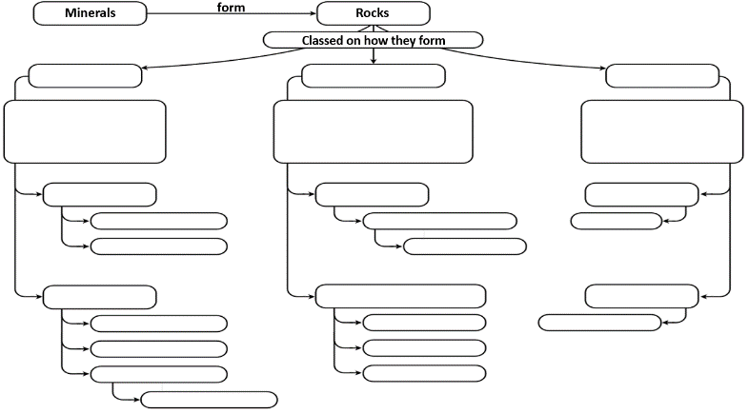  Rough Idea for Flowchart:  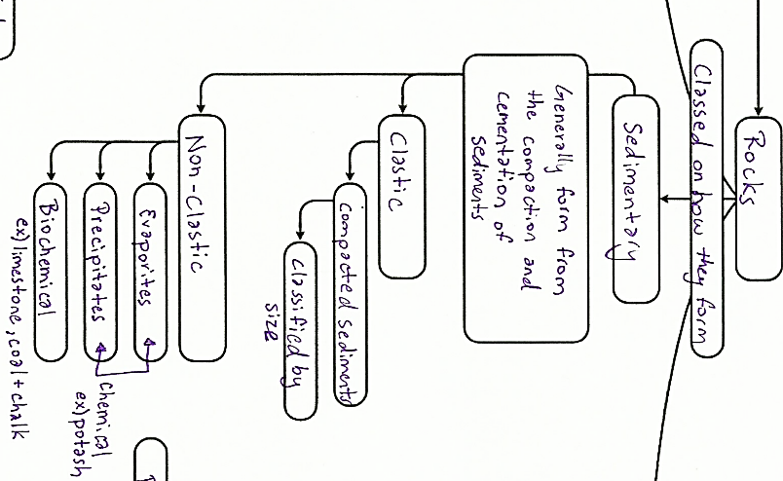  Safety:  - Some samples might be pokey and sharp. Do not throw or toss items to anyone  - If something breaks, inform the teacher immediately  - Return all materials and samples  - Wash hands before and after handling samples  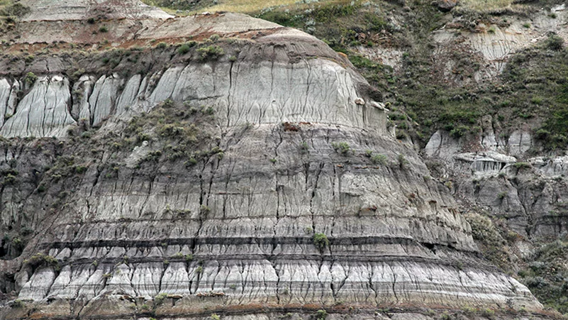  Possible Questions  - How do sedimentary rocks form?  - What are some of the environments that they form in?  - What physical properties do sedimentary rocks have?  - What characteristics can you observe that might be able to help you in describing the sedimentary rocks at your table?  - Is the sedimentary rock clastic or non-clastic, how can you tell?  - What is the grain size?  - Are there any fossils?  - What is the deposition environment that it formed in? How about the energy level?
Stage 4: Determine Evidence for Assessing Learning
Learners will show they achieved the skills by…
- Responses to in class questions and discussions
- Check flowcharts for completion
- Sedimentary depositional environment activity
- Drawing and recording observations of different Sedimentary samples
- Being able to identify different samples based on physical properties (colour, grain size, clastic/non-clastic, setting/deposition environment, energy level…)
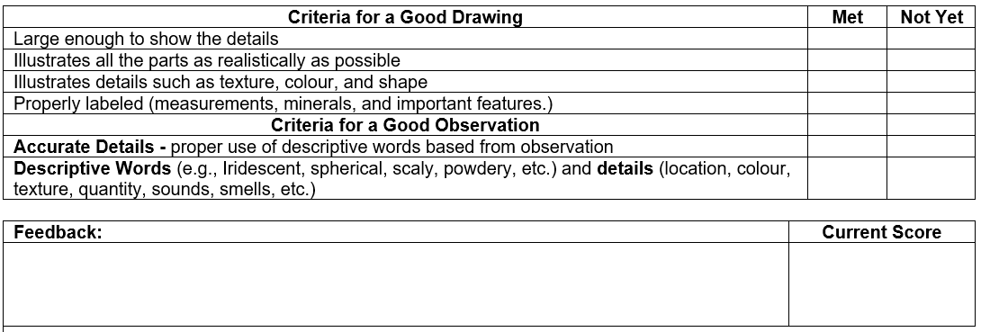
Feedback that students will receive…
- Informal class responses and discussion
- Feedback from identification worksheet
- Feedback from Sed. Depositional environment activity
- Create a Criteria Chart

Extensions
- If you have a microscope and thin section samples of Sedimentary rocks, you can setup a separate station with questions that students have to take turns completing throughout the lab.

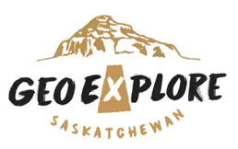
- For younger students, you could simplify the information about the main rock types and instead of labs have students create their own Mineral/Rock ID booklet. Focus on observations rather than correct terminology for physical properties.

Look at the GeoExplore Saskatchewan website for further information and a deeper understanding of the importance of Saskatchewan’s geological history. It is a digital version of the original paper Geological Highway Map of Saskatchewan:

Main Website
https://www.arcgis.com/apps/MapSeries/index.html?appid=a845cbb370f7401597806887318e2676&entry=11
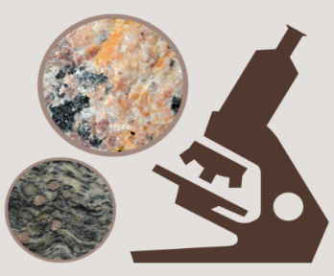
For more background information related to this lesson check out
- Main tab “Geo 101”

Additional Resources
Virtual Hand Samples and Microscope Samples of Rocks
https://www.virtualmicroscope.org/

Name: ____________________

Sedimentary Depositional Environments

Name of the Sedimentary Deposition Environment:

Drawing

Description

Energy Level  (Low)  (High) | Sorting of Sediment  (Well Sorted)  (Poorly Sorted) | Shape of Sediment  (Rounded)  (Angular) | Size of  Sediment  (Fine Grained)  (Coarse Grained) | Sedimentary Rocks
Sedimentary Depositional Environments

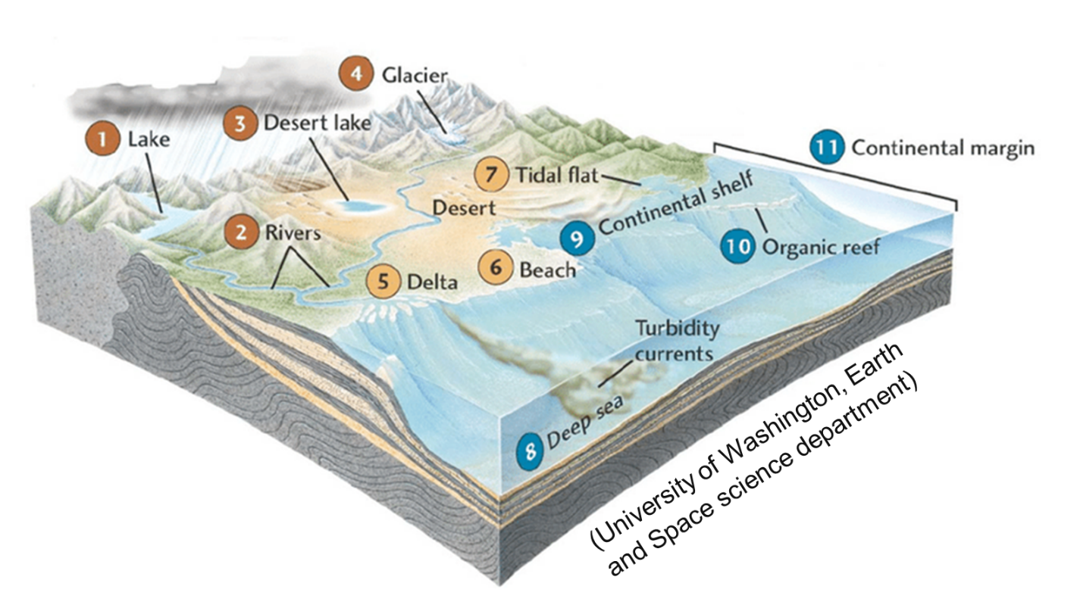
Terrestrial Environment | Description | Sedimentary Rocks
Lake | A deep lake will have muddy sediments, which will form shale. Medium to low energy environment. Some organic material might be present. Grain size will increase closer to shore. Terrestrial and plant fossils possible. Lakes vary widely in size and characteristics (open vs closed system) so the sediment supply can be diverse. There is no “typical” description. | Shale  Siltstone Sandstone
Alluvial Fan | Occurs at the base of a mountain range as a result of gravity (landslides) or water. Sediments on alluvial fans are poorly sorted and have lots of gravel to even boulder sized fragments. Coarse grained sediments with muddy matrix. High energy environment. | Breccia
River | Coarser sediment tumbles along the channel, collecting in ripple beds. As the slope decreases and the energy decreases, finer sediment settles along banks and floodplains. Sorting is poor to moderate depending on how far down the river you are. Rounding of grains depends on how far it has travelled down river. Medium to High Energy. Terrestrial and plant fossils possible. | Conglomerate  Sandstone  Siltstone  Shale
Desert Lake  Evaporite | Water evaporates from a desert lake or a shallow sea and minerals precipitate (Halite or Gypsum). Low energy environment. | Potash  Rock Salt
Desert | Dry exposed ground surface blown by wind and piles into sand dunes. Little rain and sparse vegetation. The sediment quartz rich and is sand sized. The sediments are well rounded and well sorted. Medium Energy. | Sandstone
Glacier | Ice can move any sediment size. As it moves down a mountain it picks up sediment and as it melts it forms glacial till (boulder to clay sized sediment). Unsorted sediments that are sub-angular, polished or striated. Medium to high energy. | Glacial Till  Rock Flour
Swamp | Organic matter from dead plants accumulates in a swamp. Eventually, the organic matter becomes buried in an oxygen depleted water source and forms into coal. Low energy. | Coal
Boundary  Environment | Description | Sedimentary Rocks
Delta | The mouth of a river reduces flowing when enters sea, so lots of sediment settles out in a wedge shape or triangle shape. Fine grained mostly mud with varying energy levels. Root traces and shells are possible. | Sandstone  Siltstone  Shale
Beach | Sand washes back and forth in surf causing well sorted and rounded sediments. Sediment size depends on the source. Most beaches accumulate well sorted and well-rounded sand. High energy level. May have both terrestrial and marine fossils. Carbonates and evaporates can form if the shoreline is hot and dry. Limestone can form too if it is well sheltered. | Sandstone
Tidal Flat | Occur along the shore where tides periodically submerge and expose the shore with in incoming and outgoing tide. Usually have large areas of fine-grained sediments. Low to medium energy levels. Fossils and plant matter possible. | Sandstone  Shale  Peat
Marine Environment | Description | Sedimentary Rocks
Deep Sea | Turbidity currents deposit graded beds. Only fine clay and plankton provide source for sediment. Example: mudstone, chalk, bedded chert. No calcite or limestones are preserved. Based of continental slope. Mostly low energy environment. | Mudstone  Shale  Chert  Chalk
Shelf | Fine grained, well sorted, rounded and habitable by marine organisms (fossils). Affected by waves, storms and tides. Limestones can form if it is well sheltered with little clastic input. Skeletal fragments of reef. Cross-bedding structures. | Sandstone  Shale  Carbonates
Organic Reef | Free of clastic sediments and are warm, clear, nutrient rich water. Hosts many organisms that make up most of the sediment that accumulates. Low energy environment. | Limestone  Carbonates

Name: ________________
Sedimentary GeoExplore Lab
- Wear Safety Goggles
- HCl - use a small amount and dry the sample with paper towel
- HCl will ruin your clothes if you spill it on yourself
- If you notice irritations then wash your hands
- Some samples might be pokey and sharp – use caution
- Return all materials and samples

Background Information: Sediments produced by weathering and erosion form sedimentary rocks through the process called lithification (cementation and compaction). Sediments are the fragments of rocks that have been broken into smaller pieces by the process of weathering. Erosion is the movement of the sediment. Sediment is picked up at one place and moved to another place. The dropping of sediment in a new place is called deposition. This causes sediment to accumulate. The sediments build up into many layers. This causes the bottom layers to squeeze together due to the weight of all the layers above (compaction). The tightly squeezed compacted sediments are glued together. New minerals grow between the sediments and holds together the grains to form a rock (cementation).
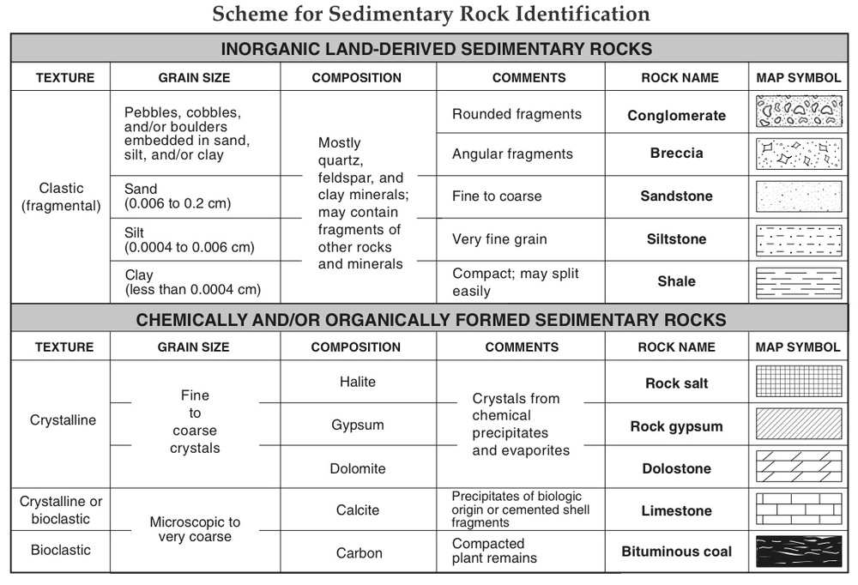
Sedimentary Name: Physical Properties/ Observations
Drawing | Colour
 | Clastic or Non-Clastic
 | Grain Size
 | Deposition Environment
 | Energy of Environment
 | Fossil? What type?
 | Other
 | Other

Sedimentary Name: Physical Properties/ Observations
Drawing | Colour
 | Clastic or Non-Clastic
 | Grain Size
 | Deposition Environment
 | Energy of Environment
 | Fossils? What type?
 | Other
 | Other

Sedimentary Name: Physical Properties/ Observations
Drawing | Colour
 | Clastic or Non-Clastic
 | Grain Size
 | Deposition Environment
 | Energy of Environment
 | Fossils? What type?
 | Other
 | Other

Sedimentary Name: Physical Properties/ Observations
Drawing | Colour
 | Clastic or Non-Clastic
 | Grain Size
 | Deposition Environment
 | Energy of Environment
 | Fossils? What Type?
 | Other
 | Other

Name: ________________
Sedimentary GeoExplore WebQuest
Answer the following questions, and fill in the following boxes by going to GeoExplore Saskatchewan
Where do you find Sedimentary Rocks in Saskatchewan?  (Hint - Sedimentary Basins tab)  - __________________________  - ________________________  Pick your colours to shade in your map that represents the different Sedimentary Rocks.  Why did Sedimentary Rocks form at those locations?  ______________________________________  ______________________________________  ______________________________________  ______________________________________  ______________________________________  ______________________________________ | Shade in the Map showing the location of Sedimentary Rocks in Saskatchewan
______________________________________  ______________________________________  ______________________________________ | Check Mark → The Sedimentary Terminology  ❐ Basalt ❐ Tyndall ❐ Dolostone  ❐ Sandstone ❐ Slate ❐ Athabasca
Circle → True or False  The Athabasca Basin was created by deposition in braided rivers from ancient Saskatchewan mountains.  Evidence of river deposition…  ___________________ | What resources are associated with Sedimentary Rocks in Saskatchewan?  (Hint - Our Resources tab)  1. ___________________________  2.___________________________  3.___________________________  4.___________________________  5.___________________________  6.___________________________
Draw some Sedimentary structures & fossils and Label your drawings

Ask & Answer a question related to this lesson and that can be found in the WebQuest | Conglomerate Cliffs  Where can you find the Conglomerate Cliffs?  ____________________  What is the Cree word for the answer above that means ‘beautiful uplands?’  _______________________  What type of Sedimentary Depositional environment where the Conglomerate Cliffs created from?  ___________________________
Presentation Notes
Slide 1 –
Ask - What does the Grand Canyon, the Pyramids, toothpaste and cement have in common. Answer – They are all made up of Sedimentary rocks.
Ask – Are the layers on the top younger than the layers on the bottom in the photo? Or are the layers on the bottom younger than the layers on the top? Answer – The layers on the bottom are older. The layers on the top are younger. The photo is from the Big Muddy Badlands of Southern Saskatchewan.

Slide 2 -
Engage: Ask – What is the name of the planet in the picture? Answer – Mars
Have you heard any news about Mars or what do you know anything about Mars?
Check out the link on the PowerPoint to learn about Mars.
Possible discussion about the new rover named Perseverance that landed on Mars in February 2021 (Picture on slide). One of Perseverance’s main goals is to look for signs of ancient life and to collect rock samples. Mars has lots of Basalt. Ask – What type of rock is Basalt? Answer – Igneous (If, you did the previous Igneous lesson, then you could ask some review questions or ask what students learned about Igneous rocks.) Ask – Why would I show you Mars when we are going to discuss Sedimentary rocks? Answer - Mars also has Sedimentary rocks. One of the big questions scientists are investigating is if there is life on Mars? Ask – What do you need to support life? Answer – hopefully, a student says water. Then, ask – is there water on Mars or was there ever water on Mars? Listen to students’ answers. Point to the lower picture on the bottom and explain that the rock is a conglomerate. A conglomerate is a type of sedimentary rock. In 2012 Mars rover Curiosity discovered these conglomerate rocks on the surface of Mars. The round clasts (pieces) provide evidence that a beach or river moved the rocks and tumbled them into rounded edges. This conglomerate provides strong evidence that water once flowed on Mars. The same process happens on Earth. We can take what we learn about geology on Earth and use it to understand what is happening on other planets.

Slide 3 - The three main rock groups are Igneous, Sedimentary and Metamorphic. Have students add this to their chart if they have not already. Each rock group should take up a third of the page. This lesson covers Sedimentary Rocks, students should add onto the Sedimentary part of the flowchart.

Slide 4 - Have students add how Sedimentary rocks are formed to their charts. Read ahead before deciding what to do (possible demo opportunity, just need paper and water). Sedimentary rocks are formed by breaking down existing rock into tiny pieces called sediments. The process of breaking down rock is called weathering and when the weather material is moved its called erosion. Then, the sediments are deposited and accumulated and then become buried. The sediments are squeezed and compacted together physically and chemically. The compaction (physical) and cementation (chemical) is known as lithification. The next couple of slides will break it down and define key terms. Ask students what they think the terms “sediments,” “weathering,” “erosion,” and “lithification” mean. You can use paper and water to demonstrate as a teacher demo. Have the students coach you through it asking questions along the way. Tear the paper into tiny pieces (existing rocks breaking down into sediments by weathering and erosion). Then, pile all the sediments together. Try to squeeze the pieces together (compaction). Ask students why it is not working and eventually have them suggest using water to act as a glue (cementation). Then, show students your Sedimentary rock (wet paper ball). You could have students coach you through the demo as they problem solve or it could be more teacher led.
Image – is of Sedimentary rocks at Five Islands, Nova Scotia.
Slide 5 - The next couple of slides are going to explain some words that students might not be familiar with. You can have students underline, highlight, circle, etc. and have them add the definitions to their own flowcharts. Rocks broken down into smaller pieces are called sediments. Sediments range in size from huge boulders to tiny pieces. Big Image – A field geologist is “boulder hopping,” over the Current River in Northern Ontario. Small Image – a farm in Southwestern Saskatchewan suffering from drought. The soil is turning into sand and being blown by wind to create ripples.

Slide 6 - Weathering is the process of breaking down of rock into smaller pieces (sediments). Ask students to give some examples of how rocks can be broken down. Rocks are broken down by wind, water (rain, rivers, waves, and waterfalls), ice, plant roots, animals and chemically. Ask students to explain how water or animals might break down rocks. Erosion is the movement of the sediment. Sediment is picked up at one place and moved to another place. Ask students how sediment can be moved. Sediment can be moved by… wind (air), water, ice (glaciers), gravity (landslides). Deposition is the dropping of sediment in a new place. This piles up (accumulates) sediment. Sediment can be deposited by wind (sand dunes), water (velocity of water decreases and causes sand banks), ice (at the base of a glacier) and gravity (landslides at the base of the mountain). There will be more discussion about deposition later on in this PPT.

Slide 7 - After the sediments are dropped off (deposition) and they pile up (accumulation) the process of lithification happens. “Lithos” means stone, so stoneification or making stone (making rock).
- Compaction (squeezes) the sediments together by building up the sediments into many layers. The bottom layers squeeze together due to the weight of all the layers above. This is a physical change.
- Cementation (glues) the sediments together by new minerals growing between the sediments and holds together the grains to form a rock.

Slide 8 – Review

Slide 9 - A mystery that geologists were trying to solve was how these rocks, some weighing several hundred pounds, moved across the dry lake bed of Death Valley National Park. This mystery has puzzled scientists for more than 60 years! No one actually saw the rocks move, but only saw what you see in the picture. Challenge students to try to solve the mystery. Let students discuss with a partner and come up with an explanation. Ask students to share their explanations. Then, ask students the following questions and let them add to the discussion.
- Are they moved by people or animals?
- Did the rocks slide off the mountains nearby?
- Are they moved by wind?
- Are they moved by ice?
- How do you think geologists solved the mystery? How would you set up your experiment to try and solve the mystery? What equipment might you use, what data would you collect?
Follow the link to review the article with the class.
https://www.sciencenewsforstudents.org/article/solved-mystery-sailing-rocks

Slide 10 - Sedimentary rocks are categorized into two parts. The first part is clastic Sedimentary rocks. Clastic means composed of sediments. It is exactly what we have been discussing. Clastic Sedimentary rocks are composed of broken pieces of fragments (sediments) that have been compacted and cemented together to form a rock. Clastic Sedimentary Rocks are identified by their grain size (sediment size). If you have samples, you can handout different samples, one at a time, showing the differences in grain size. Also, start asking questions to students about what type of environment would they find these at. Begin to talk about energy level and, for example, finding shale in a low energy environment. Or why Breccia has angular grains while Conglomerate has rounded grains.
- Coarse Grained - > 2mm (Conglomerate or Breccia)
- Medium Grained >1/256 - < 2mm (Sandstone)
- Fine Grained - < 1/256 mm (Shale)

Slide 11 - The second part type of Sedimentary rocks are called non-Clastic. These Sedimentary rocks are formed chemically or organically. They are not made of fragments/sediments. The formation of chemical and biochemical sedimentary rocks involves the process of evaporation and precipitation of minerals. If you have samples, you can handout different samples, one at a time, explaining each one.
- Chemical – supersaturated solutions or evaporation (potash)
- Biochemical - formed from the remains of once living organisms or plants (limestone, coal, & chalk)
You can ask students questions – What is potash? What is potash used for? Potash is a potassium rich salt rock that precipitated from very salty seas. We use potash for agriculture around the world. Saskatchewan produces one third of the world’s potash. What is coal made out of? What type of environment would coal form in? Coal is made up of dead plant matter that came from swamps. What is chalk made out of? Chalk is made of really small shells of fossilized marine creatures.

Slide 12 - Hear students’ responses to the question. Answer – Sedimentary rocks can contain fossils because these sediments were deposited on or near the Earth’s surface in the same environmental where plants and animals live. Sedimentary rocks form at temperatures and pressures that generally do not destroy fossils, unlike Igneous and Metamorphic rocks which form deep in the earth at high pressures and temperatures.

Slide 13 - This Sedimentary rock classification chart is included in your lab. You can use it to help you identify the Sedimentary rocks that you will be examining in the lab. This classification chart is divided into Clastic (fragments) or non-Clastic (chemical or organic) rocks. Then, use the combination of the grain size and the comments to help you figure out the rock name. Remember that your observations are important! Don’t change your observations to match the chart or become too focused on the rock name.

Slide 14 - Sedimentary Depositional Environments. Remember when we discussed Mars and I mentioned that one of the reasons why scientists believe that water flowed on Mars was because they discovered a Sedimentary rock called Conglomerate. Conglomerates have rounded sediment edges because water on a beach or in a river tumbled the rock and rounded the edges. Different kinds of Sedimentary rocks form in different environments (locations, energy level, grain size is all linked to this). Just by observing the Sedimentary rock and identifying what it is, we can deduce what type of environment it formed in. Introduce the Sedimentary Depositional Environments activity. Note - it is important that students learn about Sedimentary Depositional Environments before doing the lab.

