Igneous Rocks Lesson & Lab
Subject/Grade: Earth Science 30, Science/7, and Science/4
Created by: Hilary Roemer & Dr. Kate MacLachlan
GeoExplore Tabs: Geo 101 – Rock Cycle – 1.2.6
Stage 1: Identify Desired Results
Earth Science 30
ES30-LS1 Examine the processes that lead to the formation of sedimentary, igneous and metamorphic rocks and minerals. [SI]
Indicator(s):
a) Differentiate the three main rock groups (i.e., sedimentary, igneous and metamorphic) by their processes of formation, including the roles of time, heat and pressure. (K)
g) Classify igneous rocks according to criteria such as method of formation (i.e., intrusive or extrusive) and mineral composition (e.g., felsic or mafic).
h) Explain how geologists can infer how an igneous rock was formed by examining its texture (i.e., intrusive or extrusive).

Science 7
EC7.2 Identify locations and processes used to extract Earth’s geological resources and examine the impacts of those locations and processes on society and the environment.
Indicator(s):
b) Distinguish between rocks and minerals using physical samples, pictures, and/or video recordings and identify the minerals most often found in rocks in Saskatchewan and around the world (e.g., quartz, calcite, feldspar, mica, hornblende).
c) Classify rocks and minerals based on physical properties such as colour, hardness, cleavage, luster, and streak.

EC7.3 Investigate the characteristics and formation of the surface geology of Saskatchewan, including soil, and identify correlations between surface geology and past, present, and possible future land uses.
Indicator(s):
a) Model the processes of formation of the three major types of rocks: sedimentary, igneous, and metamorphic.
c) Construct a visual representation of the rock cycle (e.g., formation, weathering, sedimentation, and reformation) and relate this representation to the surface geology of Saskatchewan and Canada.
d) Develop and use a classification key for rocks based on physical characteristics and method of formation.

Science 4
RM4.1 Investigate physical properties of rocks and minerals, including those found in their local environment. [CP, SI]
Indicator(s):
a) Pose questions about the properties of rocks and minerals (e.g., What is the difference between rocks and minerals? Where do we find rocks and minerals? Do rocks become minerals?).
b) Document the locations and characteristics of rocks that exist in their local environment.
g) Record observations of rocks and minerals using jot notes, labelled diagrams, and charts.
h) Compare the physical properties of rocks and minerals from their local environment with those from other geological areas.
i) Develop their own classification scheme to organize their understanding of rocks and minerals.
k) Differentiate between rocks and minerals.
l) Develop simple generalizations about the physical characteristics of rocks and minerals based on observation and research.

RM4.3 Analyze how weathering, erosion, and fossils provide evidence to support human understanding of the formation of landforms on Earth.
Indicator(s):
c) Explain how rocks can be classified as igneous, sedimentary, or metamorphic based on the processes by which they form.

Key Understandings: (‘I Can’ statements)  I can… describe what a rock is.  I can… explain what an igneous rock is.  I can… make observations that describe the physical properties of igneous rocks.  I can… use observed characteristics of rocks to determine what type of rock I am looking at.  I can… infer the setting this rock was formed in based on its physical properties.  I can… record and organize my observations into a chart. | Essential Questions:  - What is a rock?  - What is an Igneous rock?  - What are some physical properties of igneous rocks that can be used to identify them?  - What setting was this Igneous rock formed in based on your observations?  Concepts:  - Rock Identification  - Physical Properties of Igneous rocks  Scientific Inquiry  - Make observations that describe physical properties of Igneous rocks  - Record and organize observations in a chart format

Stage 2: Teacher Background
This lesson was originally created for older students, but can be adapted for younger students.

Teacher Preparation -
- Have a system to label your rocks. For example, use white out, black permanent marker and clear nail polish to label your rock samples with numbers. Then, create a spreadsheet with the numbered rock labels and the rock name. If you are using borrowed rock kit and cannot label them, then make sure the rocks are in the correct spots of the kit to begin with and then take a picture.

- Divide your class into groups and make rock kits/boxes/trays for each group. Each kit should have four Igneous rocks. During the lab make sure students write down which kit they used, so if you have to double check observations/answers you can find the exact rock that they were observing. Alternativity, you could have students take one rock at a time from a table/collection of rocks.
Stage 3: Learning Plan
Engage Activity:  Ask students, “What is a rock?” and have students write down their answers on sticky notes and stick them on the board. Go over students answers and try to have students participate in a mini discussion about the definition of a rock.  Explain:  During the PPT. students will create a flowchart. Have students use a piece of paper that is 17 by 22 or that will fold into a normal 8.5 by 11 paper.  Depending on the grade, you can use a normal 8.5 by 11 if you think they will have enough room. Have students fold the page into three equal parts. Each third will be for each rock type. Everyone’s flowchart might look different, but that is okay. This is a different way of organizing notes. For younger grades, you may want to create a fill in the blank flow chart based on the information that is relevant to them. In this lesson students will fill in the Igneous section of their flow chart.  New! – Minerals & Rocks Doodle Notes now available  The “Igneous Rocks” PPT. has teacher notes included for each slide to help explain the slide, make it more engaging for students and includes questions you can ask students. Some slides might suggest to pass around a rock sample to help demonstrate a point.  Depending on lesson length –  - If your lesson is 45min to an hour, then you will likely just complete the “Explain” part and you can have students fill out an exit slip. There is an exit slip handout included in this lesson, if you want to use it. Then in the next lesson complete the “Explore” part. Make sure you do a refresher and address the exit slips with the students at the beginning of class.  - If your lesson length is longer, then continue on with the “Explore” part. Students can still do the exit slip at the end of class if you want.  Explore:  Explain that students will work in groups and will have to observe and fill out the worksheet for all four samples that they have at their table. Let the groups pick a box set of Igneous Rocks. Groups will fill out their worksheet individually as they ID 4 different Igneous rock samples based on their observations. Encourage students to create large drawings with labels pointing to certain physical properties. Rotate through the room asking questions regarding the samples and the physical properties they are observing. Re-enforce the new terminology by seeing if students can use it appropriately when observing samples.  Closure:  Once each group has completed their lab, they will explain their findings to the rest of the class through an informal presentation with the name and properties observed. Make sure students wash/sanitize their hands after. Also, students can fill out an exit slip, if they have not already.  Elaborate:  Students can complete a WebQuest about Igneous Rocks specifically related to Saskatchewan. The worksheets are included below. An engage question to serve as a transition/opening depending on class length  - Are there volcanoes in Saskatchewan?  - Were there ever volcanoes in Saskatchewan? | Materials/Equipment:  - Igneous Rocks PPT.  - Appropriate Student Handouts/Worksheets  - Igneous Rock Kits  - Flowchart Paper  - Sticky Notes  - Computers (Elaborate: WebQuest)  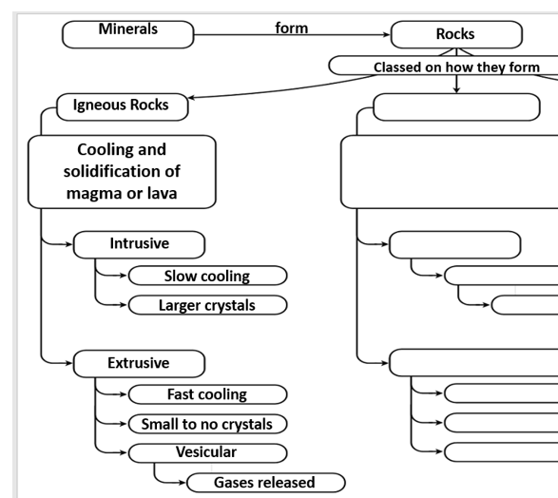  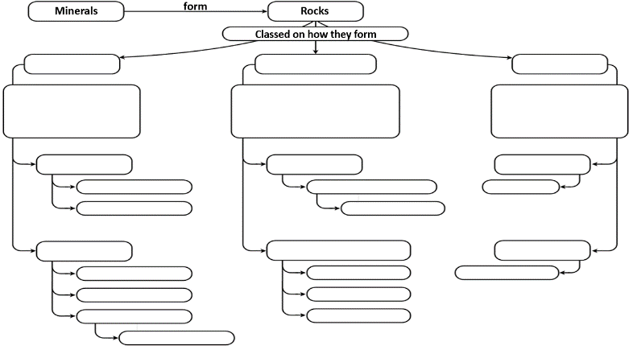  Rough Idea for Flowchart:  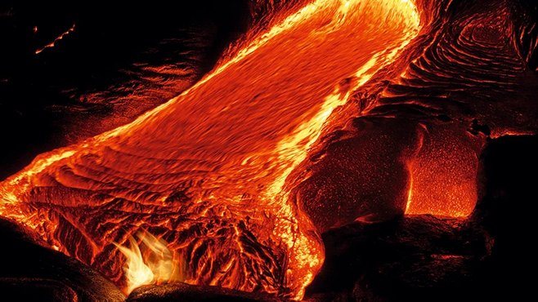  Safety:  - Some samples might be pokey and sharp – use caution  - Do not throw or toss items to anyone  - If something breaks, inform the teacher immediately  - Return all materials and samples  - Wash hands before and after handling samples  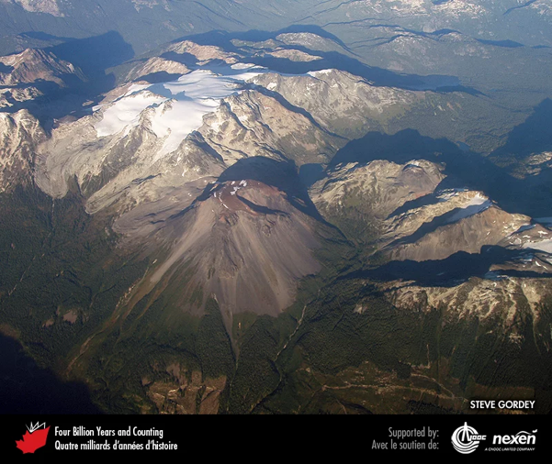
Stage 4: Determine Evidence for Assessing Learning
Learners will show they achieved the skills by…
- Responses to in class questions and discussions
- Exit slip at end of period
- Check flowcharts for completion
- Drawing and recording observations of different Igneous samples
- Being able to identify different samples based on physical properties (texture, crystal size, composition, felsic, mafic, and …)
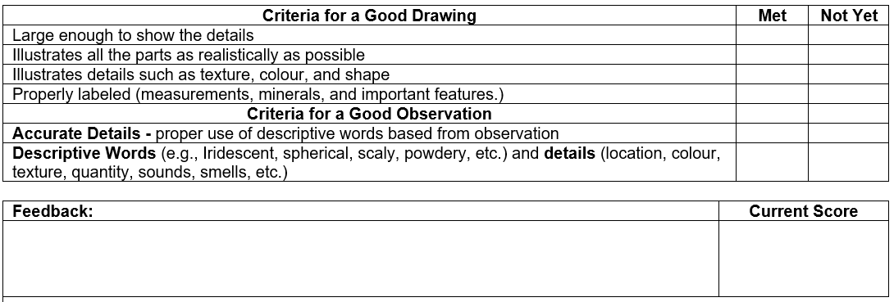
Feedback that students will receive…
- Informal class responses and discussion on trying to identify Igneous rocks
- Feedback from identification worksheet
- Feedback from exit slip for next class time
- Create a Criteria Chart similar to the one shown, to encourage practicing & reflecting on drawing and observation skills. It is important for scientists to communicate clearly by using detailed accurate descriptions with proper terminology and carefully labeled drawings with measurements for reference.

Extensions
- If you have a microscope and thin section samples of Igneous Rocks, you can setup a separate station with questions that students have to take turns completing throughout the lab.

- For younger students, you could simplify the information about the main rock types and instead of labs have students create their own Mineral/Rock ID booklet. Focus on observations rather than correct terminology for physical properties.

Look at the GeoExplore Saskatchewan website for further information and a deeper understanding of the importance of Saskatchewan’s geological history. It is a digital version of the original paper Geological Highway Map of Saskatchewan:

Main Website
https://www.arcgis.com/apps/MapSeries/index.html?appid=a845cbb370f7401597806887318e2676&entry=11
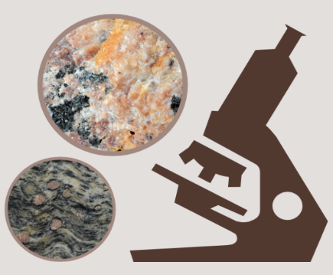
For more background information related to this lesson check out
- Main tab “Geo 101”

Additional Resources
Check out the Doodle Notes for Minerals and Rocks (NEW!)

Virtual Hand Samples and Microscope Samples of Rocks
https://www.virtualmicroscope.org/

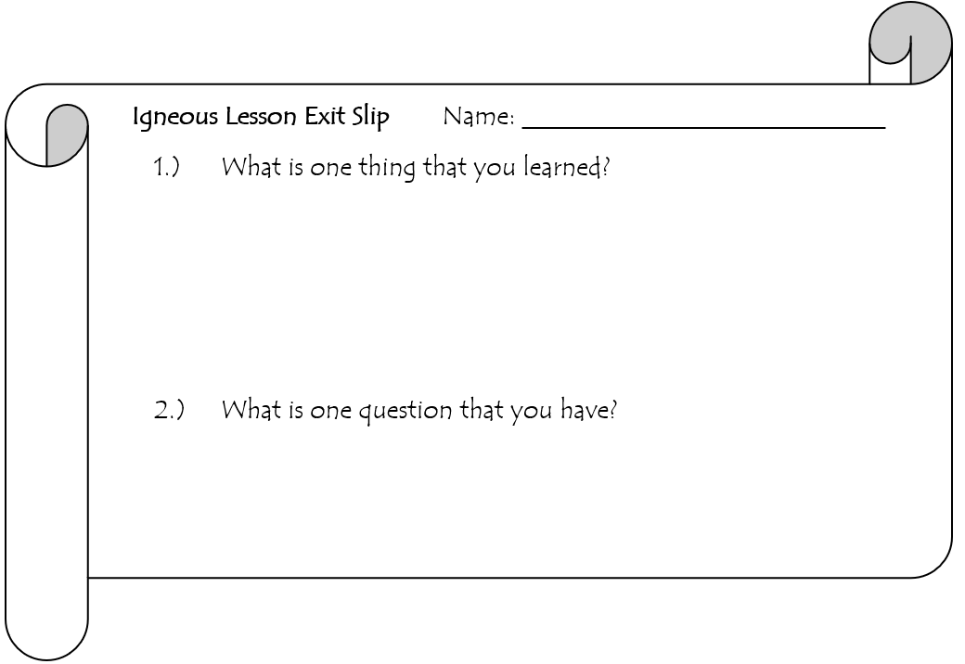
Name: ________________
Igneous Rock GeoExplore Lab Partner:
- Some samples might be pokey and sharp – use caution
- Do not throw or toss items to anyone
- If something breaks, inform the teacher immediately
- Return all materials and samples
- Wash hands before and after handling samples

Background Information: The term “Igneous” was created from the Latin word “ignis” meaning fire. Nearly all of the Earth's crust originates from flowing molten magma deep within the Earth. As magma (below surface) or lava (above surface) cools it becomes solid and forms Igneous rocks. Igneous rocks can be classified according to their texture and composition.

Texture:
- Fine grained – minerals in Igneous rocks that are really tiny or not clearly visible with the eye caused by fast cooling above the surface (Extrusive).
- Vesicular – some extrusive Igneous rocks may have a bubbly texture from gas escaping.
- Coarse grained – minerals in Igneous rocks that are visible with the eye caused by slow cooling below the surface (Intrusive).

Composition: we will visually examine colour of the overall sample by comparing the light and dark minerals in order to understand a little bit about composition. Felsic rocks are rich in Si and Al. Mafic rocks are rich in Fe and Mg.
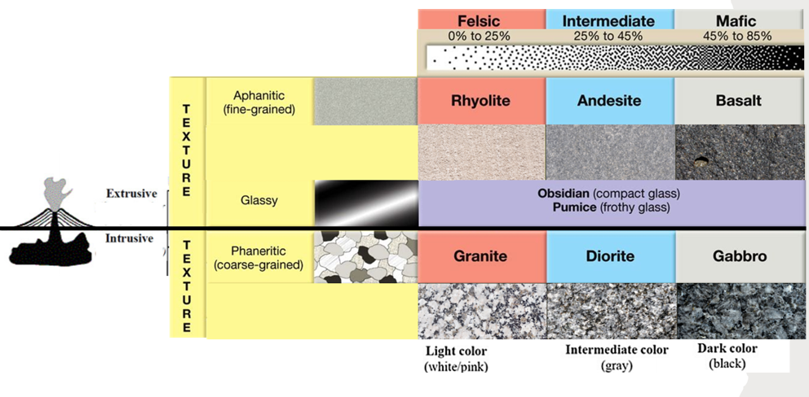

Igneous Name: Physical Properties/ Observations
Drawing | Texture
 | Colour of Minerals
 | Felsic/ Int/ Mafic Composition
 | Extrusive/ Intrusive
 | Cooling Speed
 | Other

Igneous Name: Physical Properties/ Observations
Drawing | Texture
 | Colour of Minerals
 | Felsic/ Int/ Mafic Composition
 | Extrusive/ Intrusive
 | Cooling Speed
 | Other

Igneous Name: Physical Properties/ Observations
Drawing | Texture
 | Colour of Minerals
 | Felsic/ Int/ Mafic Composition
 | Extrusive/ Intrusive
 | Cooling Speed
 | Other

Igneous Name: Physical Properties/ Observations
Drawing | Texture
 | Colour of Minerals
 | Felsic/ Int/ Mafic Composition
 | Extrusive/ Intrusive
 | Cooling Speed
 | Other

Name: ________________
Igneous Rock GeoExplore WebQuest
Answer the following questions, and fill in the following boxes by going to GeoExplore Saskatchewan

Where do you find Igneous Rocks in Saskatchewan?  (Hint - explore Canadian Shield tab)  - __________________________  - ________________________  Pick your colours to shade in your map that represents the different Igneous Rocks.  Why did Igneous Rocks form at those locations?  ______________________________________  ______________________________________  ______________________________________  ______________________________________  ______________________________________  ______________________________________ | Shade in the Map showing the location of Igneous Rocks in Saskatchewan
______________________________________  ______________________________________  ______________________________________ | Check Mark → The Igneous Terminology  ❐ Basalt ❐ Gneiss ❐ Batholith  ❐ Sandstone ❐ Mafic ❐ Kimberlite
Circle → True or False  “About 2050 million years ago, the Manikewan Ocean began to form in northern Saskatchewan.”  Evidence for the Manikewan Ocean…  ___________ _______________ | What resources are associated with Igneous Rocks in Saskatchewan?  (Hint - explore Our Resources tab, especially the sub tab Minerals and Mines)  1. ___________________________  2.___________________________  3.___________________________  4.___________________________  What does VMS Stand for?  V M S
Draw the uses of the resources associated with Igneous Rocks and Label the resource

Ask a Question related to this lesson and that can be found in the WebQuest | Swap papers and have a classmate answer the question or answer it yourself  Who answered? __________________

Presentation Notes
Slide 1 – Fact: the term “Igneous” was created from the Latin word ignis meaning fire.

Slide 2 - Review student’s definitions of a rock and compare it to the sticky note definition on the slide. Ask students what “naturally occurring” means and what “aggregate” means. Tell students rocks are made up of minerals. If you look close enough, you can see the different minerals. Show and pass around a rock sample (e.g. Granite) that students can easily see different minerals making up the rock. If you pick Granite tell students that the slightly pink minerals are microcline feldspar, the white minerals are plagioclase feldspar, the milky grey minerals are quartz, and the black minerals are biotite and hornblende. Have students begin their flowcharts. Students can center this at the very top of their page. Explain that minerals make up rocks and that rocks are classified or organized into three groups based on how they form.

Slide 3 - The three main rock groups are Igneous, Sedimentary and Metamorphic. Have students add this to their chart. Each rock group should take up a third of the page. This lesson covers Igneous Rocks, so students should continue to add onto the Igneous part of the flowchart.
Did you know??? The oldest rocks in Saskatchewan are about 3.3 billion years old and are located north of Lake Athabasca.

Slide 4 - Nearly all of the Earth's crustal material originates from flowing molten magma deep within the Earth. As magma or lava cools it becomes solid and forms Igneous rocks. Ask - What does solidification mean? Answer – turning into a solid. Ask – what is the difference between magma and lava? Answer – magma forms below the surface and lava is when it is above the surface. Have students add the definition to their flowchart. Ask – Where do you think this picture might be from? Do we have volcanos in Canada? Answer – The picture is of Ring Mountain in British Columbia. It is a volcano called Tuya and was active around 2.5 million years ago.

Slide 5 - Igneous rocks can be divided into two groups: Extrusive and Intrusive. Have students copy the diagram and the words into their flowcharts. Give students time to do this before explaining. Extrusive Igneous rocks formed at the surface. They cool faster causing minerals to be tiny and it creates a fine-grained texture. Pass around a sample of an Extrusive Igneous rock (Andesite, Rhyolite or Basalt). Emphasize the fine-grained texture is caused by fast cooling so minerals do not have enough time to grow larger. Also, some extrusive Igneous rocks may have a bubbly texture called vesicular, caused by gas bubbles. Pass around a sample of vesicular basalt. Collect the samples back. Intrusive Igneous rocks form below the surface of the earth. These rocks take a long time to cool causing large minerals to form and it creates a coarse-grained texture. Pass around a sample of an Intrusive Igneous rock (Granite, Diorite, or Gabbro). Collect the samples back.

Slide 6 - Think, Pair, Share…
- What happens when an Igneous rock cools super-fast? – Follow up questions – What would cause an Igneous rock to cool really fast? Would it be Extrusive or Intrusive? When an Igneous rock cools really fast, there is not enough time for minerals to grow. It forms a glass with sharp edges. This rock is called Obsidian. Obsidian was important for many Indigenous Peoples around the world because it was a good resource for making spearheads, knifes, and arrowheads. Obsidian usually is black, but can vary in colour. If you have a sample, you can pass it around.
- What happens when an Igneous rock cools really slowly? – Follow up questions – What would cause an Igneous rock to cool really slowly? Would it be Extrusive or Intrusive? How big could the minerals get? You might think that if a Igneous rock cooled really slow that the minerals would be really large, however there are other factors than just cooling rate. For example, Pegmatites have very large crystals because water was present and the minerals had space to grow occurs this way but there are other factors like the influence of fluids and the amount of space available that are the main reasons why the minerals grow so big. In other words, there is a limit to how big minerals in Igneous rocks can grow even if you have super slow cooling. It is a combination of factors that might make the minerals huge, not just one. If you have a sample, you can pass it around.

Slide 7
… Think, Pair, Share…
Can an Igneous rock float on water? – Follow up questions – If a rock could float on water what physical properties does it need to have? What about texture? Hint – it is almost like a mixture of two igneous rocks that were discussed before…. have students share their ideas (Obsidian and Vesicular basalt). What characteristics might this rock have, if it shares similar characteristics between Obsidian and Vesicular Basalt? Obsidian cools really fast so it is glassy in texture. Vesicular Basalt has holes where the gas escaped.
Answer – Yes. Pumice is an example of an Igneous rock that can float on water. It forms from explosive eruptions and it cools really fast while lots of gas is escaping. Pumice is vesicular and glassy. It has lots of holes and interconnected tunnels (porous) that make it light and able to float. It can be as small as dust particles to as big as a house. Sometimes underwater volcanos will produce so much pumice that floats it creates a floating island in the ocean that can be seen from space. Pumice has baffled scientists because sometimes it floats, sometimes it sinks and sometimes it does both like a lava lamp. Challenge students to try to Solve the Mystery with ideas of their own. If you have pumice, you can do your own class experiment with it.
- https://www.universityofcalifornia.edu/news/solving-mystery-floating-rocks-pumice

Slide 8 -
So far, the major physical property that we looked at is texture. Texture or how big or small the minerals are can tell us a lot about where the Igneous rock formed. Another important physical property is composition. Geology involves knowing many different fields of science including chemistry and physics. Ask students if they can name the elements based on the symbols for the elements. Answer – Si (Silica), Al (Aluminum), Fe (iron) and Mg (Magnesium). If you take a university geology course, you will slowly learn more about the chemistry involved. We will use colour as a way of interpreting chemical composition. Typically, dark minerals are rich in Fe and Mg and light minerals are rich in Si and Al. Have students add this to the bottom of their flowchart in the Igneous section (only the part that is in the box).
- Felsic – igneous rocks that are lighter in colour. These rocks are usually rich in Si and Al causing the formation of feldspar and quartz. The most common felsic Igneous rock is Granite. Felsic magmas/lavas form at lower temperatures and are thick and sticky. They will most likely have explosive eruptions from a volcano.
- Intermediate – igneous rocks that are greyish in colour with sub-equal proportions of dark and light minerals.
- Mafic – igneous rocks that are dark in colour. These rocks are Fe and Mg rich causing the formation of olivine, pyroxene, amphibole, and biotite. The most common Mafic Igneous rock is Gabbro (intrusive) or Basalt (extrusive). Mafic magmas are generally less explosive because they form at higher temperature and are less viscous (runnier). In addition to temperature, the amount of silica (Si) affects how thick (viscous) the magma is. More silica makes it stickier. That’s another reason why felsic magma is more viscous.
You could go on YouTube and look up volcanic eruptions. Also, you could discuss current news about volcanoes around the world because usually there is something happening.

Slide 9 –
This Igneous rock classification chart is included in your lab. You can use it to help you identify the igneous rocks that you will be examining in the lab. This classification chart focuses on texture and composition (Felsic, Intermediate, and Mafic) to help you identify common Igneous rocks. Point out certain things on the chart (texture section, composition, basic rock types, intrusive extrusive divide, etc.). Depending on class time, you can begin to explain the lab and your expectations or have students complete an exit slip. The composition is based on the proportion of dark minerals. Granite is commonly pink because orthoclase (potassium feldspar) commonly contains inclusions of iron oxide.

