The Rock Cycle Bill Nye & Lab

Subject/Grade: Earth Science 30, Science/7, and Science/4

Recreated by: Hilary Roemer & Dr. Kate MacLachlan

GeoExplore Tabs: Geo 101 – Rock Cycle – 1.2.5

Stage 1: Identify Desired Results
Outcome(s)/Indicator(s)

Earth Science 30
ES30-LS1 Examine the processes that lead to the formation of sedimentary, igneous and metamorphic rocks and minerals. [SI] Indicators
e) Differentiate among the three main rock groups (igneous, sedimentary and metamorphic) by their processes of formation, including the roles of time, heat and pressure. f) Outline the basic transitions inherent in the rock cycle and the forces that disrupt equilibrium to cause these transitions.

Grade 7 Science
EC7.3 Investigate the characteristics and formation of the surface geology of Saskatchewan, including soil, and identify correlations between surface geology and past, present, and possible future land uses. [DM, SI] Indicators
a) Model the processes of formation of the three major types of rocks: sedimentary, igneous, and metamorphic.

Grade 4 Science
RM4.1 Investigate physical properties of rocks and minerals, including those found in their local environment. [CP, SI]
Key Understandings: (‘I Can’ statements)  I can ... explain what ‘geology’ means.  I can ... describe what a geologist does and why they are important.  I can ... differentiate among the three main rock types – Igneous, Sedimentary and Metamorphic.  I can ... explain the basic transitions within the rock cycle. | Essential Questions:  - How would you define geology?  - How would you define a geologist?  - What does a geologist do?  - Explain the rock cycle?

Stage 2: Teacher Background

What is the rock cycle? In this lesson students will develop a deeper understanding of the rock cycle by watching a Bill Nye the Science Guy video and by using Starburst candy to recreate a model the rock cycle.
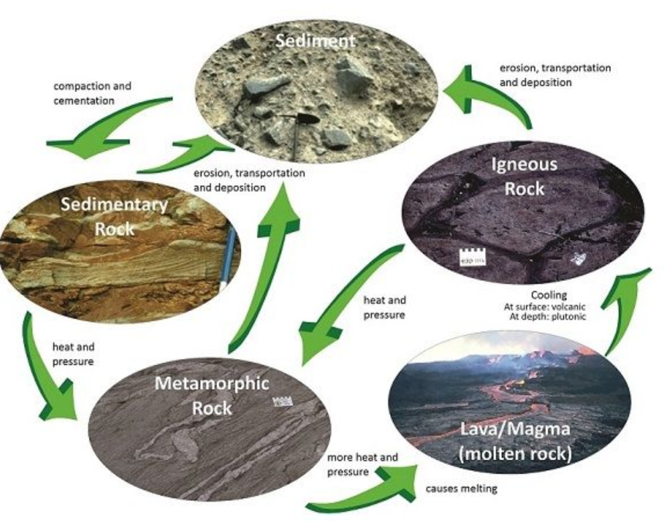
Vocabulary
Rock Types: rocks are classified into three main types based on how they formed, which can be represented by a diagram called the rock cycle.
- Igneous - derived from the Latin word ignis meaning fire. These are rocks formed from the solidification of molten (melted) material (magma = underneath surface or lava = above surface).
- Metamorphic - change form or shape. Rocks change into a different rock because of heat and pressure.
- Sedimentary - rocks that form by the compaction (squeezing) and cementing (gluing) together of small particles (sediments).

Rock Cycle Lab Explanation

Each group receives three different colours of unwrapped Starburst candy and scissors.
- Sediments - take the three Starbursts and use scissors to cut them into pieces. Draw a picture of your sediments. Words used to describe this = weathering, erosion, breakdown, pieces…
- Sedimentary Rock - take all of the pieces and squeeze them together into a solid form. Draw a picture. Words used to describe this = compaction, cementation, squeezing, gluing….
- Metamorphic Rock - Students will take their solid form and add heat from the hands and pressure from their hands to squish it into a pancake. Students can use books to help. Draw a picture. Words used to describe this = heat, pressure, squish, flatten, bend, fold, align….
- Lava/Magma - students will put their solid form on wax paper and put it in the microwave for 10 second increments or use a hot plate and make a foil bowl. Put up a sign on safety and instructions or guide students, depending on age. Draw a picture. Words used to describe this = heat, pressure, melt, molten, liquid, flow…
- Igneous Rock - set the ‘magma’ on a table and observe it as it cools. Draw a picture. Words to describe this = cool, solid, solidification, crystalize…

Note students may do this in a different order or figure out how to include the other arrows in the rock cycle (for example melting a sedimentary rock to form an igneous rock or using scissors to cut an igneous rock into sediments). For best results, you don’t want all the colours muddled together by melting it first.

Stage 3: Build Learning Plan
Set (Warm-up, Focusing the Learning): Time: 20min  - Play the Bill Nye Video as learners complete their fill in the blank worksheets about the rock cycle.  - Look up on YouTube “Bill Nye the Science Guy – S03E04 Rocks & Soil.”  Development: Time: 30 – 40min  - Explain to students that they will create their own rock cycle by completing an inquiry lab activity. Students will fill in their own rock cycle by drawing observations in the circles and by using arrows and words to describe how to get from one circle to another.  - Discuss lab safety  - Each group will receive three different colours of Starburst candy and tell students to start with sediments.  - Provide guidance  - Have students do the igneous rock last because all of the colours will mix together or have lots of extra Starbursts.  Learning Closure: Time: 5 – 10min  - Have students clean up  - Discuss the rock cycle by having groups come up to the board to help fill in the rock cycle diagram projected onto the board. Ask questions to check for understanding.  - If students are missing arrows help them fill in the arrows by demonstrating with the Starbursts or by asking questions.  - Show students the picture of the rock cycle.  - If there is time, you can do the extension activity |  | Materials/Equipment:  - Rock Cycle Worksheets  - Different coloured Starburst Candies (3 per group)  - Scissors  - Microwave and wax paper  Or Hotplates and tin foil  Safety Considerations:  Microwave  - Use wax paper and be careful not to spill hot starburst liquid on yourself or others  - Use the microwave in 10 sec increments  - Do not overheat  Hotplate  - Be careful not to burn yourself  - Use tin foil and create a bowl or plate with raised edges  - Do not spill hot starburst liquid on yourself or others  - Do not overheat

Stage 4: Determine Evidence for Assessing Learning
- Can mark the fill in the blank and the starburst rock cycle together as a class at the end of the lesson when reviewing together and then record student marks.
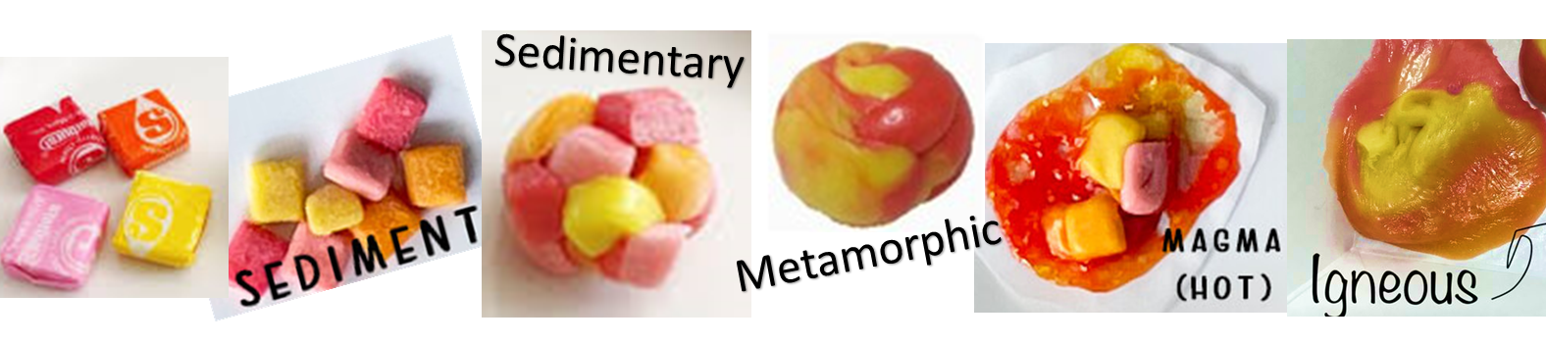
- Can have learners complete a self-assessment. An example is included at the end.

Extensions
Activity -
Each group will get three rocks - a rock representing each rock type. Have students place the rocks where they think they belong on the rock cycle by classifying them into the appropriate rock types. Have groups discuss how they classified the rocks. Check in with groups as they are working and challenge them to try to place them all correctly. Ask them questions. Once the groups are ready, do a final check where you tell them which belong where. Note - this can become very competitive.

Use rock samples that are very distinguishable for that rock type.
- Sedimentary - conglomerate, sandstone, samples with fossils
- Metamorphic - samples with foliation (gneiss and schist)
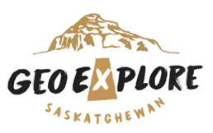
- Igneous - vesicular (filled with holes) samples (e.g., vesicular basalt) or amygdaloidal (holes have been filled with minerals)

Resource -
Look at the GeoExplore Saskatchewan website for further information and a deeper understanding of the importance of Saskatchewan’s geological history. It is a digital version of the original paper Geological Highway Map of Saskatchewan:

Main Website
https://skgeolhighwaymap.maps.arcgis.com/apps/MapSeries/index.html?appid=a845cbb370f7401597806887318e2676

For more background information related to this lesson check out
- Main tab “Geo 101”

Additional Resources
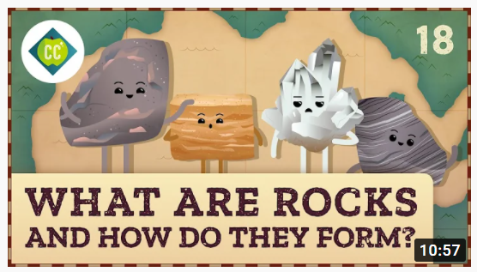
What Are Rocks and How Do They Form? Crash Course Geography #18

Recommendations
Slow it down! Lots of information at once.
Good summary/connecting ideas video after learning about layers of the Earth, plate tectonics and minerals & rocks.

https://www.youtube.com/watch?v=7Bxw4kkeHJ8

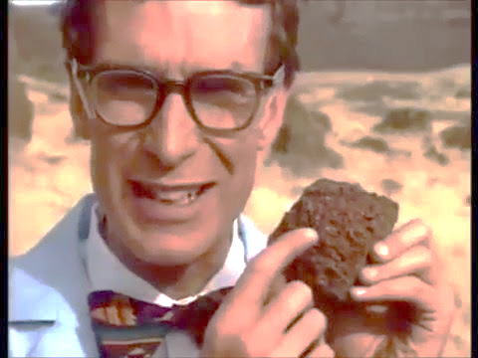
The Rock Cycle
Fill in the Blanks: The words can be used more than once.
Fire Wind Rock Cycle
Rain Sedimentary Three
Billions Metamorphic Volcanoes
Sediment History Weathering
Changing Shifting Diamond

- Different rocks form in different ways. When you are looking at a rock, you are looking at __________________.
- ___________ and __________ moving over the Earth’s surface break rock down.
- This process where rocks are broken down and reformed has been going on for _______________ of years.

- Scientists like to think of ____________ types of rocks.

- Igneous comes from the word __________. Igneous rocks form by melting other rocks into hot magma/lava and then they cool down to form new rocks.

- ________________ can be sand, silt or mud. Sediments are squeezed and glued

together by compaction and cementation to make __________________ rocks.

- ______________________ rocks are formed by heat and pressure acting on a pre-existing rock to cause change.

- Rocks are always _______________ and are part of the _________ _________.

- The reason why we have _______________ and earthquakes is because the Earth’s

crust is made of gigantic _____________ of rocks that are shifting.

- Soils are formed in layers by rocks ______________ down by erosion into sediments.

- _______________ are associated with ______________. Coal under pressure will NOT turn into diamond, even though they are both made of carbon.

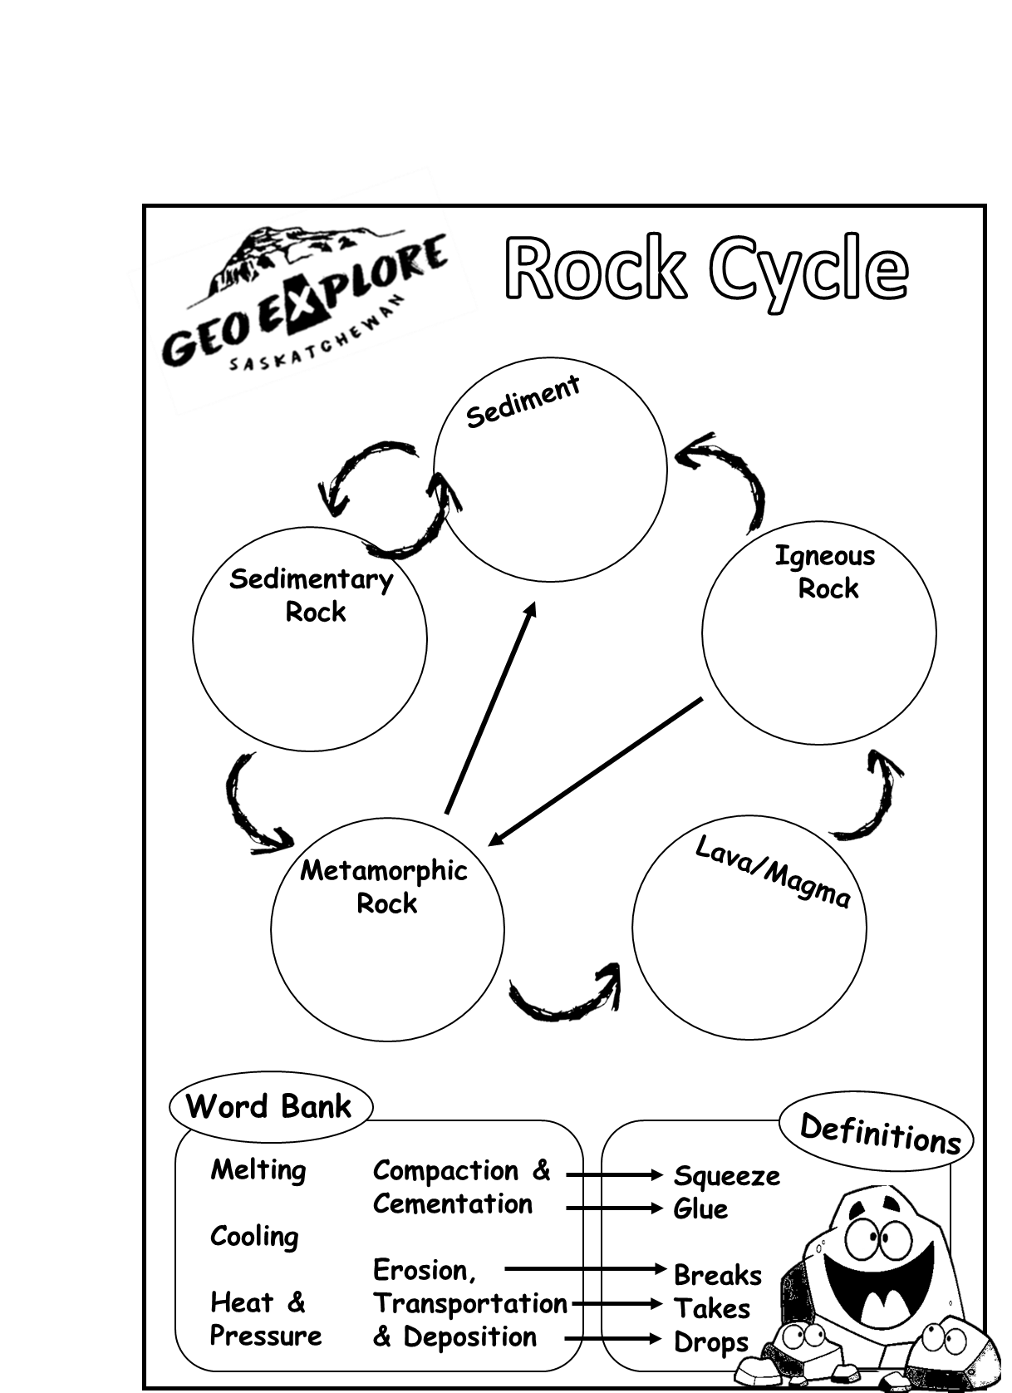

Name: ___________________
Self-Assessment Topic:
Where do you think you are at in terms of reaching the outcome/learning goal for the “Topic?”
Exceeding (+4) | Meeting (+3) | Progressing (+2) | Beginning (+1)
Did you participate equally and collaborate with other peers? |  |  |  | Yes (+1) | No
Did you put your best effort into completing the worksheet/activity? |  |  |  | Yes (+1) | No
Did you have neat & detailed writings/drawings that show critical thinking? |  |  |  | Yes (+1) | No
Did you act in a respectful, responsible, and safe manner? |  |  |  | Yes (+1) | No
Did you ask/answer questions about the topic to your peers or teacher? |  |  |  | Yes (+1) | No
Did you clean up your lab station and put materials away properly? |  |  |  | Yes (+1) | No

Grade _____ / 10

Name: ___________________
Self-Assessment Topic:
Where do you think you are at in terms of reaching the outcome/learning goal for the “Topic?”
Exceeding (+4) | Meeting (+3) | Progressing (+2) | Beginning (+1)
Did you participate equally and collaborate with other peers? |  |  |  | Yes (+1) | No
Did you put your best effort into completing the worksheet/activity? |  |  |  | Yes (+1) | No
Did you have neat & detailed writings/drawings that show critical thinking? |  |  |  | Yes (+1) | No
Did you act in a respectful, responsible, and safe manner? |  |  |  | Yes (+1) | No
Did you ask/answer questions about the topic to your peers or teacher? |  |  |  | Yes (+1) | No
Did you clean up your lab station and put materials away properly? |  |  |  | Yes (+1) | No

Grade _____ / 10

