Mineral Uses Lesson

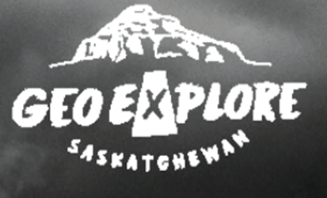
Subject/Grade: Earth Science 30, Grade 7 Science & Grade 4 Science

Created by: Hilary Roemer & Dr. Kate MacLachlan, P.Geo.

GeoExplore Tabs: Geo 101 – Rock Cycle – 1.2.4

Stage 1: Identify Desired Results
Outcome(s)/Indicator(s)
Earth Science 30 ES30-LS1 Examine the processes that lead to the formation of sedimentary, igneous and metamorphic rocks and minerals. [SI] Indicator(s): (p) Research the ways in which society makes use of minerals and rocks for various purposes such as art, architecture, industrial materials and energy resources.
Grade 7 Science EC7.2 Identify locations and processes used to extract Earth’s geological resources and examine the impacts of those locations and processes on society and the environment.
Grade 4 Science RM4.2 Assess how human uses of rocks and minerals impact self, society, and the environment. [DM] Indicator(s): b) Identify objects in their local environment that are made from rocks and minerals (e.g., nickel, table salt, pottery, cement, brick, jewelry, bicycle, nutrients, battery, copper wiring, soda can, plumbing pipe, and sidewalk). c) Research historical (e.g., flint arrowheads, gold jewelry, paint pigments, and coal heating) and contemporary (e.g., fertilizer, building products, ceramics, glass, salt, silver fillings, and electronics) uses for rocks and minerals in Saskatchewan. f) Identify locations where minerals, including potash, sodium sulphate, salt, kaolin, uranium, copper, coal, diamond, and gold, are extracted in Saskatchewan.
Key Understandings: (‘I Can’ statements)  I can ... collaborate and communicate with others in order to explain how minerals are used in my everyday life.  I can … explore how an object can be dissected into the minerals that it is made up of and where those minerals come from. | Essential Questions:  - How do you use minerals in your everyday life?  - What are the top ten uses for minerals in our society?  - What minerals make up certain everyday objects (pencil, lightbulb, etc.)?  - Where do minerals come from?

Stage 2: Teacher Background
This lesson covers mineral uses by having students participating in a classroom challenge done in groups. At the end of the challenge students collaborate to create a top ten list that covers all categories of mineral uses. Then, students explore an ordinary everyday object and dissect it into all the minerals that it is made up of. Students create a poster/doodle note page dissecting their object into its minerals. This lesson was originally designed for older students but can be adapted to younger students or give you ideas/resources to create your own lessons.

Stage 3: Build Learning Plan
Engage:  - Pass out the student handouts. Have students complete the first page of the worksheet where they reflect on the minerals they used so far today. They can write down the products or mineral names.  - Then, have students share some of their responses.  Development:  101 Challenge -  - Explain the rules of the challenge – in small groups students will write down 101 uses for minerals on chart paper or whiteboards. They can use laptops, I-Pads or cellphones to help with some research. For every ten uses students will switch the colour that they use on the chart paper and there can be no repeats. Also, writing has to be legible. Once a group has 101 uses, they will ask for the teacher/judge. To win students have to be the fastest to get judge approved check.  - The prizes are small school supplies items, snacks, etc.  - Everyone will get a prize if they finish the 101 Challenge, but the prizes are selected by the students in the order that they finish in.  - Have students develop a top ten broad category list for mineral uses. Then have a class discussion combining everyone’s top ten list together into one. Students will write the final top ten list on their student worksheets.  Explore & Explain:  Students will pick an object to research and create a doodle notes page or poster that explains the minerals within the object.  - Handout the Mineral Dissection project and set a due date  - Explain the project and how you are grading it  - Let students work on the project for the remaining class and the rest of next class.  - Have students briefly informally present what object they picked and a key takeaway that they learned at the beginning of next class. Have students’ hand in their mineral dissections. |  | Engage & Explain Materials/Equipment:  - Student Handouts  - Chart Paper or Whiteboards  - Markers or Whiteboard markers  - Optional Prizes (snacks, stationary, etc.)  - Laptops / I-Pads / Cellphones  - Blank Paper & colouring supplies or Poster paper & poster supplies  Example – Final Top Ten List  - Infrastructure / Building Materials  - Religion  - Resources / Economics  - Electronics / Technology  - Art / Recreation  - Health (Human Body)  - Agriculture  - Animals / Plants  - Formation of Soil  - Transportation

Stage 4: Determine Evidence for Assessing Learning
Learners will show they achieved the skills by…
- Informal responses to in class questions and discussions.
- Participating in the 101 Uses of Minerals Challenge
- Creating a Mineral Dissection of an object – an outline of criteria is included within the handouts. The “x4” on the handout means at least four minerals identified, explained and mention of mining locations.

Feedback that students will receive…
- Informal class responses and discussion on mineral usage
- Teacher feedback on their Mineral Dissection Project

Extensions
Look at the GeoExplore Saskatchewan website for further information and a deeper understanding of the importance of Saskatchewan’s geological history. It is a digital version of the original paper Geological Highway Map of Saskatchewan:

Main Website: https://skgeolhighwaymap.maps.arcgis.com/apps/MapSeries/index.html?appid=a845cbb370f7401597806887318e2676

Other Resources of Interest
- Under “Our Resources” in GeoExplore there is a subtab about Sask’s Critical Minerals
- Minerals and Metals Facts (nrcan.gc.ca)
- https://mineralseducationcoalition.org/
- In what ways do you interact with minerals in your daily life?
https://www.youtube.com/watch?v=1BFPmxBMFOI
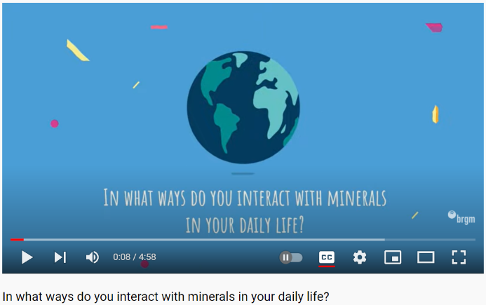

Name: ___________________________

Dig A Little Deeper: Mineral Uses
Think About It: Many people take the presence of minerals in their lives for granted. But if you stop to think about it, without minerals, society as we know it would cease to function. Life in our homes, our schools, and our places of work depends on the constant supply of minerals.

Minerals are a part of our everyday lives. They are found in everything including within ourselves. We depend on them to live. Think back throughout today and list 10 different ways that you have used minerals.

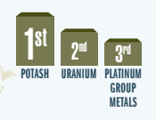
In 2019 globally Canada ranked
1st in Potash production, 2nd in Uranium
and 3rd in Platinum Group Metals
(Ref NRCAN ).

Class Collaboration: Top Ten Mineral Uses in Society

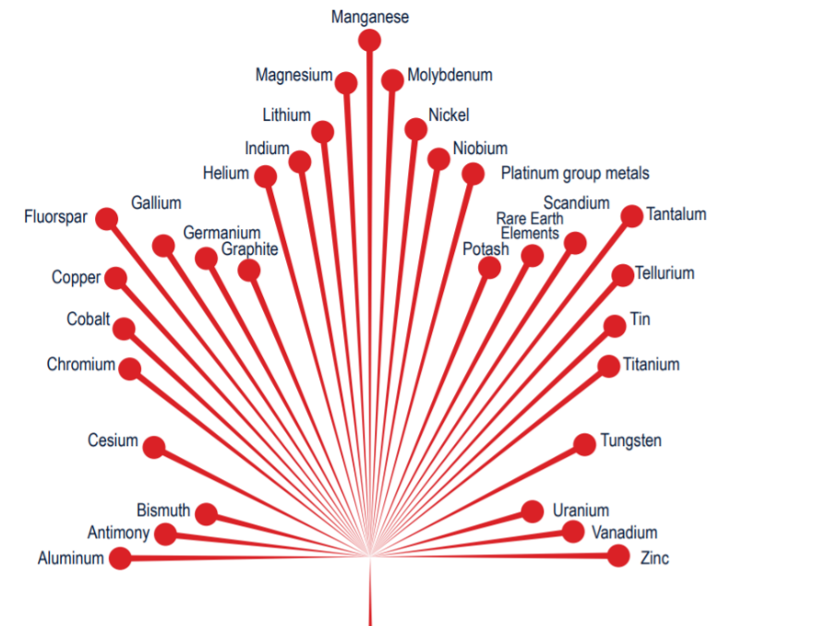

The list of critical minerals is country-specific but commonly includes 35 minerals, metals and gases. Twenty-two of these occur in Saskatchewan, notably potash, uranium, helium and lithium.
Name(s): ___________________________

Mineral Dissection

Pick an object or item, for example a lightbulb, and create a poster or doodle notes page that dissects the object into the minerals that it is made up of.

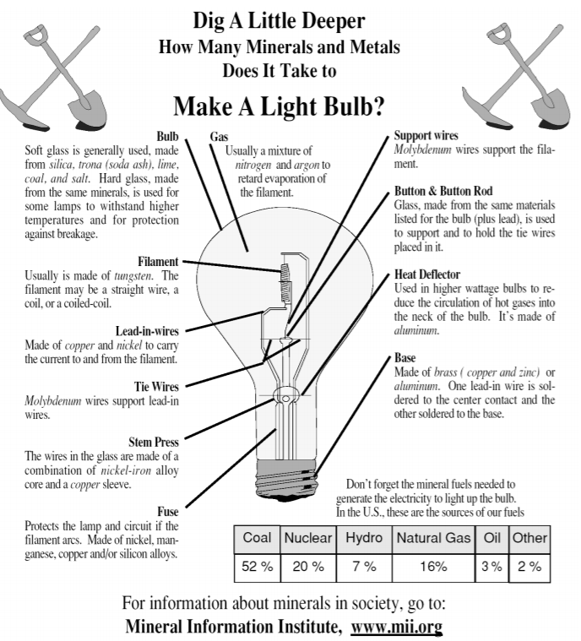
Include:

- Name of the object (1)

- Drawings (1)

- Question with answer somewhere within your mini poster/doodle notes (1)

- Fun Fact (1)

- Minerals with a small description (4)
- Where the minerals are mined (4)

- Creativity & Effort (2)

_________ /14

Teacher Feedback

