Mineral Formation Lesson & Lab

Subject/Grade: Earth Science 30

Created by: Hilary Roemer & Dr. Kate MacLachlan

GeoExplore Tabs: Geo 101 – Rock Cycle – 1.2.3

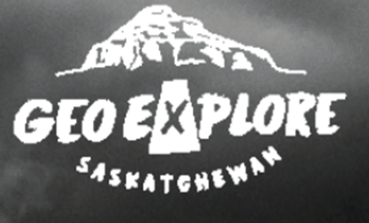
Stage 1: Identify Desired Results
Outcome(s)/Indicator(s)
Earth Science 30 ES30-LS1 Examine the processes that lead to the formation of sedimentary, igneous and metamorphic rocks and minerals. [SI]
Indicator(s): (a) Pose scientific questions about the characteristics and formation of rocks and minerals. (c) Compare the three primary methods of mineral formation (i.e., precipitation of mineral matter, crystallization of molten rock and solid-state transformation related to changing temperature and pressure during metamorphism).
Key Understandings: (‘I Can’ statements)  I can ... compare the different types of mineral formation.  I can ... explain the different types of mineral formation and provide examples.  I can ... collaborate and communicate with others in order to explain what type of mineral formation I am dealing with based on my observations. | Essential Questions:  - How do minerals form?  - How is a mineral formed by precipitation and give examples?  - How is a mineral formed by crystallization of a magma and give examples?  - What is biomineralization and give examples?

Stage 2: Teacher Background
This lesson covers mineral formation by explaining to students the methods of mineral formation through a PowerPoint and then having students either explore a guided mineral formation lab or students can form groups and have a mineral formation growing competition. The lab/competition will take a couple of weeks for the minerals to grow, so at the beginning or end of class students can check in with their minerals and record observations during the growing process.
Key Takeaways -
- Minerals can form in three primary ways being precipitation, crystallization from a magma and solid-state transformation by chemical reactions (metamorphism).
- Mineral Precipitation is when a mineral is formed by crystallization from a solution. Examples include quartz, halite (table salt), calcite, and gypsum.
- Minerals can also crystallize from a magma as it cools. Common magmatic minerals are olivine, pyroxene, quartz, feldspar and mica.
- Minerals can be transformed by solid state chemical reactions during metamorphism. This is because different minerals are stable at different temperatures and pressures. Common metamorphic minerals are garnet, amphibole, mica (biotite and muscovite), quartz and feldspar.
- A special type of mineral formation known as biomineralization is when a mineral is formed by living organisms. Examples include seashells (forms of calcite), bones in mammals + birds and bacteria producing gold.

Stage 3: Build Learning Plan
Engage:  - Up at the front of the classroom have the worksheets and enough geode samples for each group. Have one person from each group pick up the worksheets for their group members, and a geode for the group.  - Write on the front board and verbally say – Record your observations through writing and drawing. Then, explain what it is and speculate how it formed.  - Have the students record their observations and drawings in their activity sheet for the lab (“Actual”).  - Then, have groups share their thoughts and explain their reasoning. Have students return the samples.  Explain:  Present the PowerPoint to explain how minerals are formed and the different ways minerals can form. As you go through the slides have students make a concept map on their worksheets. Also, hand out samples that students can examine and pass to each other. The samples should represent each mineral formation type and be handed out when you are talking about the appropriate mineral formation type. Give time for students to pass the samples around and make sure you get back the samples before giving out the next set of samples.  Examples of samples for each mineral formation type…  - Precipitation = geodes (quartz), calcite, gypsum, halite, travertine (calcite), sylvite (the key component in potash)  - Magmatic crystallization (igneous rocks) = olivine, pyroxene, plagioclase (feldspar) potassium-feldspar, quartz and biotite,  - Solid state chemical reactions (metamorphic rocks… next lesson is the introduction of the rock cycle, so do not get to focused on the metamorphic and igneous terminology and explanation yet) = garnet, amphibole, quartz, feldspar, biotite and muscovite  - Biomineralization = seashells  Final Thoughts Informal – ask if there are any questions and what students found interesting.  Depending on what you pick for the Explore part -  - You can explain the competition and have students begin to brainstorm ideas for the rest of class.  - Have a video about mineral formation, if there is still time left at the end of class. |  | Engage & Explain Materials/Equipment:  - Mineral Formation PowerPoint  - Student Worksheets  - Geode samples for each group  - Samples that represent each mineral formation type  - Laptops (if brainstorming for competition)  Safety Considerations:  - Use caution when handling the samples.  - If something breaks, inform the teacher immediately.  - Wear safety goggles  - Tie long hair back  - Alum powder may irritate your skin; wash your hands if you touch it (Guided Lab)  - Use extreme care around the boiling water and hotplates  - Use proper safety procedures for any other equipment and materials that students might use in their mineral growing competitions.
Explore:

Guided Lab
Materials
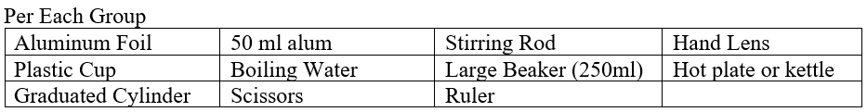
Each group will create a geode and complete the lab activity. See the student worksheet that has the procedure. This lab activity has to sit for a week or two as the crystals grow. Have a place that students can keep their experiments and label them. Students can spend some time during the start of class or at the end of class, while their crystals are growing, to ‘check in’ with their experiments to record observations, take pictures, etc.
Make sure students fill in their observations for the alum powder and initial experiment set up. So, they will have the actual geode observation already filled out from the engage activity and then they will have the initial experiment set up filled out. Students will then have to fill out observations as crystals are growing and Model Geode observations on their own. Have a set date that this is due where students hand in all their worksheets.
Questions to ask during the lab…
- What do you think the purpose of the alum is? How does the alum aid in the formation of crystals?
- What is a supersaturated solution?
- Why might some geodes not form crystals? (If you have unbroken geodes, pull groups aside and let them break one- put it in a cloth and use a hammer, and smash on a surface you don’t care about). Before they break one open have students predict if there would be well-formed crystals inside or not?
- What do you think would happen if you did not supersaturate the solution?
- What do you think might happen if we added cold water to the solution to cool it down faster?
- What would you do to try to form layers of mineral growth?
- What would restrict mineral formation in a geode?
- Why do you think it is important to understand the conditions of mineral formation?
- Why might it be difficult to try to conduct a lab on the other types of mineral formation?
- What resources do you think result from mineral formation?

Quick closure: have students clean up lab supplies, label their experiments and put them in a safe place. Ask to predict what might happen with their experiments overtime and what could affect their experiments.
Possible Adaptations/Differentiation - change the worksheets to suit your own needs, use a different method of mineral formation (salt/sugar/borax, etc.) or have groups do different methods of mineral formation.
Competition
Materials - will vary based on what groups decide to do. Have students get the materials mostly themselves, but if they do not have something or need to use a specific chemical then assist them.

Ideas
- Students can use chart paper to write up their lab in the format of POE (Predict, Observe, Explain). For Predict, have students record predictions, materials and method/procedure. For Observe, have students draw and write observations every x number of days. For Explain, have students reflect on their experiments at the end.
- Students can complete a photo lab write up using computers. They take pictures throughout the duration of their experiment.
- You will need to create a rubric or checklist for grading specific to what you want to do.
- Make this a yearly competition and have a trophy that you can put the names of the group members that won the competition.

Schedule -
- Period 1 - Mineral Formation PowerPoint
- Period 2 - Expectations, brainstorming and beginning lab write up. Figure out materials/procedure, who is bringing what and get approval of your experiment by your teacher. This is the time for students to come to their teacher to ask for specific equipment (hot plates, etc.).
- Period 3 - After a weekend so students have time to get supplies, Experiment Day. Students do their experiments, label them, put them in a safe place, and continue to work on lab write up (Initial observations, changes to procedure, etc.). Students might have multiple trials/experiments to keep track of.
- Check ins - students take some time to continue on with their observations throughout the competition. Maybe, they make changes to their experiment.
- Period 4 - Last day of competition. Students make their final observations and finish their write ups. Students hand-in their work. The teacher will announce the winner only after they have examined the minerals and the lab write ups. The winner should be determined by a combination of the minerals produced and how well they did on their lab write ups.

Stage 4: Determine Evidence for Assessing Learning
- Grading of brainstorming and lab/competition worksheets based on students’ communication of their learnings through drawings, pictures, recording of observations, etc.
- Informal class responses and discussion on mineral formation.
Extensions
Look at the GeoExplore Saskatchewan website for further information and a deeper understanding of the importance of Saskatchewan’s geological history. It is a digital version of the original paper Geological Highway Map of Saskatchewan:

Main Website
https://skgeolhighwaymap.maps.arcgis.com/apps/MapSeries/index.html?appid=a845cbb370f7401597806887318e2676

For more background information related to this lesson check out
● Main tab “Geo 101”

Additional Resources
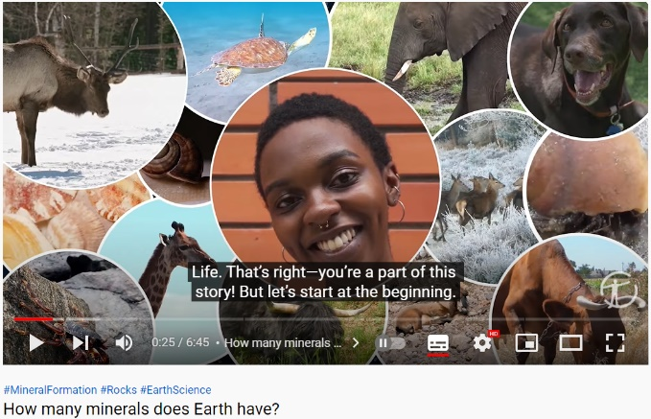
Check out the Minerals and Rocks Doodle Notes (NEW!)

Geology Kitchen #14 - Mineral Formation Methods Esteem Education Co. https://www.youtube.com/watch?v=ehOp9KbcQB0

How many minerals does Earth have? American Museum of Natural History
https://www.youtube.com/watch?v=Bnu1TG4z7bM

TED-Ed How do crystals work? - Graham Baird - https://www.youtube.com/watch?v=PgSRAsgrKmg

Name: _____________________
Mineral Formation: Concept Map / Doodle Notes

- Do not inhale the alum powder
- Do not get the alum powder in your eyes
- Alum powder may irritate your skin; wash your hands
- Use extreme care around the boiling water
Mineral Formation: Geode Lab
Background Information: Minerals are solids that have a repeating pattern of atoms and can form crystals. One-way crystals form from a solution of water and dissolved minerals. A geode is a sphere-shaped rock that contains a hollow cavity lined with crystals. Geodes begin as bubbles in volcanic rock or as animal burrows, tree roots or mud balls in sedimentary rock. Over time, the outer shell of the spherical shape hardens, and water containing minerals forms on the inside walls of the hollow cavity within the geode. The most common mineral found in geodes is quartz, but amethyst (purple quartz) and calcite are also found.
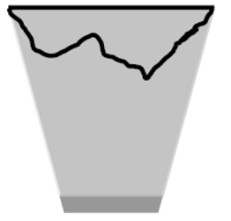
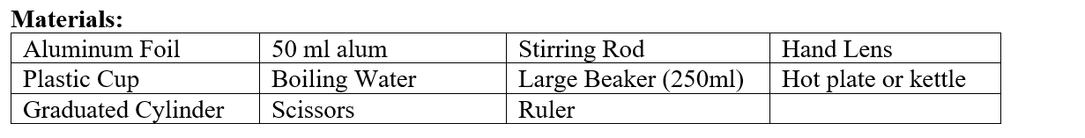Procedure:
- Cut a piece of foil about 15 cm square.
- Make a dish out of the foil.
- Place the foil “dish” on top of the cup. The foil should form a hollow area in the cup.
- Use the graduated cylinder to measure out 50mL of alum.
- Use the hand lens to observe the alum. Record your observations.
- Place the alum in a large beaker.
- CAREFULLY pour 150 ml of boiling water into the beaker.
- Stir for 3 minutes to dissolve most of the alum.
- Pour about 100 ml of the alum and water solution into the foil dish you made.
- Allow solutions to cool. Do not disturb the solutions while they are cooling.
- After 15 minutes sprinkle a small amount of alum over the surface.
- Let the crystals sit overnight. Carefully move your geode to a safe spot in the classroom and label it with your names. Clean up your lab materials and put stuff away.

Draw the initial experiment in your observation worksheet and answer the lab questions. Over the next week check-in with your experiment and draw observations as your crystals are growing. At the end of the experiment finish your final observations and then hand in the lab.

Geode Lab: Observations
Actual Geode Sample
Drawing | Description
Initial Experiment Setup Date:
Drawing | Description
Alum Powder Observations:

As Crystals are Growing Date:
Drawing | Description
As Crystals are Growing Date:
Drawing | Description
Final Observations of Model Geode Date:
Drawing | Description
Reflection:

Geode Lab: Questions
1.) What type of mineral formation is a Geode? ___________________________
2.) Using your own words explain how geodes form.

3.) How is the actual geode sample similar to the model geode?

4.) How is the actual geode sample different from the model geode?

5.) Speculate on how changing the saturation of the solution might affect crystal growth?

6.) Speculate on how changing the rate of cooling might affect crystal growth?

7.) Could we do a lab replicating the other types of mineral formation? Explain.

Presentation Notes
Slide 2 - General Outline of the presentation. Students will be creating a concept map or doodle notes of the presentation, so this is a rough outline. Emphasize the types of mineral formation and have them write examples in their concept maps or doodle notes.

Slide 3 - Words in a red box are what students should write down.
Picture from geology.com

Slide 4 - A ₃B ₂Si ₃O ₁₂, where A is a divalent cation (Fe ²⁺, Ca ²⁺, Mg ²⁺, Mn ²⁺) and B is a trivalent cation (Fe ³⁺, Al ³⁺, Cr ³⁺). Depending on which elements are in each position you get different types of garnet. The end-members pyrope, almandine, and spessartine form one solid solution series, while the end-members grossular, andradite and uvarovite form another.

Slide 5 - Depending on what element fills the spot it can change the colour of the mineral. Also, impurities, element concentrations, alteration and weathering can affect the colours of minerals. Which elements make up a mineral depends on the elements available when it is forming and the conditions of temperature and pressure.

Slide 6 - Diamonds do not form from coal!!!! - https://geology.com/articles/diamonds-from-coal/ Diamond can only form at very high pressure deep in the mantle.

Slide 7 - Compositional zoning in plagioclase is common. Either Ca or Na can be the predominant cation in the plagioclase crystal structure. As the abundance of these cations’ changes in the mineral growth environment, the composition of the mineral changes, thus creating growth zoning.

Slide 9 - Hand out mineral precipitation hand samples.

Slide 10 - Potash is formed by evaporation in ancient oceans that were buried as other sedimentary rocks were formed on top of them. Geodes are formed by hydrothermal fluids flowing through round, open spaces (formed in a variety of ways) and veins form when minerals are precipitated in cracks in the earth. Quartz is a very common mineral found in veins. Quartz veins host the gold in many gold mines around the world including Seabee Mine in Saskatchewan.

Slide 11 - Retrieve mineral precipitation samples.

Slide 12 - Hand out – crystallization samples.

Slide 13 - In the early 1900's, N. L. Bowen and others at the Geophysical Laboratories in Washington D.C. began experimental studies into the order of crystallization of minerals from a magma. The progression which they determined is still accepted as the general model for the evolution of magmas during the cooling process. Bowen determined that specific minerals form at specific temperatures as a magma cools.

Slide 15 - As the temperature and pressure increase the minerals change and the rock type changes. Different minerals are stable at different temperatures and pressures. As the temperature and pressure changes the minerals react together (solid state chemical reaction) and created new minerals. For example, the minerals andalusite, sillimanite and kyanite all have the same chemical composition (polymorphs), but different crystal structures that are stable at different temperatures and pressures. Another example would be a sedimentary rock formed of clay called kaolinite and sand made of quartz grains. When the sediment is buried and the temperature and pressure increase, the clay and sand grains react together to produce pyrophyllite and water. This is a dehydration reaction (water is removed). As temperature and pressure increases another dehydration reaction occurs to produce andalusite + quartz + water. If the reaction happened at higher pressure, then kyanite would form instead of andalusite. If the temperature increased then kyanite would transform into sillimanite.

Retrieve Samples

Slide 16 - Hand out – Biomineralization samples

Slide 17 – Retrieve samples

