Mineral Identification Lesson & Lab
Subject/Grade: Earth Science 30, Science/7, and Science/4
Created by: Hilary Roemer & Dr. Kate MacLachlan
GeoExplore Tabs: Geo 101 – Rock Cycle – 1.2.2

Stage 1: Identify Desired Results
Outcome(s)/Indicator(s)
Earth Science 30
ES30-LS1 Examine the processes that lead to the formation of sedimentary, igneous and metamorphic rocks and minerals. [SI]
Indicator(s):
b) Identify the characteristics geologists use to determine whether an Earth material is a mineral. d) Observe and classify mineral samples using standard physical properties (cleavage, fracture, crystal form, hardness, luster, colour, magnetism and streak).

Grade 7 Science
EC7.2 Identify locations and processes used to extract Earth’s geological resources and examine the impacts of those locations and processes on society and the environment. Indicators
b) Distinguish between rocks and minerals using physical samples, pictures, and/or video recordings and identify the minerals most often found in rocks in Saskatchewan and around the world (e.g., quartz, calcite, feldspar, mica, hornblende).
c) Classify rocks and minerals based on physical properties such as colour, hardness, cleavage, lustre, and streak.

Grade 4 Science
RM4.1 Investigate physical properties of rocks and minerals, including those found in their local environment. [CP, SI]
Key Understandings: (‘I Can’ statements)  I can… explain what a mineral is.  I can…explain and make observations that describe the physical properties of minerals  I can…record and organize my observations into a chart.  I can… use a mineral identification chart to name a mineral based on my observations. | Essential Questions:  - What is a mineral?  - What are some physical properties of minerals that can be used to identify them?  Concepts:  - Mineral Identification  - Physical Properties of Minerals  Scientific Inquiry  - Make observations that describe physical properties of minerals  - Record and organize observations in a chart format

Stage 2: Teacher Background
This is a two-part lesson and lab that will likely cover two class periods.

In the lesson students will learn about what a mineral is and what a mineral is not. Then, students learn what physical properties aid in identifying minerals. The PowerPoint has teacher notes within it. The Bell Ringer can be updated to reflect current Science in the News - focusing on minerals. To make this lesson more interactive use different mineral samples and pass them out to students throughout the lesson. Make sure you get all the samples back. Also, you can bring students up to demonstrate how to test for hardness or how to use a streak plate.

In the lab students explore the physical properties of minerals through observations and identification. Students will apply their learning from the previous lesson on how physical properties aid in identifying minerals.

Teacher Preparation -
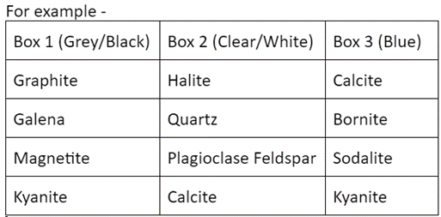
Have a system to label your minerals. For example, use white out, black permanent marker and clear nail polish to label your mineral samples with numbers. Then, create a spreadsheet with the numbered mineral labels and the mineral name. If you are using borrowed minerals or a mineral kit and cannot label them, then make sure the minerals are in the correct spots of the kit to begin with and then take a picture.

Divide your class into groups and make mineral kits/boxes for each group. Shoe boxes work well and are easy to label. During the lab make sure students write down which shoe box kit they used, so if you have to double check observations/answers you can find the exact mineral that they were observing. If you don’t have anour of the same type of mineral for each group, you can arrange them by colour. Each box had four minerals of the same colour, so students could not focus on colour to try to ID their minerals (colour is not always a reliable characteristic because some minerals can be a variety of different colours). Also, each box had a penny, butter knife, glass, streak plate ± magnets, and ± 1 mol HCl ± pipettes. Design your boxes based on the minerals you have available.

Then create a mineral ID chart based on the minerals you used. For example….…
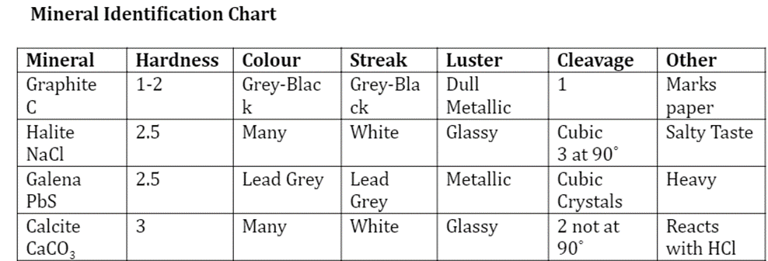

Stage 3: Build Learning Plan
Part 1 - Lesson  Set (Warm-up, Focusing the Learning): Time: 5 min  Bell Ringer: (five-minute wait time/attendance time)  Show students the first slide on the PowerPoint. What do all of these things have in common?  Think – think about it by yourself and write down your thoughts.  Pair – discuss with the person next to you about what you wrote.  Share – share your response with the rest of the class.  Next Slide – all of the items have talc in them. Talc is used in cosmetics, rubber, paper, and paint. What is talc?  Next Slide – Talc is a mineral.  Explain: Time: 45 min  - Proceed with PowerPoint slides introducing what a mineral is. The PowerPoint has note viewer to remind you to ask questions and pass out samples, etc.  Learning Closure: Time: 5 min  Give time for students to come up with one question each and hand it in as an exit slip. Also, on the Exist slip ask a question about one thing they learned.  Brain Buster – If diamond is the hardest mineral, then how was the first diamond mined?  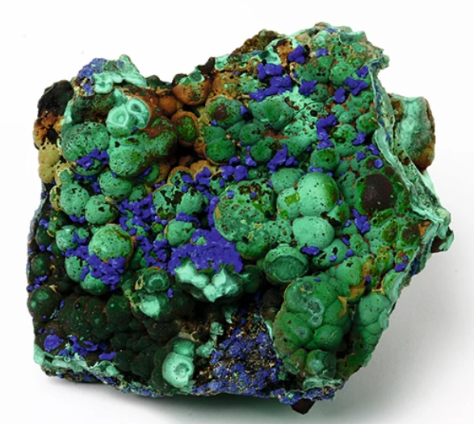  (Malachite - green and Azurite - blue) |  | Materials/Equipment:  - PowerPoint Presentation  - Student Handout  - Minerals – Biotite with good cleavage, calcite with good cleavage, quartz with conchoidal fracture, another mineral sample showing fracture.  - Exit Slips  Safety Considerations:  - Some samples might be pokey and sharp – use caution when handling samples  - Keep mineral samples away from eyes and mouth  - Do not throw or toss items to anyone  - If something breaks, inform the teacher immediately. They will clean up any spills or broken glass/objects.  - Return all materials and samples  Possible Adaptations/  Differentiation  - Use different samples to demonstrate with  - Have students write fill-in the blank notes, or doodle notes  - Combine the PPT and lab lesson, simplify and cover it in one lesson instead of two  - Have students demonstrate how to use the lab materials during the lesson.
Part 2 – Lab  Refresher: Time: 10 min  - Go over mineral identification briefly.  - Answer the exit slip questions that students handed in from the Introduction to Minerals Lesson.  Questions – How would you identify minerals? What physical properties do minerals have?  Explore: Time: 30 - 45 min  - Go over Safety and hand out the worksheets.  - Explain to the students that they will work in groups and will have to observe and fill out the worksheet for all four minerals that they have at their table.  - Let the groups pick a box set of minerals and tools.  - Separate the groups far apart while they work.  Students will explore the physical properties of minerals and will be working on the worksheets. Circulate around to all the groups to check in. Some questions you could ask…  - What characteristics can you observe that might be able to help you in describing the minerals at your table?  - Can other classmates identify your minerals based off of the observation chart that you created?  - How can you use the materials at your table to help you describe the minerals?  - What can the different tools/materials tell you about your mineral?  - How do you know that this is a mineral?  - How do you test for … hardness, streak, etc? And what does that tell you about the mineral?  * Encourage students to draw detailed pictures and label features, or even include colouring. Being able to draw is an important skill for scientists, especially for geologists.  Once students have been given enough time to observe, draw and describe the minerals, give groups a mineral identification chart in order for them to name the minerals that they were observing.  Circulate and help groups with some of the identifications by asking questions and giving hints – some of the minerals can be tricky. Make sure all groups have identified the minerals properly. Make sure students are not erasing their observations to match the ID chart that they were given.  Explain: Time: 5 - 10min  Have each group explain their findings to the rest of the class. They will informally present the minerals that they identified and how they identified it. They will also say the name of the minerals – at this time other groups might speak up/interrupt since there are identical minerals that look completely different.  Some questions you can ask to help in guiding the presentations…  - What were the distinctive physical properties of the minerals that you identified?  - How did you use the tools to test for mineral properties?  - What were some unique physical properties that you thought were the most interesting?  - How can you use the physical properties of minerals to help you identify minerals?  - How many minerals are there all together?  - How many minerals were there on the mineral identification sheet?  - Why do you think that there is a different number between the two?  Hopefully the students will realize and point out that some of the minerals are the same and just a different colour. The minerals in the examples above were Kyanite (black and blue) and Calcite (white/clear and blue).  Extend  Final Thoughts – Now that we have learned what a mineral is and how to identify minerals based on their physical properties, how do you think minerals might form?  Mineral formation will be covered in the next lesson.  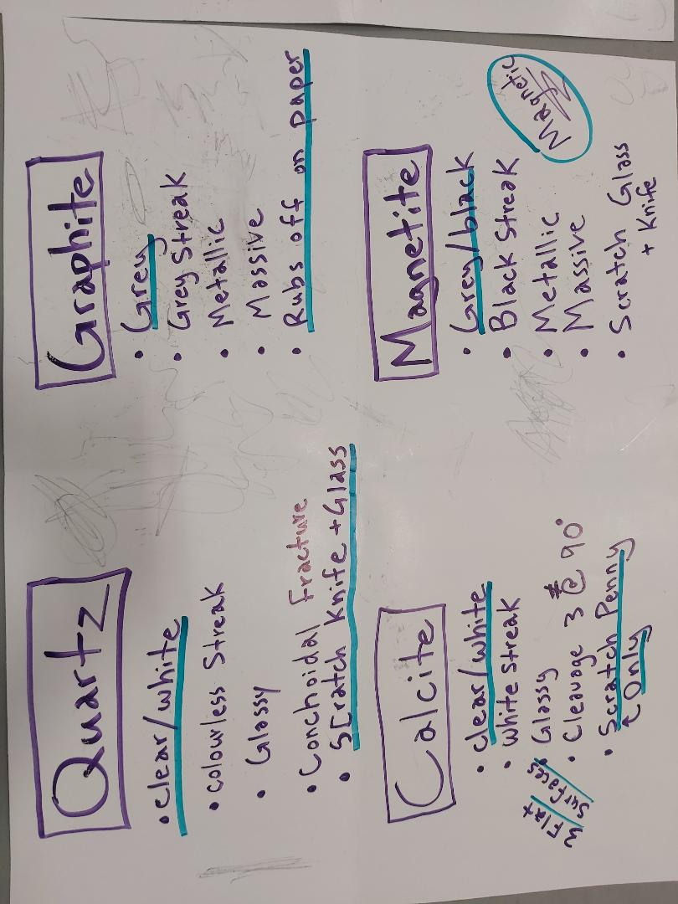 | Materials/Equipment:  - A set of minerals for each group  - A mineral identification kit for each group (penny, butter knife, glass, streak plate ± magnets, and ± 1 mol HCl ± pipettes).  - Worksheet Handout  - Appropriate mineral identification chart for the minerals used.  Safety Considerations:  - Wear safety goggles  - When using HCl use a small amount and wash the sample and dry the sample with a paper towel. HCl will ruin your clothes if you spill it on yourself. If you notice irritations then wash your hands.  - Use caution when handling the mineral samples, streak plates and glass  - If something breaks, inform the teacher immediately. They will clean up any spills or broken glass/objects.  - Wash hands after handling samples  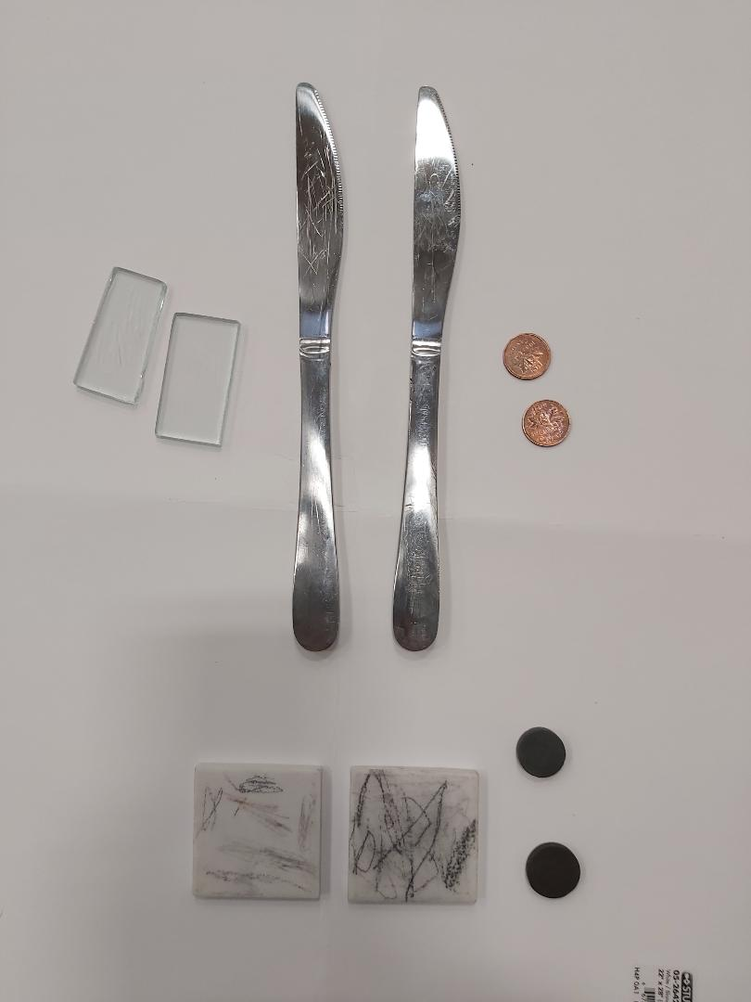  Possible Adaptations/  Differentiation  - Go through an example together before students explore on their own.  - If you do not have enough minerals to make kits, put the minerals you have at a front table and have groups choose one mineral at a time.  - You don’t have to organize your kits by colour.  - Instead of using the lab sheet provided, you could show students a mineral identification book and have them create their own mineral ID field guide based on the samples you have given them.  - For younger students, you could have them work in groups with chart paper. Written on the chart paper are the minerals with key identifying characteristics. Students place the minerals on the proper spots on top of the chart paper.

Stage 4: Determine Evidence for Assessing Learning
Learners will show they achieved the skills by…
- Informal responses to in class questions and discussions.
- Informal responses to Bell Ringer question and Final Thoughts.
- Informal Exit slip – one thing they learned and one question they still have.
- Drawing and recording observations of different minerals.
- Being able to identify different minerals based on physical properties (cleavage, fracture, crystal form, hardness, luster, colour, magnetism and streak).

Feedback that students will receive…
- Informal class responses and discussion on trying to identify minerals.
- Going over the questions from the exit slip
- Drawing and recording will meet established criteria – marked with feedback.
- The mineral identification worksheet

Extensions
Look at the GeoExplore Saskatchewan website for further information and a deeper understanding of the importance of Saskatchewan’s geological history. It is a digital version of the original paper Geological Highway Map of Saskatchewan:

Main Website
https://skgeolhighwaymap.maps.arcgis.com/apps/MapSeries/index.html?appid=a845cbb370f7401597806887318e2676

For more background information related to this lesson check out
- Main tab “Geo 101”

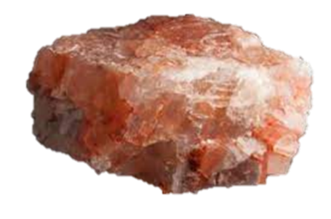
Link this lesson to Saskatchewan resources by including a potash sample. Have students try to figure out what minerals are in the potash sample. They could compare sylvite and halite with quartz. Have students research about the importance of potash to Saskatchewan and create doodle notes/infographic/etc. from what they learned.

- Students could include a drawing of potash with arrows identifying the minerals, drawn map identifying mine locations in Saskatchewan, uses of potash with explanation, mining process, how much Saskatchewan produces, etc.
- Helpful Link - Click on tab “Our Resources” and then subtab “Minerals and Mines”
https://skgeolhighwaymap.maps.arcgis.com/apps/MapSeries/index.html?appid=a845cbb370f7401597806887318e2676

Additional Resources
Check out the Doodle Notes for Rocks and Minerals (NEW!)
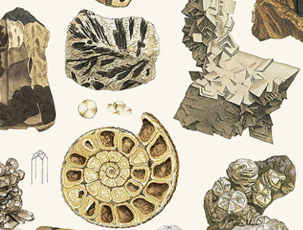
James Sowerby’s 2,242 Mineral Illustrations Virtual Collection
https://www.c82.net/mineralogy/

APEGS Presents: Mineral Identification Teacher Demo APEGS - Engineers and Geoscientists Saskatchewan –
https://www.youtube.com/watch?v=9-kub7o2594
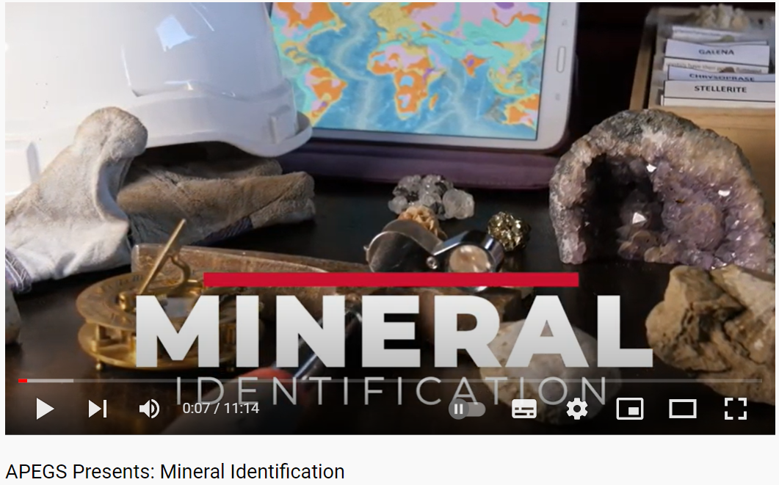

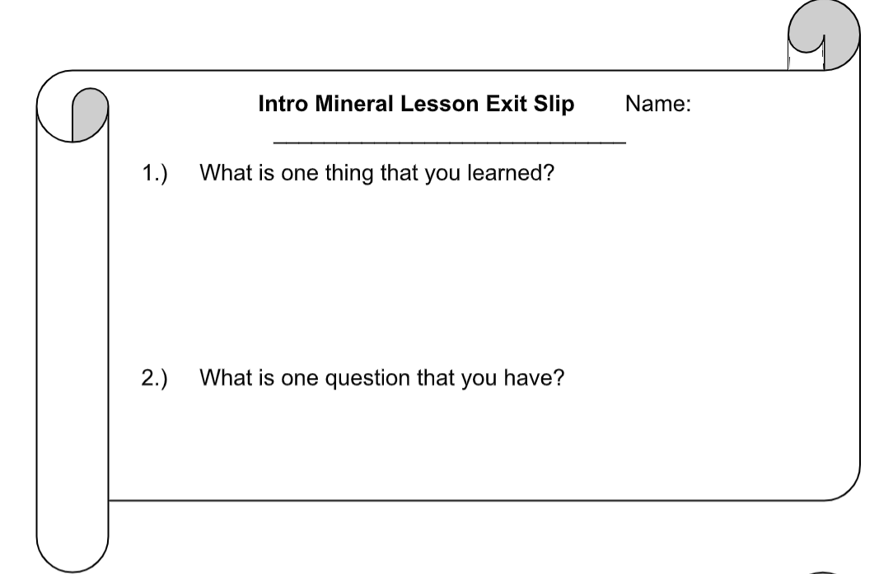
Name: ___________

Mineral Introduction

Think About It: Earth’s crust is composed of about 3000 minerals. Only 30 of these minerals are very common. Minerals are everywhere. For example, graphite is your pencil lead.

What is a mineral?

Is ice a mineral?

Is water a mineral?

Is plastic a mineral?

Is glass a mineral?

Are the elements on the periodic table minerals?
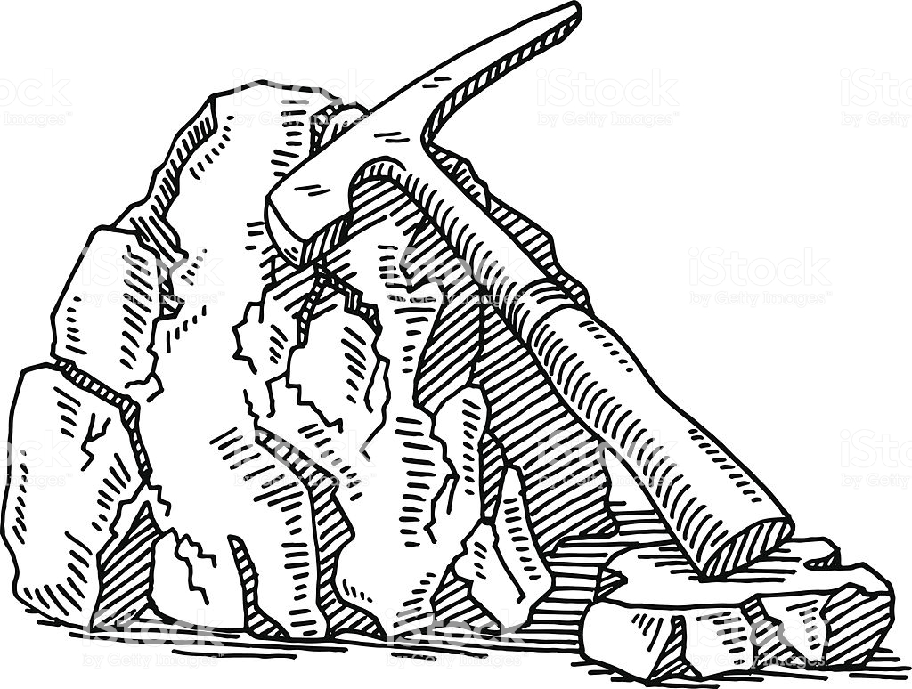
What are the physical properties of minerals?
Make a concept map

Ask Questions, Doodle, Create & Brainstorm

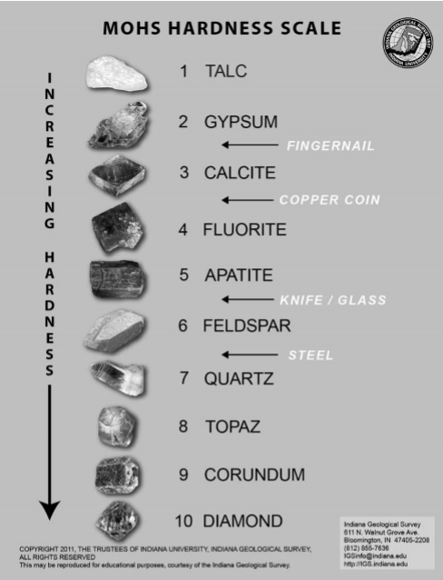

Name: ________________
Mineral Identification Lab
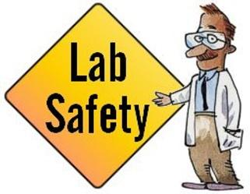
- HCl - use a small amount and dry the sample with paper towel
- HCl will ruin your clothes if you spill it on yourself
- If you notice irritations then wash your hands
- Some samples might be pokey and sharp – use caution
- Use caution handling mineral samples, streak plates and glass
- Return all materials and samples

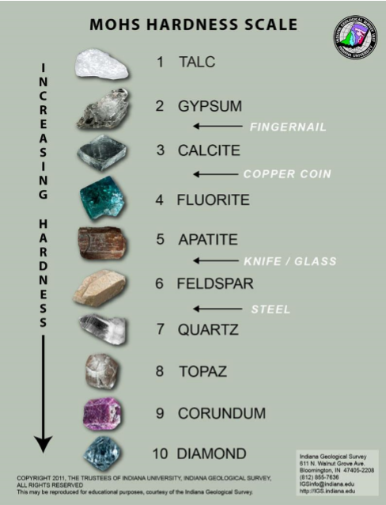
Background Information: Minerals are the building blocks of rocks and sediments comprising the Earth and its landscapes. Minerals are naturally occurring inorganic solids with a definite chemical composition and an ordered internal crystalline structure. Geologists use several different ways to identify minerals. One way is by looking at a mineral’s physical properties. You need to use a combination of many tests to identify a mineral.

- Hardness – describes a mineral's resistance to scratching. Hardness is measured on a scale of 1 to 10, with 1 being the softest minerals and 10 being the hardest minerals.
- Colour – the colour of the mineral.
- Streak Colour – the color of the finely ground powder of the mineral when using a streak plate.
- Luster – describes the way a mineral reflects light. Minerals can be categorized as Metallic and Nonmetallic.
- Cleavage – how a mineral breaks along flat surfaces (usually one, two, three or four surfaces).
- Fracture – are rough or jagged, irregular surfaces that the mineral breaks along.
- Other properties include crystal shape, heaviness (density), magnetism, and if it reacts with HCl acid.

Observations Criteria and Feedback

Criteria for a Good Drawing | Met | Not Yet
Large enough to show the details
Illustrates all the parts as realistically as possible
Illustrates details such as texture, colour, and shape
Properly labeled (measurements, minerals, and important features.)
Criteria for a Good Observation
Accurate Details - proper use of descriptive words based from observation
Descriptive Words (e.g., Iridescent, spherical, scaly, powdery, etc.) and details (location, colour, texture, quantity, sounds, smells, etc.)

Feedback: | Current Score

Mineral Name: Physical Properties/ Observations
Drawing | Hardness
 | Colour
 | Streak Colour
 | Cleavage or Fracture
 | Luster
 | Shape
 | Other
 | Other

Mineral Name: Physical Properties/ Observations
Drawing | Hardness
 | Colour
 | Streak Colour
 | Cleavage or Fracture
 | Luster
 | Shape
 | Other
 | Other

Mineral Name: Physical Properties/ Observations
Drawing | Hardness
 | Colour
 | Streak Colour
 | Cleavage or Fracture
 | Luster
 | Shape
 | Other
 | Other

Mineral Name: Physical Properties/ Observations
Drawing | Hardness
 | Colour
 | Streak Colour
 | Cleavage or Fracture
 | Luster
 | Shape
 | Other
 | Other

Presentation Notes
Slide 3 - On December 5th 2018– Health Canada proposes that “inhaling loose talc powders and using certain products containing talc in the female genital area may be harmful to human health”. Using products like baby powder, diaper creams and bath bombs that have talc may increase the risk of developing ovarian cancer. Ingesting talc or using it in cosmetics was found to be not harmful. The government is working on a final assessment and if it is confirmed they might consider restricting talc’s use.
Note - can update Bell Ringer to current science in the news about minerals.

Slide 4 - Minerals are the building blocks of rocks and sediments comprising the Earth and its landscapes. Earth’s crust is composed of about 3000 minerals. Only 30 of these minerals are very common. Minerals are everywhere. For example, the “lead” in your pencil is mostly graphite (it is not actually made of lead anymore, although it was in ancient Roman times).

Slide 6 - Largest gold nugget ever found in the world. It was found in California and weighs 109.2 lbs.
Another mineral that is composed of just one element is graphite = C (carbon).

Slide 9 -
Plastic? – No
Glass? – No
Elements? – Yes

Slide 10 - Geologists use several different ways to identify minerals. One way is by looking at a mineral’s physical properties. You need to use a combination of many tests to identify a mineral. Crystal shape or form can be unreliable to use due to weathering.

Slide 12 –
Saskatchewan Legislative Building = copper
Example – pennies
Example – Statue of Liberty

Slide 13 - Moh's hardness scale uses the hardness of certain minerals and other common objects to determine relative hardness. How easy can it be scratched? Does it scratch the penny? If it does than the mineral has to have a hardness greater than 3.5.

Slide 15 - Metallic luster is shiny and looks like metal. However not all minerals that have a metallic luster are metals. Nonmetallic luster is not shiny.

Slide 16 - If a mineral does not break along a flat plane/smooth surface it fractures. Fractures are rough or jagged edges that the mineral breaks into. Hand out samples showing cleavage and fracture – go over safety.

Slide 17 - Explain the samples that you handed out and then retrieve the samples.

