Pet Rock Lesson

Subject/Grade: Earth Science 30, Science/7, and Science/4

Created by: Hilary Roemer & Dr. Kate MacLachlan

GeoExplore Tabs: Geo 101 – Rock Cycle – 1.2.0

Stage 1: Identify Desired Results
Outcome(s)/Indicator(s)

Earth Science 30
ES30-LS1 Examine the processes that lead to the formation of sedimentary, igneous and metamorphic rocks and minerals. [SI]

Grade 7 Science
EC7.2 Identify locations and processes used to extract Earth’s geological resources and examine the impacts of those locations and processes on society and the environment.
Indicators
b) Distinguish between rocks and minerals using physical samples, pictures, and/or video recordings and identify the minerals most often found in rocks in Saskatchewan and around the world (e.g., quartz, calcite, feldspar, mica, hornblende).
c) Classify rocks and minerals based on physical properties such as colour, hardness, cleavage, luster, and streak.

Grade 4 Science
RM4.1 Investigate physical properties of rocks and minerals, including those found in their local environment. [CP, SI]

Key Understandings: (‘I Can’ statements)  I can… practice observing, describing, and identifying pet rocks.  - Make observations that describe identifying characteristics  I can… practice how to classify pet rocks based on identifying characteristics.  I can… think and ask questions about the characteristics of pet rocks and how they formed. | Essential Questions:  - What are some characteristics of your pet rock that can be used to identify it?  - How did your pet rock form? What is its creation story?  - Can you identify other pet rocks based on someone else’s observations?

Stage 2: Teacher Background
As a geologist, it is important to use observation skills and to be able to communicate your observations to other people. At first observing rocks might seem pointless or meaningless because they may all look the same to the untrained eye. As a result, student’s descriptions and observations usually lack detail. However, rocks and minerals have a lot to tell you, if you know how to listen to them.

In this scaffolding lesson students practice observing rocks by creating their own pet rocks with characteristics that help make it stand out from all the other pet rocks. Students are then challenged to find another person’s pet rock based on their descriptions and drawings they created. This exercise highlights the importance of detailed descriptions for mineral and rock identification.

Stage 3: Build Learning Plan
Set (Warm-up, Focusing the Learning): Time: 5 min  Bell Ringer: Guess the Million Dollar Invention  Hint #1 - “One of the most ridiculously successful marketing schemes ever.” – Newsweek 1975  Hint #2 – The idea was originally a joke  Hint #3 - The genius was in the packaging – a cardboard box with some ventilation holes, a manual and some excelsior.  The Pet Rock was invented by Gary Dahl. He earned 15 million dollars from his invention. The rocks were smooth grey stones from Rosarito Beach in Mexico.  Development: Time: 50 min  1. Show students your own pet rock and tell students that they get to decorate their own pet rocks. Give them half an hour to decorate their pet rocks and clean up.  2. Hand out the Birth Certificate sheet for students to fill out. Walk around and ask students questions. Students should describe both the decorations they added and the original rock, that is if they did not paint the entire rock.  Ask - What makes their rock unique? What are some characteristics of your rock pet that can be used to identify it?  Ask – How did your rock pet form? What is its creation story?  Ask- Can classmates identify your rock based off of its Birth Certificate that you filled out?  3. Then everyone will sit in a circle and the rock pets will be placed along the perimeter of the classroom. The students will have their Birth Certificates.  4. Create your own left right pass script or use a video. Every time students hear the words left or right they pass the Birth Certificates left or right respectively.  5. Let students try to match the Birth Certificate they received to the pet rock.  6. Then, make sure everyone gets their pet rocks and Birth Certificates to their rightful owners.  7. Have students sit back down and discuss the activity.  Ask – Did you correctly match up the Birth Certificate with the pet rock? If yes – Why do you think you were able to correctly identify the rock based on the observations? If no- Why do you think you misidentified the rock?  Learning Closure: Time: 5 min  Food For Thought: What if we did not decorate the rocks, then how would we try to identify them? What characteristics would help us identify the ‘naked’ rock pets apart from one another? |  | Materials/Equipment:  - hot glue gun and hot glue sticks  - acrylic paint  - paint brushes  - googly eyes  - rocks  - safety goggles  - Birth Certificate handout  Safety Considerations:  Hot Glue Gun  - Be careful not to burn yourself or others. If you do get burned, run your hand under cold water for a couple of minutes.  - Do not consume.  - Wear safety goggles and pull loose hair back.  - Place glue gun standing upright (not on side) on aluminum foil.  - Clear away any flammable materials.  Acrylic Paint – do not consume  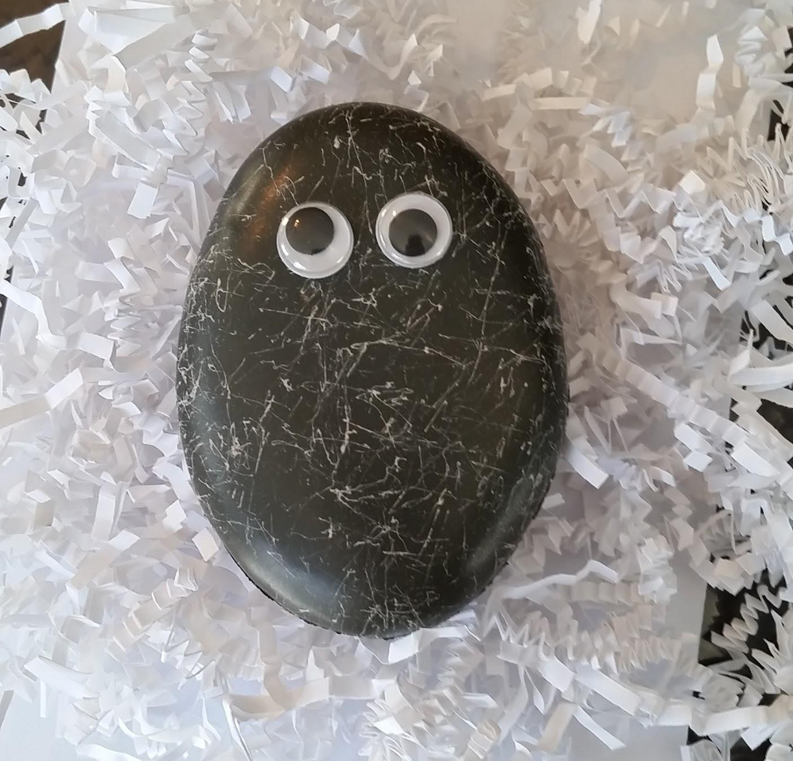

Stage 4: Determine Evidence for Assessing Learning
Learners will show they achieved the skills by…
1. Drawing and recording observations of their rock pet by filling out the Birth Certificate handout.
2. Being able to identify each other’s rock pets by using the Birth Certificate handout.
3. Responses to in class questions and discussions.
4. Responses to Bell Ringer questions.

Feedback that students will receive…
1. Drawing and recording will meet established criteria – marked as incomplete or complete with feedback (It will be the first time for students to practice with the observations criteria).
2. In class responses and discussion on trying to identify another student’s rock pet based on the Birth Certificate will be informally assessed for students’ ability to make meaningful observations that can be used as identifying characteristics.

Extensions
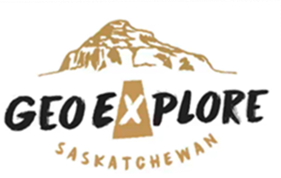
Look at the GeoExplore Saskatchewan website for further information and a deeper understanding of the importance of Saskatchewan’s geological history. It is a digital version of the original paper Geological Highway Map of Saskatchewan:

Main Website
https://skgeolhighwaymap.maps.arcgis.com/apps/MapSeries/index.html?appid=a845cbb370f7401597806887318e2676

For more background information related to this lesson check out
- Main tab “Geo 101”

Name: ___________________

Observations Criteria and Feedback

Criteria for a Good Drawing | Met | Not Yet
Large enough to show the details
Illustrates all the parts as realistically as possible
Illustrates details such as texture, colour, and shape
Properly labeled (measurements, minerals, and important features.)
Criteria for a Good Observation
Specifics measurements (length, width, mass), number of characteristics (e.g., 10 jointed legs), etc.
Descriptive Words (e.g., Iridescent, spherical, scaly, powdery, etc.) and details (location, colour, texture, quantity, sounds, smells, etc.)

Observations Include: | Feedback: | Current Score
Specifics

Descriptive details

