What if We Kept on Digging?

Stratigraphy Part 2 – Strat. Column

Subject/Grade: Science 4 & 7
Recreated by: Diana Joy Jensen, Hilary Roemer & Dr. Kate MacLachlan

Stage 1: Identify Desired Results
Outcome(s)/Indicator(s)
SCIENCE
Grade 4 Rocks, Minerals and Erosion
RM4.1 Investigate physical properties of rocks and minerals, including those found in their local environment. [CP, SI]
b) Document the locations and characteristics of rocks that exist in their local environment.
RM4.2 Assess how human uses of rocks and minerals impact self, society, and the environment. [DM]
f) Identify locations where minerals, including potash, sodium sulphate, salt, kaolin, uranium, copper, coal, diamond, and gold, are extracted in Saskatchewan.
Grade 7 Earth’s Crust and Resources
ECR7.1 Analyze societal and environmental impacts of historical and current catastrophic geological events, and scientific understanding of movements and forces within Earth’s crust.
c) Construct a visual representation of the composition of Earth, including the crust, upper and lower mantle, core, and inner core.
ECR7.3 Investigate the characteristics and formation of the surface geology of Saskatchewan, including soil, and identify correlations between surface geology and past, present, and possible future land uses. [DM, SI]
c) Construct a visual representation of the rock cycle (e.g., formation, weathering, sedimentation, and reformation) and relate this representation to the surface geology of Saskatchewan and Canada.
Key Understandings: (“I Can” statements)  I can … describe the characteristics of rocks in my environment and show where they can be found.  I can… identify where local minerals such as potash, coal, and copper are extracted from the Saskatchewan stratigraphy.  I can… model the different layers of rock deposits in Saskatchewan geology.  I can… use my model to measure the age of different rock deposits in Saskatchewan. | Essential Questions:  - What are some ways that we can describe rocks?  - What minerals can be found in the stratigraphy of Saskatchewan and where can they be found?  - What do rock deposits look like? How can they be similar or different in various locations?  - How are rock deposits used to measure the age of rock samples?

Stage 2: Teacher Background
Learners will explore the basic principles of stratigraphy and construct a stratigraphic column using information from a core taken near Estevan. You have the choice of learners constructing their stratigraphic columns on the template provided in the student worksheets or on paper towel roll tubes. An answer key is provided at the very end of this lesson plan.

Stratigraphy is the study of the Earth’s strata or layers. Two basic principles of stratigraphy are:
1) The principle of superposition: states that the oldest layers are found at the base of the formation, and that each successively higher layer is younger than the one below it.
2) The principle of original horizontality: means that sedimentary rocks were originally deposited in horizontal layers.
More Information can be found at: https://pubs.usgs.gov/gip/fossils/rocks-layers.html
Because geologists cannot see everything in the ground beneath our feet, they use various techniques to figure it out. One technique for subsurface mapping is to take a core sample. In this way geologists can make educated guesses as to the composition of the earth and the geologic history of an area.
Examining the general stratigraphy of Saskatchewan can lead to discussions and projects regarding Saskatchewan’s mineral resources.

Stage 3: Build Learning Plan
Set (Warm-up, Focusing the Learning): Time: 5 min  Ask learners to recap the previous lesson on cupcakes or ask learners about their prior knowledge. Then, as a class have learners take turns reading the first page of the student worksheets. Check for understanding.  Development: Time: 30 min  Explain that they will be making a stratigraphic column of the subsurface near Estevan.  Learners will need to to shrink the more than 3200 meters of rock onto the paper towel tube or worksheet. *Paper A scale of 1cm:200m is provided. Students will need to determine how thick each layer will be on their paper towel tube. A chart with steps is provided.  Next, learners can measure each layer onto their paper towel tube or worksheet starting from the top and working down! This is done because geologists are unsure of the exact depth to which the Precambrian igneous and metamorphic rock extends. To show this uncertainty students can measure 3cm down and then draw a zigzag line. This zigzag shows that there is some data not represented in the model.  Then, learners can colour each section of their paper towel tube or worksheet according to the legend that they created earlier. Make sure they label other important details (ages, rock types, etc.).  Learning Closure: Time: 15 min  Students can answer the questions found on the worksheets. | Materials/Equipment:  - Paper towel tubes (optional)  - Pencil crayons  - Rulers  - Student worksheets  - Stratigraphic Correlation Chart (optional)  - Geological Timescale (optional)  Adaptations  - If using paper towel rolls have students work as a team of geologists, so you would need less rolls.  - Older students could use the Stratigraphic Correlation Chart to recreate a column while finding their own scales.  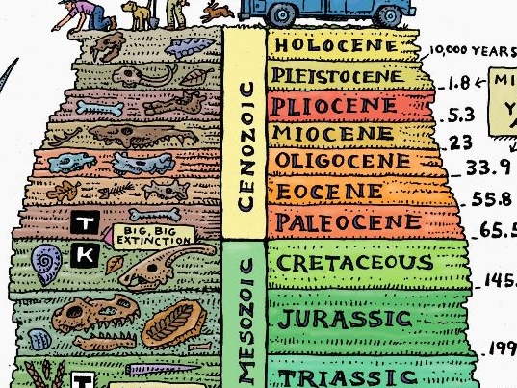

Stage 4: Determine Evidence for Assessing Learning
Completion of the stratigraphic column to scale and of the worksheet questions.

Extensions
- Students can correlate each layer to the proper geologic time period name using a geologic time scale. They can add this to their stratigraphic column on their worksheet.
- Students can research Saskatchewan Fossils on GeoExplore and add them to their stratigraphic columns with dates, names, and drawings.
- Students can use the Stratigraphic Correlation Chart to corelate approximately which layers might have different resources (oil, potash, etc.) and then add it to their stratigraphic column worksheet as arrows or symbols, or drawings.
- Students can add important extinction dates or add important events to their columns.

Look at the GeoExplore Saskatchewan website for further information and a deeper understanding of the importance of Saskatchewan’s geological history. It is a digital version of the original paper Geological Highway Map of Saskatchewan:

Main Website
https://skgeolhighwaymap.maps.arcgis.com/apps/MapSeries/index.html?appid=a845cbb370f7401597806887318e2676

For more background information related to this lesson check out
- Main tab “Geo 101” then subtab “Sask. Geology”
- Main tab “Sedimentary Basins.”

Name: __________________________

What if we just kept on Digging?
Stratigraphy Part Two – Estevan Stratigraphic Column
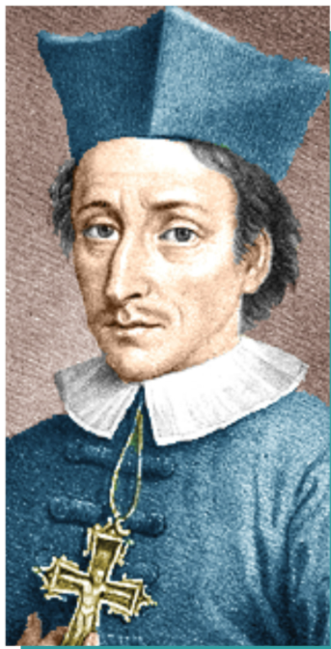
Stratigraphy is the study of the layers within the Earth’s crust. Nicolaus Steno was one of the first to study the layers and fossils in 1659 and realize that they tell a story of geological events. He defined two basic principles of stratigraphy that we still use today.
The Principle of Superposition – beds of rock on top are usually younger than those deposited below.

The Principle of Original Horizontally – sedimentary rocks are originally deposited horizontally in layers.

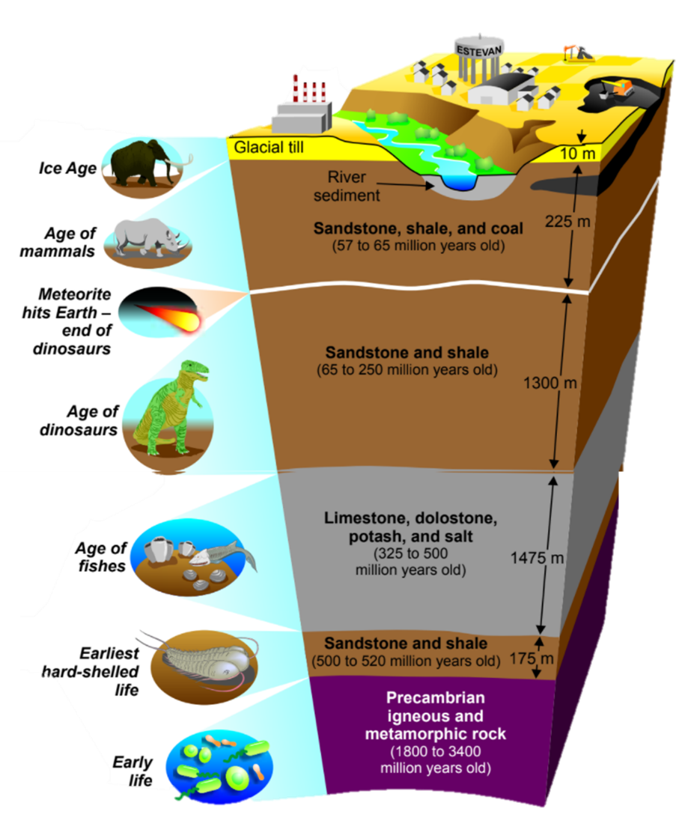
Because geologists cannot see everything in the ground beneath our feet, they can take core samples. Core samples help geologists interpret what is underground in order to understand the geological past of an area or where resources like potash, uranium and oil are located. Through many core samples and other techniques, geologists have discovered…

Southern Saskatchewan rests on a thick series of sedimentary rock layers. These layers – sandstone, shale, limestone, dolostone, potash, salt, and coal – formed during the last half-billion years.

This record of geological time is only partly complete. Numerous layers are missing due to periods of erosion – somewhat like a book with many of its pages missing.

The layers of sedimentary rock overlie ancient metamorphic and igneous rocks of Precambrian age that are exposed at the surface in the Canadian Shield of Northern Saskatchewan.

Challenge – Create a Stratigraphic Column of the subsurface by using information from a core sample taken near Estevan.

Step 1: Scale it Down
You need to shrink more than 3200 meters of rock into a stratigraphic column that fits on a piece of paper. Hint – A scale of 1cm:200m would work.
- Find the depths of each layer in meters using the diagram.
- Scale down to cm by dividing by 200.
- Represent each layer by a colour, pattern, or symbol within the legend.
Deposit (Rock Type) | Depth (m) | Column (cm) | Legend
Glacial Till
Sandstone, shale and coal
Sandstone and shale
Limestone, dolostone, potash and salt.
Sandstone and shale
Precambrian igneous and metamorphic rock | Unknown | Unknown

Examples of Common Rock Symbols used in Geology
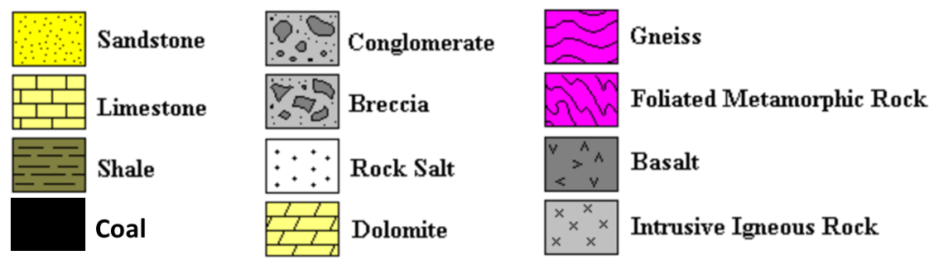

Step 2: Measure, Colour & Label
Measure each layer using a ruler starting from the top and working down! This is done because geologists are unsure of the exact depth to which the Precambrian igneous and metamorphic rock extends. To show this uncertainty at the end you can measure 3cm down and then draw a zigzag line. This zigzag shows that there is some data not represented in the stratigraphic column.
Then, colour in your layers according to your legend. To finish create a title, label the depths and label any other important information.

Estevan Stratigraphic Column Questions
- What does Stratigraphy mean?

- Which are the youngest types of deposits in Saskatchewan? How do you know?

- Which are the oldest types of rocks in Saskatchewan? How do you know?

- What was the age of fish?

- When was the age of dinosaurs?

- What event may have influenced the extinction of the dinosaurs?

- When was the age of mammals?

- How old are the Precambrian igneous and metamorphic rocks?

- Do you think that the rock layers are really as flat as the picture depicts? Why or why not?

- What might be different about a similar stratigraphic section in the area where you live?

Answers
Deposit (Rock Type) | Depth (m) | Model (cm)
Glacial Till | 10 | 0.05
Sandstone, shale and coal | 225 | 1.13
Sandstone and shale | 1300 | 6.5
Limestone, dolostone, potash and salt. | 1475 | 7.38
Sandstone and shale | 175 | 0.80
Precambrian igneous and metamorphic rock | Unknown | Unknown

- What does Stratigraphy mean?
The study of strata, the layers of the Earth.
- Which are the youngest types of deposits in Saskatchewan? How do you know?
Glacial till because it is found at the top of the section. (Principle of superposition)
- Which are the oldest types of rocks in Saskatchewan? How do you know?
Precambrian igneous and metamorphic rocks because they are found at the base of the section. (Principle of superposition)
- What was the age of fish?
325-500 million years ago
- When was the age of dinosaurs?
65-250 million years ago
- What event may have influenced the extinction of the dinosaurs?
Meteorite impact
- When was the age of mammals?
57-65 million years ago
- How old are the Precambrian igneous and metamorphic rocks?
1800-3400 million years old
- Do you think that the rock layers are really as flat as the picture depicts? Why or why
not?
No, uplift, erosion and weathering would have changed the original horizontality of the layers as well as
any tectonic events such as earthquakes, which cause faulting and tilting of the layers.
- What might be different about a similar stratigraphic section in the area where you
live?
If you live in southeastern Saskatchewan, they might be quite similar! The thickness of each layer may be
slightly Different. If you live farther north or west, they might be quite different. In some areas some units might be much thinner or thicker, or possibly even absent.

