What if We Just Kept Digging?

Stratigraphy Part 1 – Cupcake Layers

Subject/Grade: Grade 4 & 7 Science
Recreated by: Diana Joy Jensen, Hilary Roemer & Dr. Kate MacLachlan

Stage 1: Identify Desired Results
Outcome(s)/Indicator(s)
Grade 4 Rocks and Minerals
RM4.2 Assess how human uses of rocks and minerals impact self, society, and the environment. [DM]
f) Identify locations where minerals, including potash, sodium sulphate, salt, kaolin, uranium, copper, coal, diamond, and gold, are extracted in Saskatchewan.
RM4.3 Analyze how weathering, erosion, and fossils provide evidence to support human understanding of the formation of landforms on Earth.
m) Explain how scientists develop explanations of natural phenomena based on observations and data.
Grade 7 Earth's Crust and Resources
ECR7.1 Analyze societal and environmental impacts of historical and current catastrophic geological events, and scientific understanding of movements and forces within Earth’s crust.
c) Construct a visual representation of the composition of Earth, including the crust, upper and lower mantle, core, and inner core.
ECR7.2 Identify locations and processes used to extract Earth’s geological resources and examine the impacts of those locations and processes on society and the environment.
f) Provide examples of technologies used to further scientific research related to extracting geological resources (e.g., satellite imaging, magnetometer, and core sample drilling).
g) Evaluate different approaches taken to answer questions, solve problems, and make decisions when searching for geological resources within Earth (e.g., trial-and-error prospecting versus core sampling).
Key Understandings: (“I Can” statements)  I can… articulate why core samples are key source of information for geologists in Saskatchewan.  I can… make predictions and revise them when I am provided with new information.  I can… compare the likeness of my cupcake to Saskatchewan's land and locations of minerals. | Essential Questions:  What does the Stratigraphy of the earth tell us about what life was like at different times?  How are geologists able to tell what the layers of the earth are like?  - What do core samples tell geologists about what the earth is like?  - Why is it important for geologists to have access to core samples around the world?

Stage 2: Teacher Background
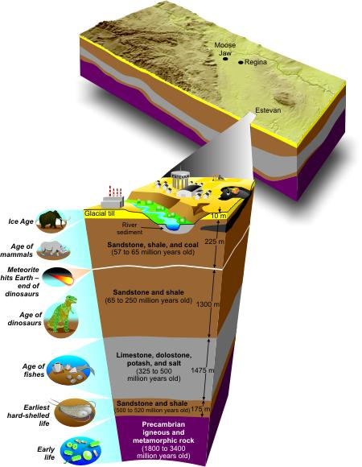
Stratigraphy is the study of the Earth’s strata or layers.

Two basic principles of stratigraphy are:
1) The principle of superposition: states
that the oldest layers are found at the base of the formation, and that
each successively higher layer is younger than the one below it.
2) The principle of original horizontality:
means that sedimentary rocks were originally deposited in horizontal
layers.
More Information can be found at:
https://pubs.usgs.gov/gip/fossils/rocks-layers.html
- Because geologists cannot see
everything in the ground beneath our feet, they use various techniques to figure it out. One technique for subsurface mapping is to take a core sample. In this way geologists can make educated guesses as to the composition of the earth
and the geologic history of an area.

Examining the general stratigraphy of Saskatchewan can lead to discussions and projects
regarding Saskatchewan’s mineral resources.

Stage 3: Build Learning Plan
Set (Warm-up, Focusing the Learning): Time: 5 min  Ask students what is below their feet, if they kept digging into the ground. Encourage students to share their responses. Then, tell students that the cupcakes represent what is below their feet. The icing represents the soil or layer of dirt that we can see. Have students begin the lesson by making predictions about what they believe the inside of the cupcake will look like underneath the icing. On the activity sheet, students should draw what they think the inside the cupcake looks like.  Development: Time: 20 min  Distribute cupcakes to your students. Explain that geologists can study what is below our feet, the composition of the Earth and the geological history of an area by taking core samples. Then, have them insert a straw into the center of the cupcake and take a “core sample.” (The children may have to blow their samples out of the straw.) Have students draw the inside of the cupcake based on the information from the “core sample”. For older students, let them decide how to get more information from the cupcake without cutting it open. Extract two more “core samples” and revise the sketch. Cut the cupcake in half and draw the actual center of the cupcake.  Learning Closure: Time: 15 min  Have a class discussion…  - One thing that surprised them when they took the core sample, and why it surprised them.  - How their original drawing was similar or different to the inside of the cupcake and why they believed it to be that way.  - What is below your feet? Layers of different types of rocks stacked on top of each other.  - Why are core samples important for geologists? Core samples help geologists interpret what is underground in order to understand the geological past of an area or where resources like potash, uranium and oil are located. |  | Prep Work:  Prepare enough batter for cupcakes for the entire class. Separate the batter into three parts and dye each part a different colour. Layer the coloured batter into foil cupcake liners or tart tins and bake. When cool ice with chocolate icing. The 3 different cupcake colors represent different rock successions beneath the surface in Southern Saskatchewan: glacial deposits, sedimentary rocks of Western Canada Sedimentary Basin and igneous and metamorphic rocks of the Precambrian shield. The chocolate icing represents the layer of dirt on top.  Materials:  Cupcake mix, food colouring, foil and liners.  Per child: cupcake, napkin, straw, and student activity sheet. Teacher: butter knife  Key Vocabulary:  Stratigraphy (explanation included in the teacher background section)  Safety Considerations:  Make sure to take allergies, and food restrictions for you class into consideration.  Possible Adaptations/  Differentiation  This activity could be done in pairs, or groups having 1 cupcake per group.

Stage 4: Determine Evidence for Assessing Learning
Product:
Completion of the activity sheet including drawings and answers to the questions for discussion.
Process:
Having students complete the activity of getting a core sample from their cupcake and adapting their drawings accordingly.
Conversation:
Through conversation with individual students during the activity as well as during the learning closure students will be able to share what they have learnt.

Extensions
Use the three colours in proportion to represent the core, mantle and crust, when learning about the internal structure of the earth. (suggested for grade 7)

Look at the GeoExplore Saskatchewan website for further information and a deeper understanding of the importance of Saskatchewan’s geological history. It is a digital version of the original paper Geological Highway Map of Saskatchewan:

Main Website
https://skgeolhighwaymap.maps.arcgis.com/apps/MapSeries/index.html?appid=a845cbb370f7401597806887318e2676

For more background information related to this lesson check out
- Main tab “Geo 101” then subtab “Sask Geology”
- Main tab “Sedimentary Basins.”

Name: __________________________

What if we just kept on Digging?
Stratigraphy Part One – Cupcake Core Exploration Drawings

Prediction Drawing: What does the cupcake look like on the inside? | Prediction Drawing: What does the cupcake look like on the inside after one core sample?
Prediction Drawing: What does the cupcake look like on the inside after three core samples? | Conclusion Drawing: What does the cupcake look like on the inside after cut in half?

Cupcake Core Exploration Questions

- How did your drawings compare to the actual cupcake?

- Did taking core samples help you to determine what the inside of the cupcake looked like? Why or why not?

Flip
- How is the cupcake similar to the Earth?

- What types of problems do geologists encounter when mapping?

- What is one major consideration to make when looking at core?

- Why would geologists take core samples?

Bonus: Do you know where the core from Saskatchewan is kept?

What if we just kept on Digging? Answers
Stratigraphy Part One – Cupcake Core Exploration Questions

- How did your drawings compare to the actual cupcake?
Answers will vary

- Did taking core samples help you to determine what the inside of the cupcake looked like? Why or why not?
Answers will vary

- How is the cupcake similar to the earth?

The earth is layered. Parts of the Earth are hidden.

- What types of problems do geologists encounter when mapping?
They can’t see the rocks underground; it is not safe or easy to get to those depths.

- What is one major consideration to make when looking at core?
You are only looking at a small piece of the subsurface, in order to make correlations you must take and map several samples over a large area.

- Why would geologists take core samples?
To learn more about the Earth, to find resources like oil or potash, or to find out about the geologic past of an area.

Bonus: Do you know where the core from Saskatchewan is kept?
The Subsurface Geological Laboratory in Regina.

